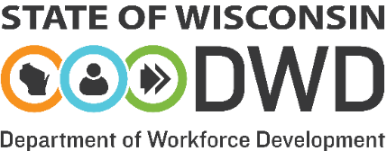

Wisconsin One-stop Delivery System Self-Certification Attestation

As a representative of Choose an item., and on behalf of the counties within the Workforce Development Area (WDA), I hereby notify the State of Wisconsin that the One-Stop Delivery System and the following Job Centers in the WDA have been certified consistent with WIOA Title I-A & I-B Policy & Procedure Manual, Chapter 2.8.

The Workforce Development Board (WDB) has completed one One-Stop System Checklist (Attachment A) for the WDA, and one Job Center Checklist (Attachment B) for each Job Center within its borders that will be included in its One-Stop Delivery System MOU(s) and/or receive Title I one-stop infrastructure funding. Required checkboxes have been marked; supporting documentation has been attached as applicable; and every question has been answered on both respective checklists.

I understand that the local WDB will be asked to substantiate the certifications in future monitoring conducted by the Wisconsin Department of Workforce Development.

Name of Center | Address | Comprehensive, Affiliate

Printed Name of Chief Elected Official |  | Signature of Chief Elected Official |  | Date

Printed Name of Board Director |  | Signature of Board Director |  | Date

Attach the completed Certification Checklists and local WDB policies/procedures, as referenced in the checklists, when submitting the Job Center Certification packet to DETWIOA@dwd.wisconsin.gov.

WIOA Title I-A & I -B Policy and Procedure Manual Chapter 2.8
WIOA Title I-A & I -B Policy and Procedure Manual Chapter 2.2.3

