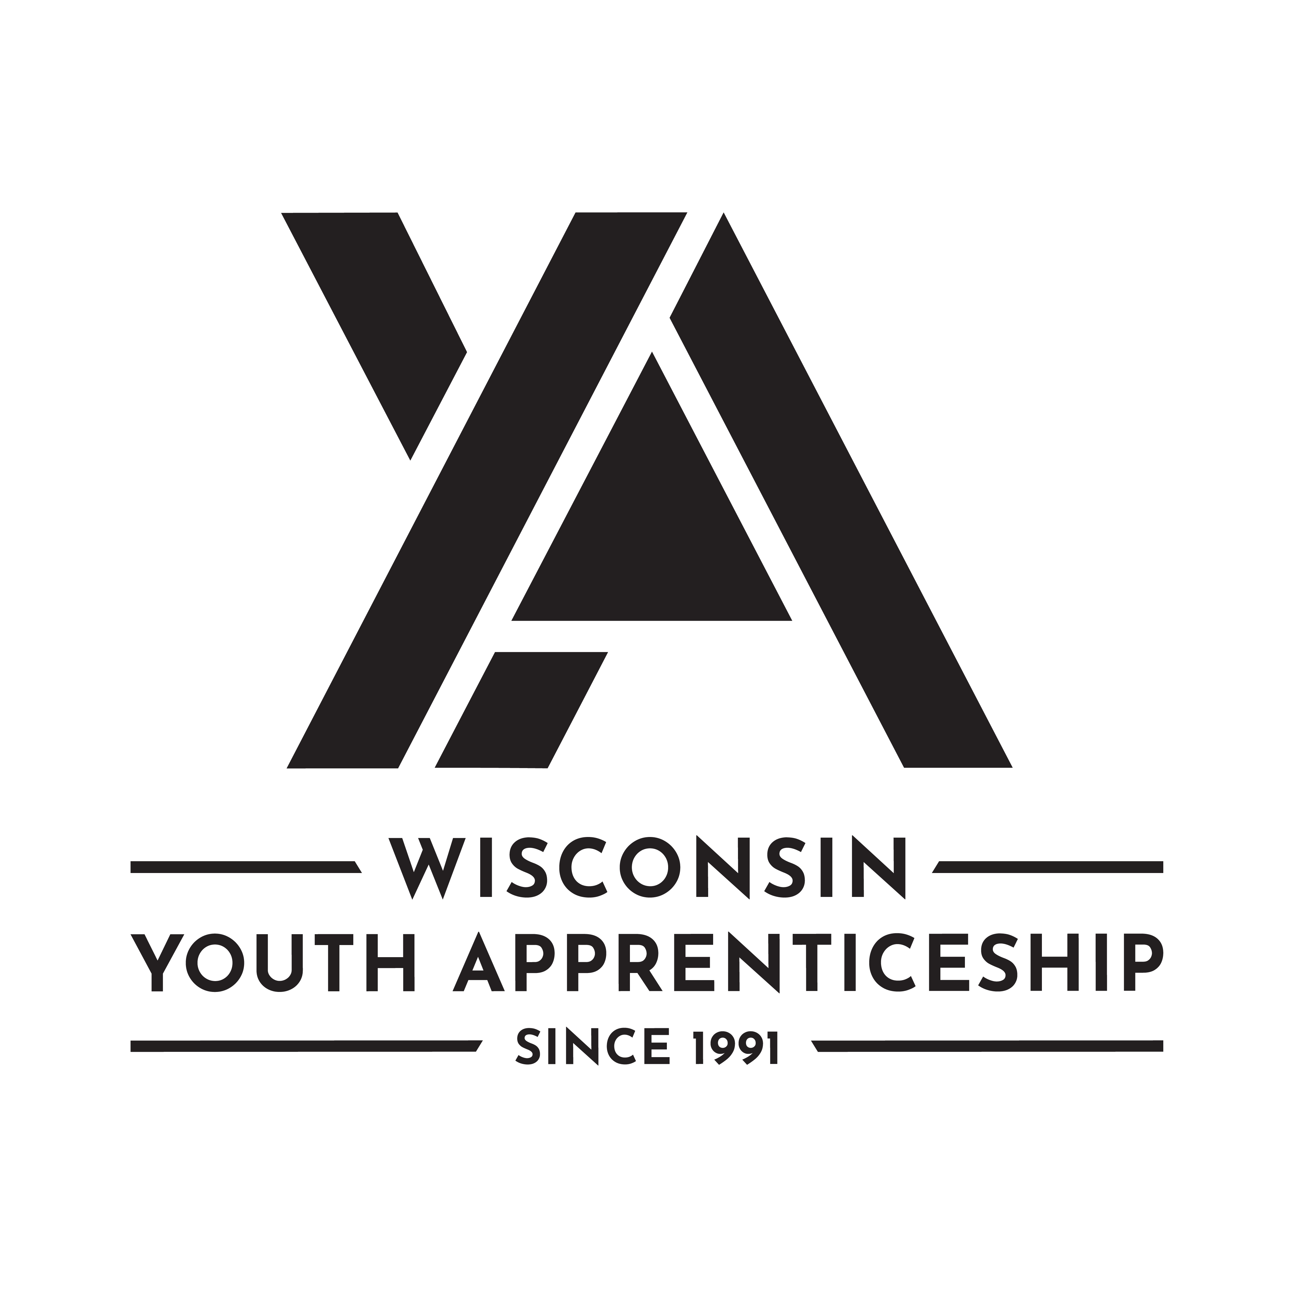 | Transportation, Distribution, and Logistics Occupational Pathway  Youth Apprenticeship  Related Instruction Guide

Recommendations
These recommendations are intended to be used by the YA Consortiums to determine appropriate related technical instruction for the youth apprenticeship programs in the Transportation, Distribution, and Logistics occupational area. These recommendations are not all-inclusive.

Related Instruction Credits
The minimum number of related instruction credits for youth apprentices per year is indicated below. Youth apprentices may take more related instruction courses than the minimum required. No matter the options offered for the related instruction, youth apprenticeship students must receive high school credit toward graduation.
Options for related instruction include the following. Students must complete one of the options below.
Course Options | Minimum Number of Credits
High School Course | 1 high school credit per year
College Course | 3 college credits per year
Other options: employer provided training, online learning, independent study, etc. | 1 high school credit (options may be combined in various ways but must be equal to one high school credit—the student must receive high school credit toward graduation for this work)

Related Instruction options
Related instruction must be provided to all youth apprentices to support the attainment of knowledge necessary to master the competencies. Courses selected for related instruction should be aligned to the competencies identified in the program On-the-Job Learning Performance Standards Guide.
Related courses can be drawn from a variety of options:
Type | Description
Registered Apprenticeship Bridge Courses | Youth apprentices may take courses that are part of the registered apprenticeship at local technical colleges or at other technical colleges online. These courses are excellent options for students because they provide a pathway for the student to seamlessly bridge into the registered apprenticeship having completed some of the required coursework.
College Transcripted/Dual Credit Courses | Transcripted credit courses (also referred to as dual credit) provide an opportunity for the student to earn college credit directly from the college. Usually offered through the technical college, these courses may be taught by a technical college instructor or a high school instructor who holds an appropriate credential. Transcripted credit courses are good options because they allow students to earn credit toward a degree at the technical college or sometimes toward related instruction in a registered apprenticeship.
High School Courses | High school courses that relate to the apprenticeship job competencies can be used for related instruction. Sometimes these courses can be articulated with the local technical college for advance standing. If the student goes on to take courses at the technical college, advance standing may be awarded for the course based on an articulation agreement between the high school and the college.
Other Options | Other options to help students learn related instruction content include:  - Employer provided training  - Online courses provided by professional organizations  - Independent study courses offered at the local high school  These options can be combined in various ways provided they are related to the competencies in the On-the-Job Learning Performance Standards Guide and meet the minimum number of hours required for one high school credit.

Checklist for Course Selection
When choosing the courses for a youth apprenticeship using the competencies in the On-the-Job Learning Performance Standards Guide, consider these questions or refer to the decision flowchart.
- Does the course bridge to a registered apprenticeship?
- Does the course apply to a related college program?
- Does the course qualify for dual credit?
- Does the course qualify as a Perkins Pathway CTE course?
- Is the course required for an occupation certification?
If YES to any above:
- Is the course accessible to the student?
NOTE: Courses accessibility is determined by district or high school availability, transportation, course supply accessibility, course offering timeline, and distance or virtual learning resources required.
If NO to any above, contact the DWD YA Staff through the YA mailbox (ya@dwd.wisconsin.gov) to discuss options.

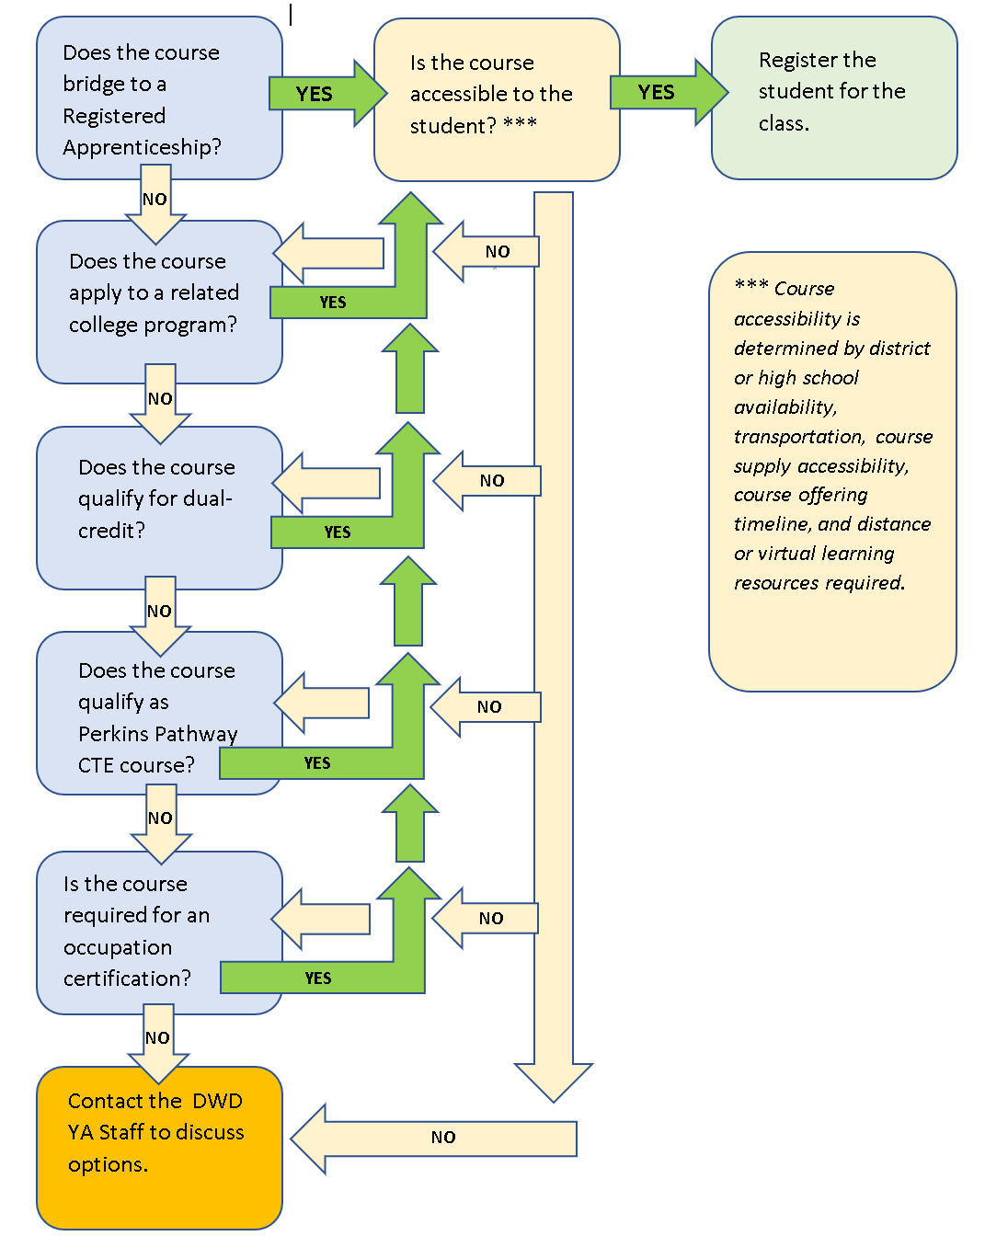

Opportunities for Registered Apprenticeship Bridge
The following programs can bridge into a registered apprenticeship.
Youth Apprenticeship | Registered Apprenticeship
Diesel Technician | Diesel Technician

Supply Chain Pathways

Suggested Related Instruction Courses FOR SUPPLY CHAIN Pathways
The following courses are suggested as options for related instruction because they are aligned to the apprenticeship competencies in the On-the-Job Learning Performance Standards Guide. These recommendations are not all-inclusive.
Suggested College Courses (titles are representative)
Course | Credits (College) | Supply Chain Assistant | Storage and Warehousing | Inventory Management | Distribution and Transportation Operations | Planning and Purchasing
Supply Chain Career Exploration | 1-2 | X | X | X | X | X
Fundamentals of Supply Chain | 3 | X | X | X | X | X
Principles of Inventory | 3 | X | X | X | X | X
Intro to Business | 3 | X | X | X | X | X
MS Office | 1-3 | X | X | X | X | X
Excel | 1-3 | X | X | X | X | X

Automotive Pathways

Suggested Related Instruction Courses for Automotive PATHWAYS
The following courses are suggested as options for related instruction because they are aligned to the apprenticeship competencies in the On-the-Job Learning Performance Standards Guide. These recommendations are not all-inclusive.

Suggested College Courses (titles are representative)

Course | Credits (College) | Auto Technician | Collision Repair | Diesel Technician
Small Engines/Engines | 3 | X |  | X
Basic Welding | 3 | X | X | X
Electronics | 3 | X | X | X
Machine Shop Fundamentals | 3 |  | X
Metal Fabrication | 3 |  | X | X
Power Equipment | 1-3 | X | X | X
Auto Service Fundamentals | 3 | X | X | X

Bridged Courses to Registered Apprenticeship
The following courses bridge to the Diesel Technician registered apprenticeship.
Course # | Course Title | Credits
10-412-119 | Diesel Brake Systems 1 | 1
10-412-125 | Diesel Brake Systems 2 | 2
10-412-120 | Preventative Maintenance 1 | 1
10-412-127 | Diesel Preventative Maintenance 2 | 2
10-412-126 | Heavy Duty Suspension & Steering 1 | 1
10-412-124 | Heavy Duty Suspension & Steering 2 | 2
10-412-118 | Diesel Electrical Systems 1 | 1
10-412-123 | Diesel Electrical Systems 2 | 2
10-442-XXX | Intro to Welding | 1
10-XXX-XXX | CDL Permit Preparation | 1
10-601-195 | Written Communication | 3

Aviation Pathways

Suggested Related Instruction Courses for AVIATION PATHWAYS
The following courses are suggested as options for related instruction because they are aligned to the apprenticeship competencies in the On-the-Job Learning Performance Standards Guide. These recommendations are not all-inclusive.

Suggested College Courses (titles are representative)

Course | Credits (College) | Aviation Maintenance Fundamentals | Airframe and Powerplant (A&P) | Avionic Technology | Airport Operations Management
Small Engines/Engines | 3 | X | X | X | X
Basic Welding | 3 | X | X | X | X
Electronics | 3 | X |  | X
Physics | 3 | X | X | X
IT Support/Network Basics | 3 |  |  | X
Marketing Principles | 3 |  |  |  | X
Intro to Engineering | 3 |  |  |  | X
HVAC Basics | 3 |  |  |  | X
Intro to Business | 3 |  |  |  | X

DWD is an equal opportunity employer and service provider. If you have a disability and need assistance with this information, please dial 7-1-1 for Wisconsin Relay Service. Please contact the Division of Employment and Training at 888-258-9966 and press 6 to request information in an alternate format, including translated to another language.

