Information Technology Occupational Pathway
Youth Apprenticeship
Related Instruction Guide

Recommendations
These recommendations are intended to be used by the YA Consortiums when determining appropriate related technical instruction for the youth apprenticeship programs in the Information Technology cluster. These recommendations are not all-inclusive.

Related Instruction Credits
The minimum number of related instruction credits for youth apprentices per year is indicated below. Youth apprentices may take more related instruction courses than the minimum required. No matter the options offered for the related instruction, Youth Apprenticeship students must receive high school credit toward graduation.
Options for related instruction include the following. Students must complete one of the options below.
Course Type | Minimum Number of Credits
High School Course | 1 high school credit per year
College Course | 3 college credits per year
Other options: employer provided training, online learning, independent study, etc. | 1 high school credit (options may be combined in various ways but must be equal to one high school credit—student must receive high school credit toward graduation for this work)

Related Instruction options
Related instruction must be provided to all youth apprentices to support the attainment of knowledge necessary to master the competencies. Courses selected for related instruction should be aligned to the competencies identified in the program On-the-Job Learning Performance Standards Guide.
Related courses can be drawn from a variety of options:
DETA-18835-P
Type | Description
Registered Apprenticeship Bridge Courses | Youth apprentices may take courses that are part of the registered apprenticeship at local technical colleges or at other technical colleges online. These courses provide excellent options for students because they provide a pathway for the student to seamlessly bridge into the registered apprenticeship having completed some of the required coursework.
College Transcripted/Dual Credit Courses | Transcripted credit courses (also referred to as dual credit) provide an opportunity for the student to earn college credit directly from the college. Usually offered through the technical college, these courses may be taught by a technical college instructor or a high school instructor who holds an appropriate credential. Transcripted credit courses are good options because they allow students to earn credit toward a degree at the technical college or sometimes toward related instruction in a registered apprenticeship.
High School Courses | High school courses that relate to the apprenticeship job competencies can be used for related instruction. Sometimes these courses can be articulated with the local technical college for advance standing. If the student goes on to take courses at the technical college, advance standing may be awarded for the course based on an articulation agreement between the high school and the college.
Other Options | Other options to help students learn related instruction content include:  - Employer provided training  - Online courses provided by professional organizations  - Independent study courses offered at the local high school  These options can be combined in various ways provided they are related to the competencies in the On-the-Job Learning Performance Standards Guide and meet the minimum number of hours required for one high school credit.

Checklist for Course Selection
When choosing the courses for a youth apprenticeship using the competencies in the On-the-Job Learning Performance Standards Guide, consider these questions or refer to the decision flowchart.
- Does the course bridge to a Registered Apprenticeship?
- Does the course apply to a related college program?
- Does the course qualify for dual-credit?
- Does the course qualify as a Perkins Pathway CTE course?
- Is the course required for an occupation certification?
If YES to any above:
- Is the course accessible to the student?
NOTE: Courses accessibility is determined by district or high school availability, transportation, course supply accessibility, course offering timeline, and distance or virtual learning resources required.
If NO to any above, contact the DWD YA Staff through the YA mailbox at (ya@dwd.wisconsin.gov) to discuss options.

Related Instruction Course Selection Flowchart
Course S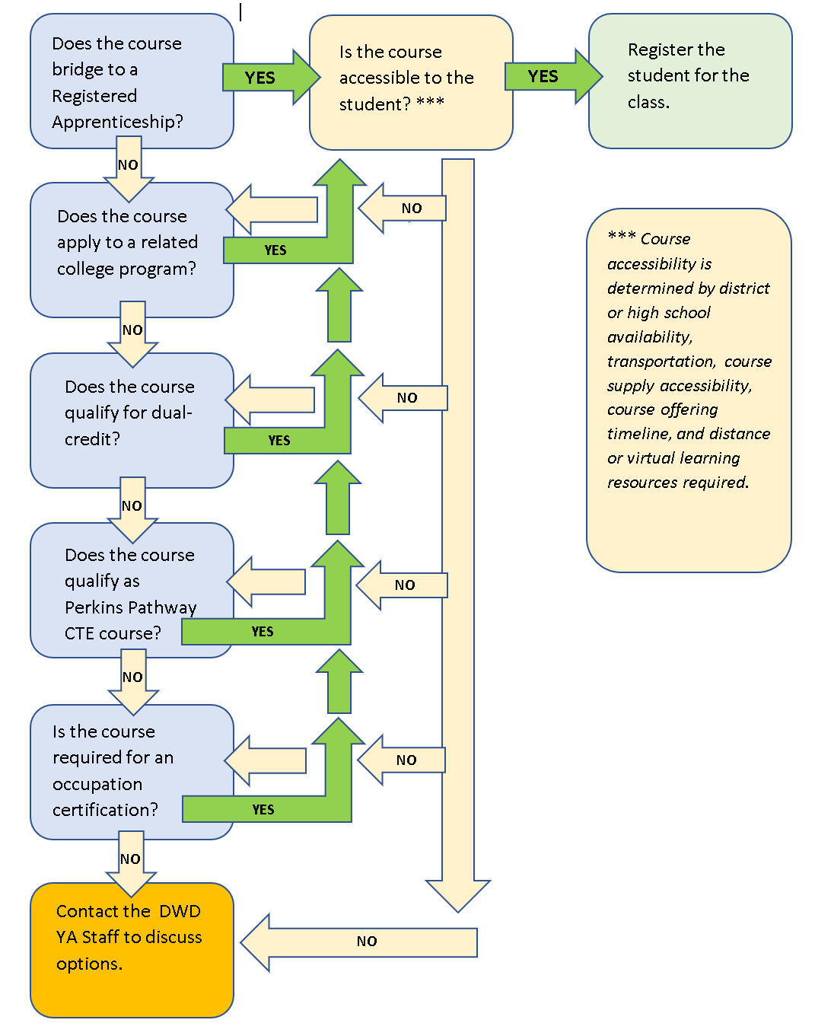

Opportunities for Registered Apprenticeship Bridge
IT: Software Developer: Software Developers develop, create, and modify general computer applications software or specialized utility programs. Analyze user needs and develop software solutions. Design software or customize software for client use with the aim of optimizing operational efficiency. May analyze and design databases within an application area, working individually or coordinating database development as part of a team.
IT: Data Analyst: The primary role of a Data Analyst is to collect and organize data to provide business insight. Data analysts are typically involved with selecting, integrating, querying, and aggregating data, and conducting a range of analytical studies on that data. They work across a variety of projects, providing technical data solutions to a range of stakeholders/customers issues. They document and report the results of data analysis activities to improve business performance. They have a good understanding of data structures, database systems, and data processing and manipulation skills using analytical tools to undertake a range of different types of analyses.
IT: Cybersecurity: A Cybersecurity professional protects, detects and defends organizational data, networks, databases, hardware, firewalls and encryption. Cybersecurity professionals may also regulate access to computer files, develop firewalls, perform risk assessments and test data processing systems to verify security measures. Cybersecurity professional may work with organizations to maintain organizational information security through planning, coordinating, and implementing information security programs.
IT: Service Desk: An IT Service Desk Technician is responsible for fielding incoming technical support communications and tickets, troubleshooting issues, communicating over the phone, email, chat, resolving help inquiries.
IT: Broadband Technology: The Broadband Service Technician assists with on-site installations, troubleshooting, repairs, and maintenance of telecommunications products and equipment that broadband providers sell and lease. The technician will have direct, face-to-face contact with our customers and is expected to be proactive with the sale of services and products. Services include, but are not limited to, Telephony, Video/CATV/DBS, Internet, Wi-Fi, and/or high-speed networks. Exceeds customer expectations by performing extraordinary customer service, identifying customer needs, and providing them with communication solutions. Understands how to use and demonstrate products and seeks sales opportunities while educating the customer. Products and services include (but are not limited to): Local Services, Central Office Services, Structured Cabling, MAC (Moves, Adds and Changes), Voice Mail, Audio and/or Video Conferencing and Non-regulated CPE.

Suggested Related Instruction Courses
The following courses are suggested course topic areas appropriate for information technology youth apprentices. These recommendations are not all-inclusive.
Course
Microsoft Office Suite (Word, Excel, PowerPoint)
Advanced Placement Computer Science
Programming (i.e. JAVA, C+, etc.)
Networking and Cybersecurity
Research and Troubleshooting for IT
Operating Systems
Telecommunications

Bridged Courses to Registered Apprenticeship
IT Cybersecurity (first semester courses)
The following courses bridge to the IT Cybersecurity Registered Apprenticeship.
Number | Title | Credits | Description
50-150-702 | IT Cybersecurity Intro to Networking | 3 | This course introduces the principles and structure of IP addressing and the fundamentals of Ethernet concepts, media, and operations to provide a foundation for subsequent networking topics
50-151-701 | IT: Cybersecurity: Security Awareness | 1 | Provides a basic survey of the importance of IT security awareness and data confidentiality through basic aspects of information security and addresses the value of securing data. The course presents best practices in access control and password policies.

IT Software (first semester courses)
The following courses bridge to the IT Software Registered Apprenticeship.
Number | Title | Credits | Description
50-152-701 | Basic Programming for IT: Software Developer | 3 | Provides an introduction to software developer skills. Focuses on the use of an integrated development environment and managing code in a repository. Apprentices use logic, function, basic collections, object oriented concepts, and programming concepts to build and debug an application.
50-152-702 | Collaborative Application Development | 2 | Explores the software development life cycle and the functional requirements used to create a successful application using a collaborative approach. Provides apprentices the opportunity to develop skills in presenting and demonstrating software to internal and external stakeholders. Emphasis is placed on clear and concise delivery. Apprentices also examine online developer resources and interpret technical information.

IT Service Desk (all Related Instruction Courses)
The following courses bridge to the IT Service Desk Registered Apprenticeship.
Number | Title | Credits | Description
50-154-701 | Research and Troubleshooting | 2 | Provides instruction to IT Service Desk Technician Research and Troubleshooting skills. Apprentices perform research and troubleshooting skills, investigate Service Desk operations, create a support utility kit, correct information, and mistakes.
50-154-702 | Service Desk Documentation | 1 | Provides instruction to IT Service Desk Technician Documentation skills. Apprentices perform communication and documentation skills related to incorporating information sources, writing procedures, maintaining a knowledge base, preparing reports, presenting oral reports, and developing ticketing skills.
50-154-703 | Service Desk Professional Skills | 1 | Provides instruction to IT Service Desk Technician professional skills. Apprentices will develop customer service skills, manage difficult customers, develop professional business skills, work with teams, minimize effects of stressful situations, develop time management skills.

IT Data Analyst (first semester courses)
The following courses bridge to the IT Data Analyst Registered Apprenticeship.
Number | Title | Credits | Description
50-156-701 | Introductory SQL | 2 | The introductory SQL course prepares apprentices to leverage a relational database management system to retrieve data. They will create and execute queries using SQL statements. They will read an Entity-Relationship Diagram to direct the creation of the correct query.
50-156-702 | Intermediate SQL | 2 | The Intermediate SQL course reviews the construction of a SQL query joining multiple tables using both INNER and OUTER joins, subqueries, scalar functions and aggregate functions. Apprentices add, modify and remove data records using DML statements; identify and create appropriate indexes to improve system query performance; and analyze the results for accuracy and completeness as well as review query performance for review and optimization.

Broadband Technology (all Related Instruction Courses)
The following courses bridge to the Broadband Registered Apprenticeship.
Number | Title | Credits | Description
50-451-701 | Broadband Installation | 2 | This course will introduce the apprentice to broadband services and practices for understanding Telco, HFC, IPTV and fiber-optic communication systems. The apprentice will be able to identify the physical layers of broadband networks and installation components. Apprentice will gain a deeper understanding of the networking devices and how they operate in the broadband network.
50-451-702 | Broadband Support and Repair | 2 | This course will provide the theory necessary to understand and troubleshoot the components and systems support unique to the broadband industry. Theory will be specialized in following areas Telco, HFC, IPTV and Fiber Optic networks. You learn to apply basic troubleshooting techniques and repair procedures of broadband service support and repair.

Suggested Related Instruction Courses
The following courses are suggested course topic areas appropriate for information technology youth apprentices. These recommendations are not all-inclusive.
Course
Microsoft Office Suite (Word, Excel, PowerPoint)
Advanced Placement Computer Science
Programming (i.e. JAVA, C+, etc.)
Networking and Cybersecurity
Research and Troubleshooting for IT
Operating Systems
Telecommunications

DWD is an equal opportunity employer and service provider. If you have a disability and need assistance with this information, please dial 7-1-1 for Wisconsin Relay Service. Please contact the Division of Employment and Training at 888-258-9966 and press 6 to request information in an alternate format, including translated to another language.

