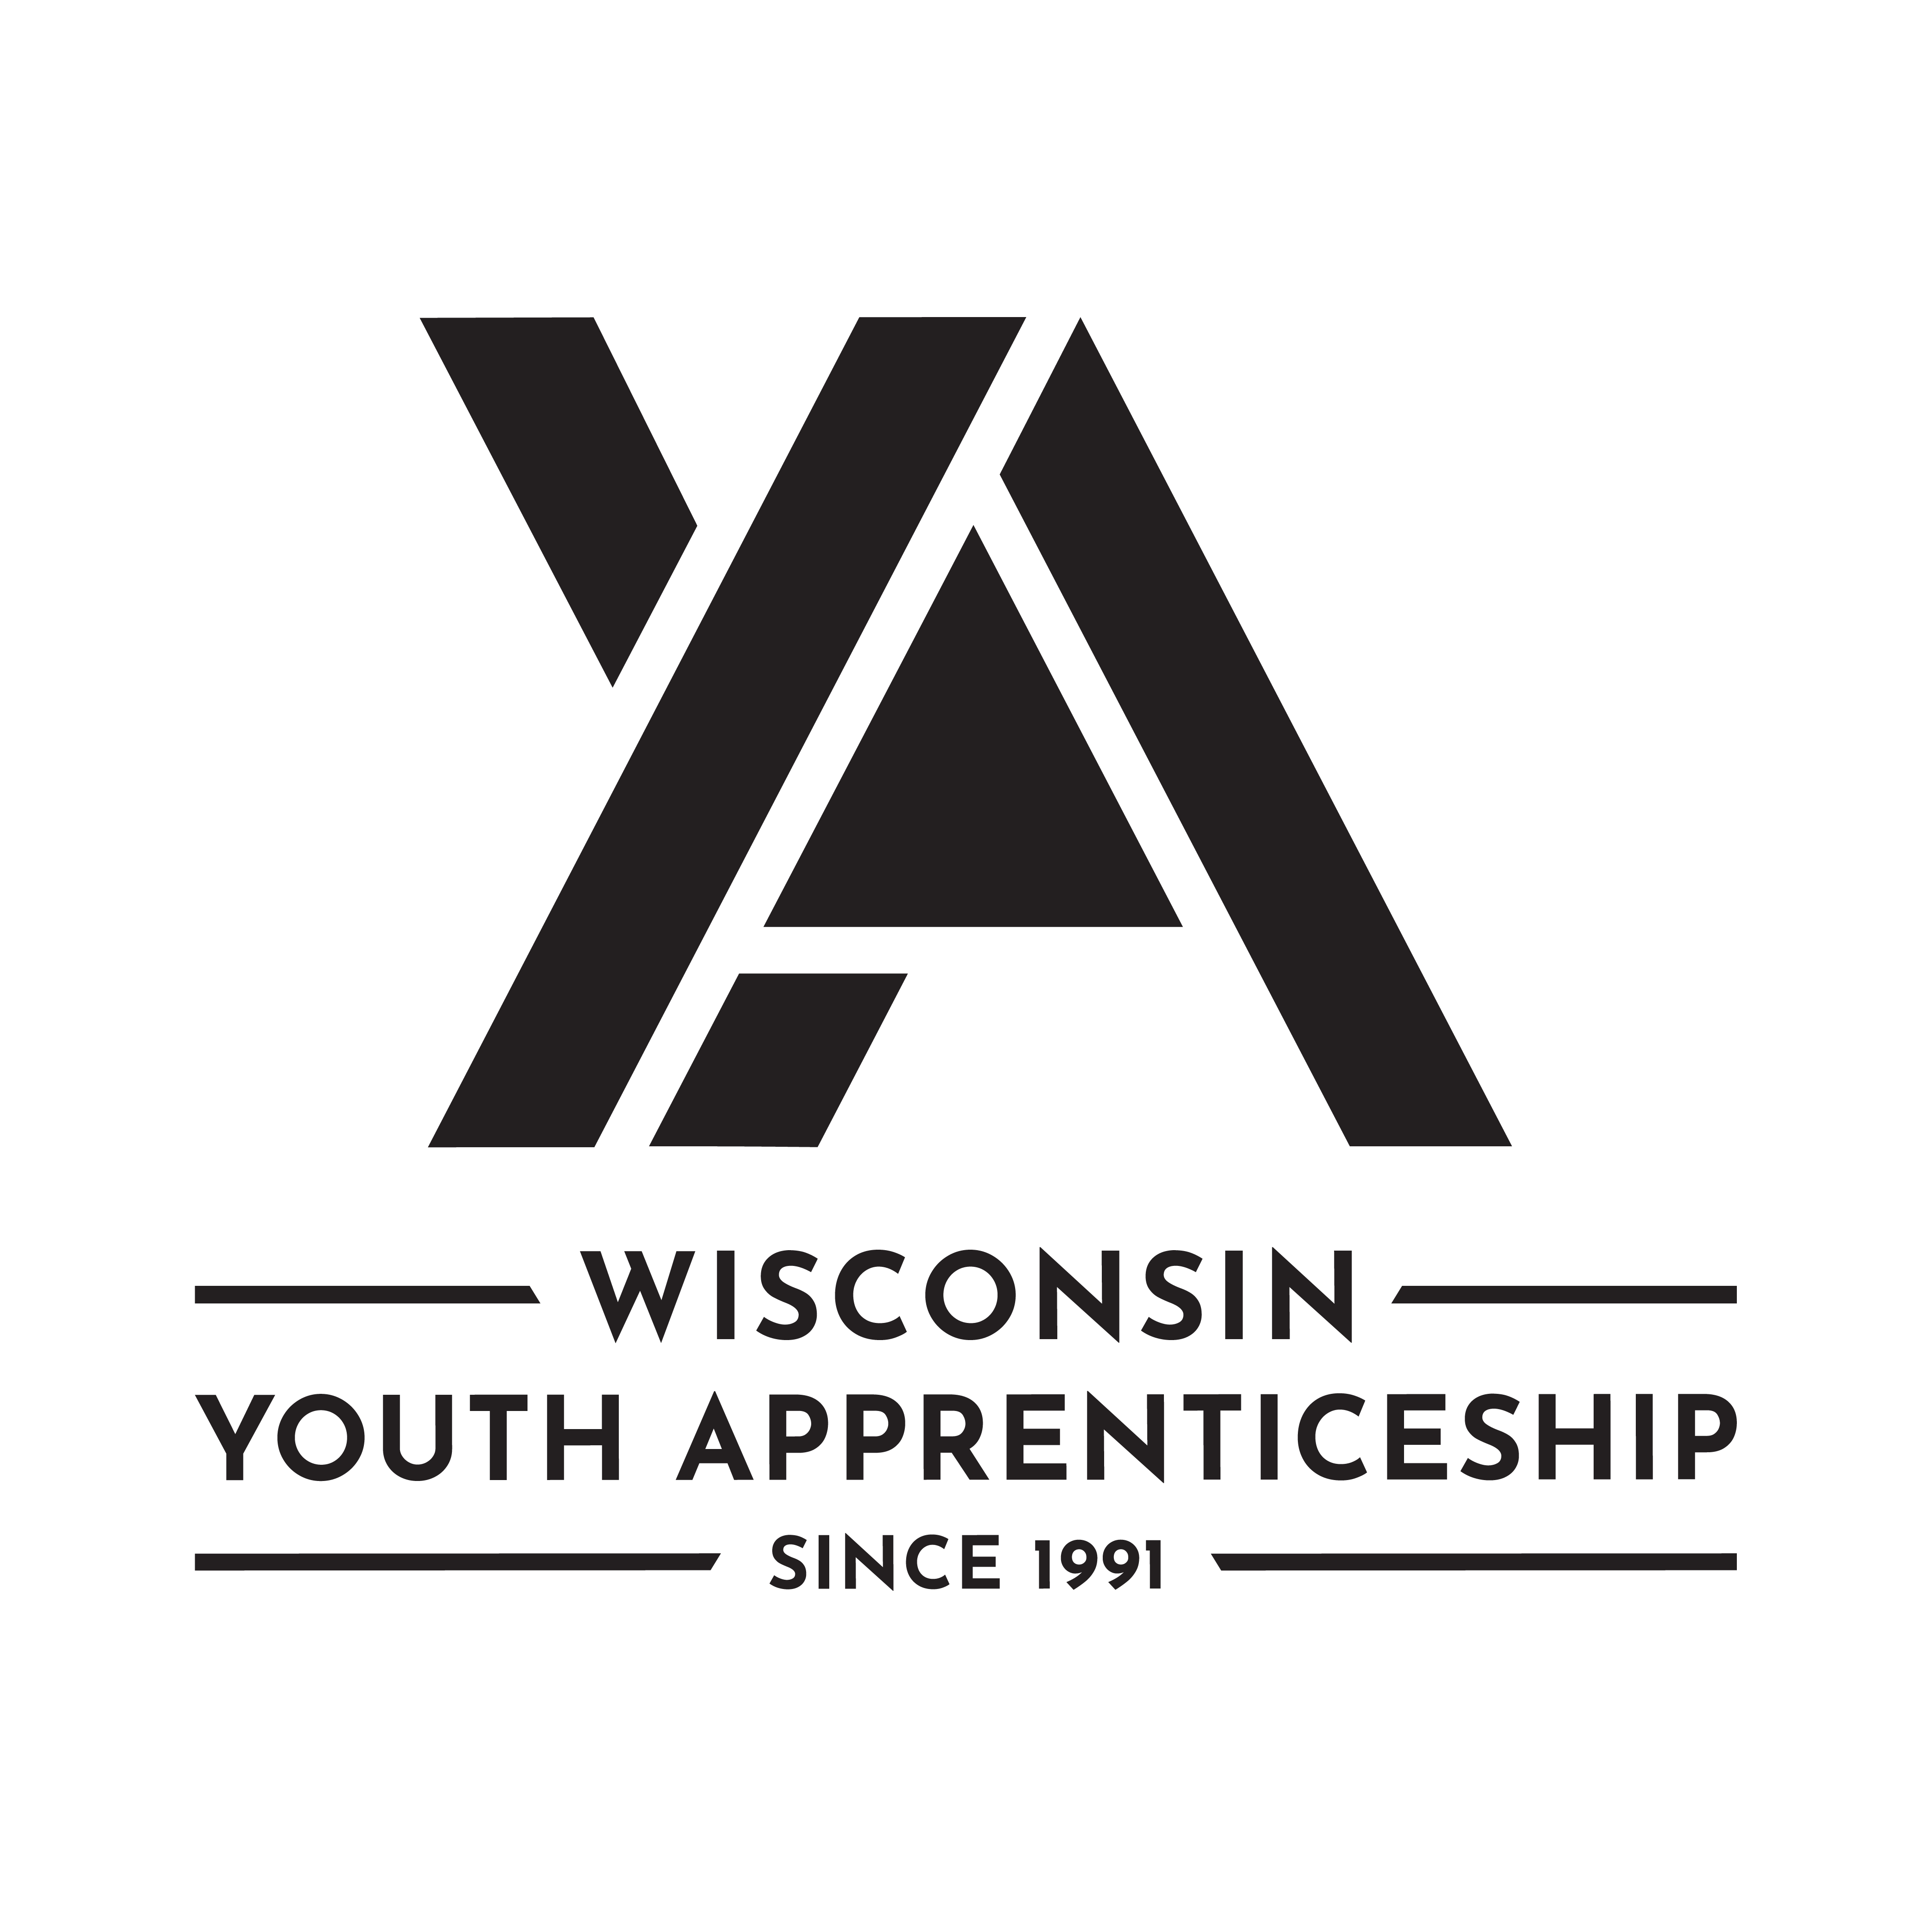 | Hospitality & Tourism Occupational Pathways  Youth Apprenticeship  Related Instruction Guide

Recommendations
These recommendations are intended to be used by the YA Consortiums when determine appropriate related technical instruction for the youth apprenticeship programs in the hospitality cluster. It is not all-inclusive.

Related Instruction Credits
The minimum number of related instruction credits for youth apprentices per year is indicated below. Youth apprentices may take more related instruction courses than the minimum required. No matter the options offered for the related instruction, Youth Apprenticeship students must receive high school credit toward graduation.
Options for related instruction include the following. Students must complete one of the options below.
Course Options | Minimum Number of Credits
High School Course | 1 high school credit per year
College Course | 3 college credits per year
Other options: employer provided training, online learning, independent study, etc. | 1 high school credit (options may be combined in various ways but must be equal to one high school credit—student must receive high school credit toward graduation for this work)

Related Instruction options
Related instruction must be provided to all youth apprentices to support the attainment of knowledge necessary to master the competencies. Courses selected for related instruction should be aligned to the competencies identified in the program On-the-Job Learning Performance Standards Guide (OJT Standards Guide).
Related courses can be drawn from a variety of options:
Type | Description
Registered Apprenticeship Bridge Courses | Youth apprentices may take courses that are part of the registered apprenticeship at the local technical college or at another technical college online. These courses provide excellent options for students because they provide a way for the student to seamlessly bridge into the registered apprenticeship with some of the coursework completed.
College Transcripted/Dual Credit Courses | Transcripted credit courses (also referred to as dual credit) provide an opportunity for student to earn college credit directly from the college. Usually offered through the technical college, these courses may be taught by a technical college instructor or a high school instructor with an appropriate credential. Transcripted credit courses are good options because they allow students to earn credit toward a degree at the technical college or sometimes toward related instruction in a registered apprenticeship.
High School Courses | High school courses that relate to the job competencies can be used for related instruction. Sometimes these courses can be articulated with the local technical college for advance standing. If the student goes on to the technical college, advance standing may be awarded for the course based on an articulation agreement between the high school and the college.
Other Options | Other options to help students learn related instruction content include:  - Employer provided training  - Online courses provided by professional organizations  - Independent study courses offered at the local high school  These options can be combined in various ways if they are related to the competencies in the OJT Standards Guide and meet the minimum number of hours required for one high school credit.

Checklist for Course Selection
When choosing the courses for a Youth Apprenticeship using the competencies in the OJT Standards Guide consider these questions or use the flowchart.
- Does the course bridge to a Registered Apprenticeship?
- Does the course apply to a related college program?
- Does the course qualify for dual credit?
- Does the course qualify as a Perkins Pathway CTE course?
- Is the course required for an occupation certification?
If YES to any above:
- Is the course accessible to the student?
NOTE: NOTE: Course accessibility is determined by district or high school availability, transportation, course supply accessibility, course offering timeline, and distance or virtual learning resources required.

- If NO to any above, contact the DWD YA Staff through the YA mailbox at (ya@dwd.wisconsin.gov) to discuss options.

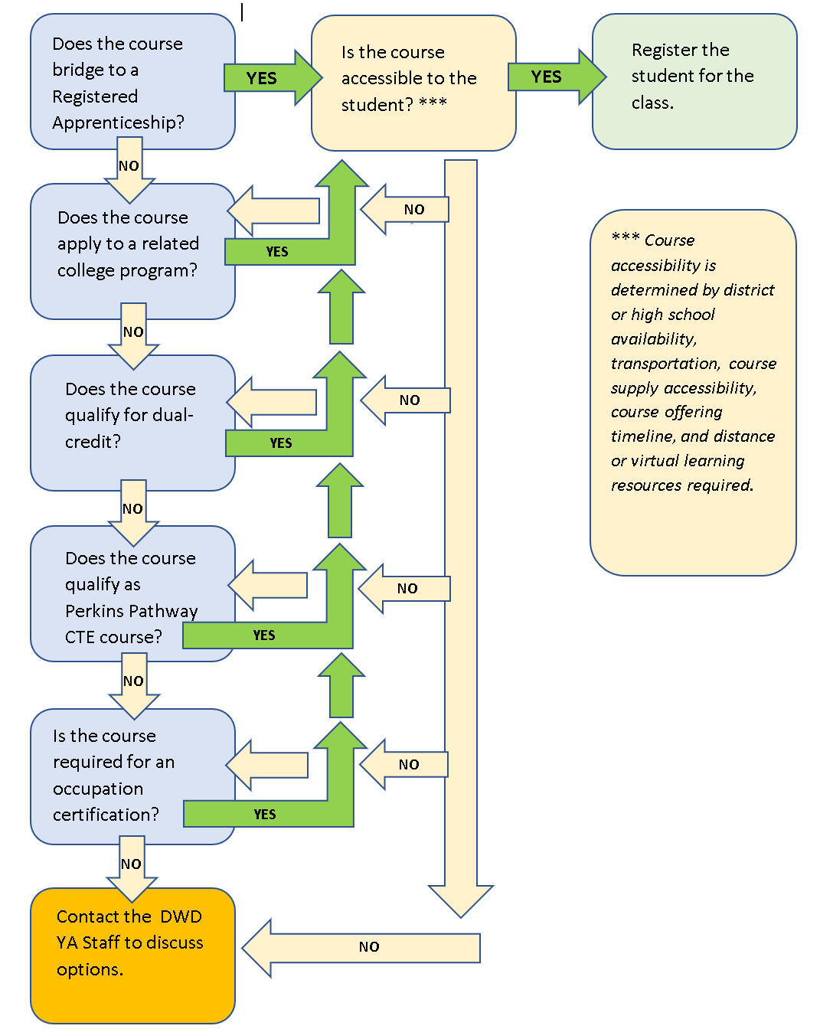

Suggested Related Instruction Courses
The following courses are suggested as options for related instruction because they are aligned to the competencies in the OJT Standards Guide. These recommendations are not all-inclusive.
Suggested College Courses (titles are representative)
Course | Hours Credits (College) | Food and Beverage Services | Lodging | Meetings and Events
Baking Principles/Ingredient Functions | 3 Credits | x
Business Organization & Management | 3 Credits | x | x | x
Business/Hospitality Finance | 3 Credits | x | x | x
Culinary Fundamentals/Culinary Skills | 1-3 Credits | x |  | x
Culinary Math/Food Quantities and Measures | 1-3 Credits | x | x | x
Professional Cooking | 3-4 Credits | x |  | x
Entrepreneurship | 3 Credits | x | x | x
Food and Beverage Operations | 2 Credits | x |  | x
Food Theory | 3 Credit | x
Hospitality Facilities Management | 3 Credit | x | x | x
Intro to Business; Business Principles | 3 Credit | x | x | x
Intro to Hotel/Hospitality Management | 2-3 Credits | x | x | x
Customer Service Techniques | 2-3 Credits | x | x | x
Intro to Hospitality/Tourism Industry | 2-3 Credits | x | x | x
Leadership and Professionalism | 1-3 Credits | x | x | x
Product ID and Purchasing | 2 Credit | x | x | x
Food Service Sanitation | 1-3 Credits | x | x | x
Software Applications for Business | 3 Credits | x | x | x

DWD is an equal opportunity employer and service provider. If you have a disability and need assistance with this information, please dial 7-1-1 for Wisconsin Relay Service. Please contact the Division of Employment and Training at 888-258-9966 and press 6 to request information in an alternate format, including translated to another language.

