Finance Occupational Pathways
Youth Apprenticeship
Related Instruction Guide

Recommendations
These recommendations are intended to be used by the YA Consortiums to determine appropriate related technical instruction for the youth apprenticeship programs in the finance cluster. These recommendations are not all-inclusive.

Related Instruction Credits
The minimum number of related instruction credits for youth apprentices per year is indicated below. Youth apprentices may take more related instruction courses than the minimum required. No matter the options offered for the related instruction, youth apprenticeship students must receive high school credit toward graduation.
Options for related instruction include the following. Students must complete one of the options below.
Course Options | Minimum Number of Credits
High School Course | 1 high school credit per year
College Course | 3 college credits per year
Other options: employer provided training, online learning, independent study, etc. | 1 high school credit (options may be combined in various ways but must be equal to one high school credit—the student must receive high school credit toward graduation for this work)

Related Instruction options
Related instruction must be provided to all youth apprentices to support the attainment of knowledge necessary to master the competencies. Courses selected for related instruction should be aligned to the competencies identified in the program On-the-Job Learning Performance Standards Guide.
Related courses can be drawn from a variety of options:
Type | Description
Registered Apprenticeship Bridge Courses | Youth apprentices may take courses that are part of the registered apprenticeship at local technical colleges or at other technical colleges online. These courses provide excellent options for students because they provide a pathway for the student to seamlessly bridge into the registered apprenticeship having completed some of the required coursework.

DETA-18831-P N.(07/2020)
Type | Description
College Transcripted/Dual Credit Courses | Transcripted credit courses (also referred to as dual credit) provide an opportunity for the student to earn college credit directly from the college. Usually offered through the technical college, these courses may be taught by a technical college instructor or a high school instructor who holds an appropriate credential. Transcripted credit courses are good options because they allow students to earn credit toward a degree at the technical college or sometimes toward related instruction in a registered apprenticeship.
High School Courses | High school courses that relate to the apprenticeship job competencies can be used for related instruction. Sometimes these courses can be articulated with the local technical college for advance standing. If the student goes on to take courses at the technical college, advance standing may be awarded for the course based on an articulation agreement between the high school and the college.
Other Options | Other options to help students learn related instruction content include:  - Employer provided training  - Online courses provided by professional organizations  - Independent study courses offered at the local high school  These options can be combined in various ways provided they are related to the competencies in the On-the-Job Learning Performance Standards Guide and meet the minimum number of hours required for one high school credit.

Checklist for Course Selection
When choosing the courses for a youth apprenticeship using the competencies in the On-the-Job Learning Performance Standards Guide, consider these questions or refer to the decision flowchart.
- Does the course bridge to a Registered Apprenticeship?
- Does the course apply to a related college program?
- Does the course qualify for dual credit?
- Does the course qualify as a Perkins Pathway CTE course?
- Is the course required for an occupation certification?
If YES to any above:
- Is the course accessible to the student?
NOTE: Course accessibility is determined by district or high school availability, transportation, course supply accessibility, course offering timeline, and distance or virtual learning resources required.
If NO to any above, contact the DWD YA Staff through the YA mailbox (ya@dwd.wisconsin.gov) to discuss options.

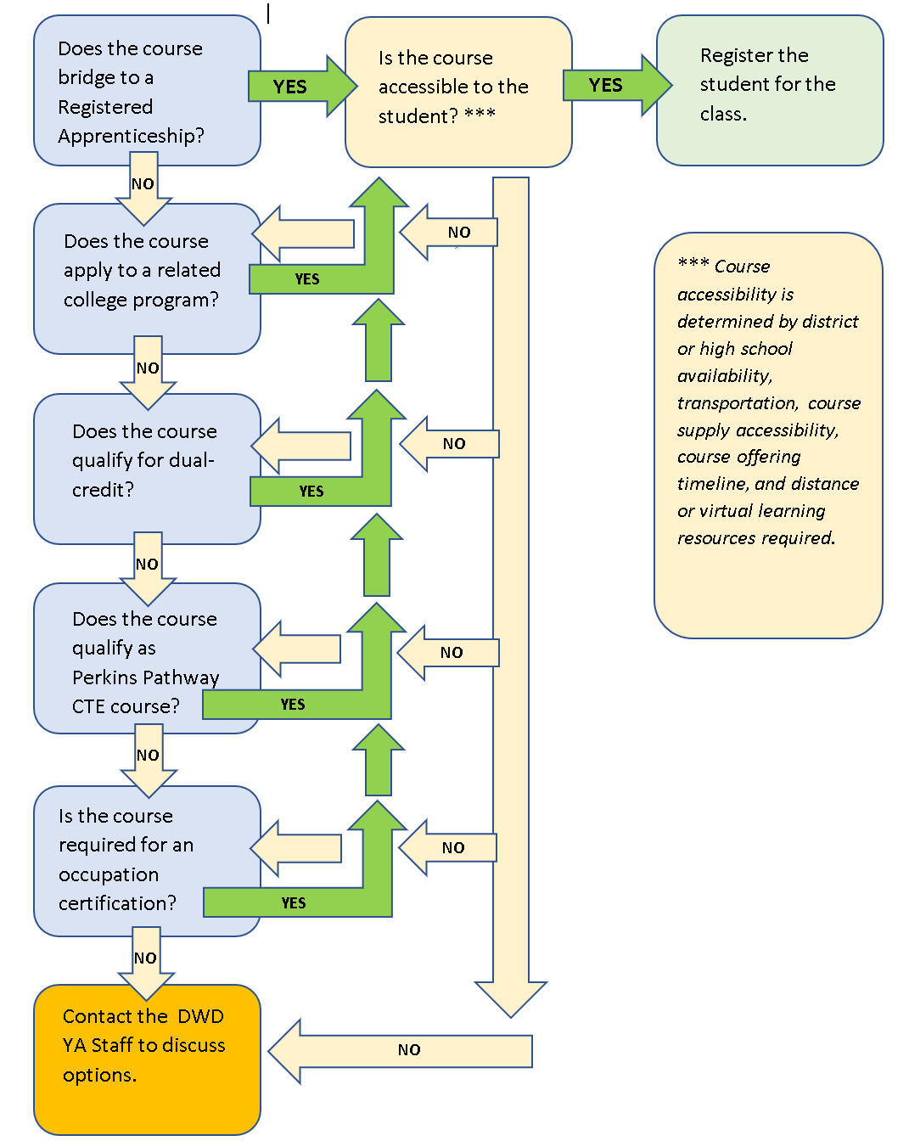

Opportunities for Registered Apprenticeship Bridge
Financial Services Apprentice: A financial services professional identifies prospective individuals and businesses to uncover needs, and implements strategies to meet client needs, and create and advise on financial plans.

Suggested Related Instruction Courses
The following courses are suggested as options for related instruction because they are aligned to the apprenticeship competencies in the On-the-Job Learning Performance Standards Guide. These recommendations are not all-inclusive.

Recommendations College Courses (titles are representative)
Course | Hours Credits (College) | Banking | Accounting | Insurance
Accounting 1/Accounting Principles/Fundamentals of Accounting | 4-5 credits | X | X | X
Accounting 2 | 4 credits |  | X
Microsoft Office | 1-3 credits | X | X | X
Excel/Spreadsheets | 1-4 credits | X | X | X
QuickBooks | 1-4 credits | X | X
Payroll Accounting | 2-3 credits |  | X
Principles of Sales or Marketing | 3 credits | X |  | X
Quality Customer Service | 3 Credits | X | X | X
Personal Financial Planning or Personal Finance | 2-3 credits | X | X | X

Bridged Courses to Registered Apprenticeship
The following courses bridge to the Financial Services Apprenticeship.
Number | Title | Credits | Description
50-114-701 | Financial Service Sales and Marketing | 2 Credits | Provides apprentices instruction to Financial Service Apprentices related to sales and marketing skills. Apprentices will learn about the sales career, buyer behavior, prospecting, negotiating, closing, team sales, and networking.
50-114-702 | Financial Service Professionalism | 1 Credit | Provides apprentices instruction related to Financial Service professionalism skills. Apprentices will learn effective communication, productivity, adapting to change, problem-solving strategies, critical thinking, personal motivation techniques, and confidentiality skills.
50-114-703 | Financial Service Case Design | 1 Credit | Provides apprentices opportunity to practice Financial Service skills. Apprentices will practice building risk, securities, and benefit strategies through case design.

DWD is an equal opportunity employer and service provider. If you have a disability and need assistance with this information, please dial 7-1-1 for Wisconsin Relay Service. Please contact the Division of Employment and Training at 888-258-9966 and press 6 to request information in an alternate format, including translated to another language.

