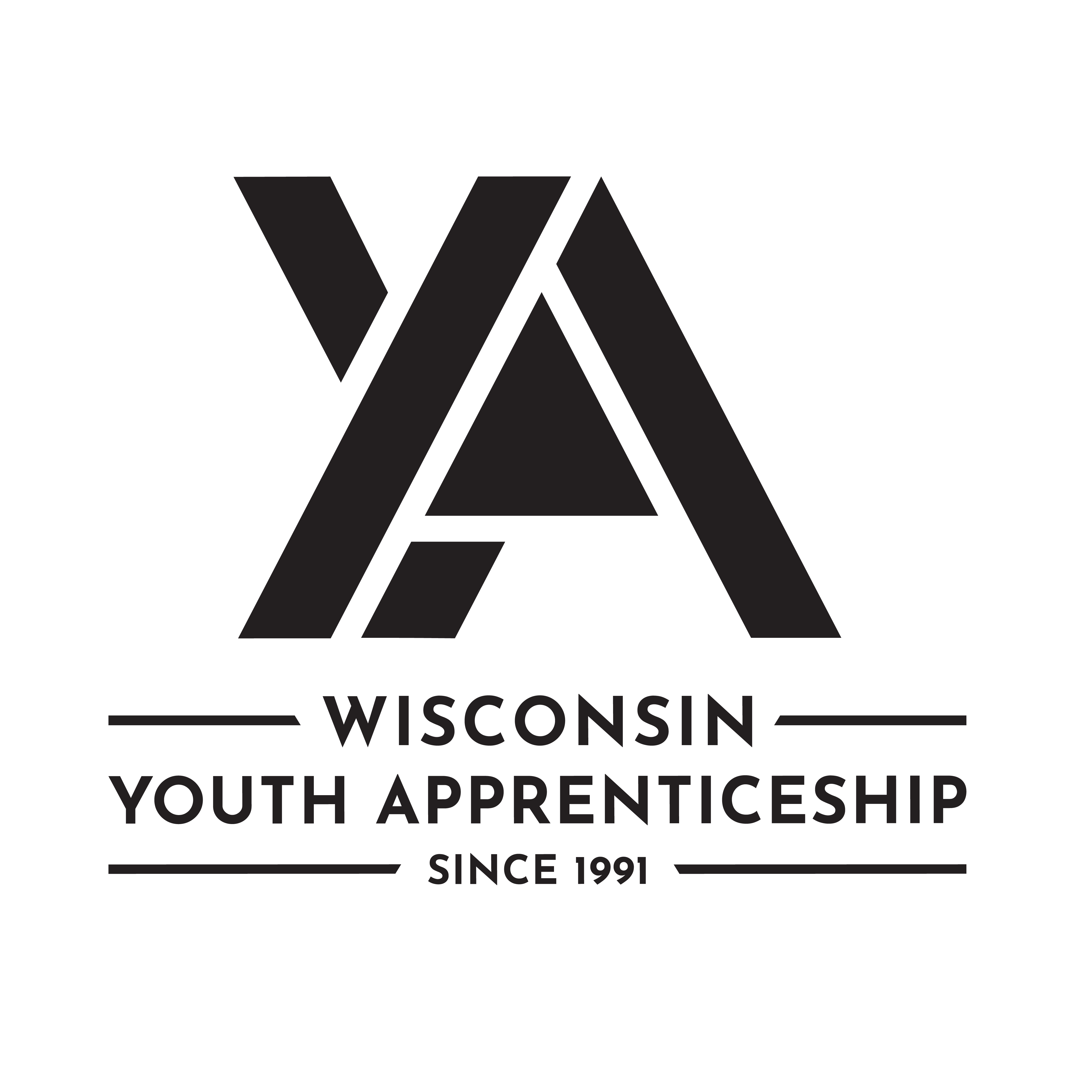 | Health Science Occupational Pathway  Youth Apprenticeship  Related Instruction Guide

Recommendations
These recommendations are intended to be used by the YA Consortiums to determine appropriate related technical instruction for the youth apprenticeship programs in the health occupational area. These recommendations are not all-inclusive.

Related Instruction Credits
The minimum number of related instruction credits for youth apprentices per year is indicated below. Youth apprentices may take more related instruction courses than the minimum required. No matter the options offered for the related instruction, youth apprenticeship students must receive high school credit toward graduation.
Options for related instruction include the following. Students must complete one of the options below.
Course Options | Minimum Number of Credits
High School Course | 1 high school credit per year
College Course | 3 college credits per year
Other options: employer provided training, online learning, independent study, etc. | 1 high school credit (options may be combined in various ways but must be equal to one high school credit—the student must receive high school credit toward graduation for this work)

Related Instruction options
Related instruction must be provided to all youth apprentices to support the attainment of knowledge necessary to master the competencies. Courses selected for related instruction should be aligned to the competencies identified in the program On-the-Job Learning Performance Standards Guide.
Related courses can be drawn from a variety of options:
Type | Description
Registered Apprenticeship Bridge Courses | Youth apprentices may take courses that are part of the registered apprenticeship at local technical colleges or at other technical colleges online. These courses are excellent options for students because they provide a pathway for the student to seamlessly bridge into registered apprenticeship having completed some of the required coursework.

Type | Description
College Transcripted/Dual Credit Courses | Transcripted credit courses (also referred to as dual credit) provide an opportunity for the student to earn college credit directly from the college. Usually offered through the technical college, these courses may be taught by a technical college instructor or a high school instructor who holds an appropriate credential. Transcripted credit courses are good options because they allow students to earn credit toward a degree at the technical college or sometimes toward related instruction in a registered apprenticeship.
High School Courses | High school courses that relate to the apprenticeship job competencies can be used for related instruction. Sometimes these courses can be articulated with the local technical college for advance standing. If the student goes on to take courses at the technical college, advance standing may be awarded for the course based on an articulation agreement between the high school and the college.
Other Options | Other options to help students learn related instruction content include:  - Employer provided training  - Online courses provided by professional organizations  - Independent study courses offered at the local high school  These options can be combined in various ways provided they are related to the competencies in the On-the-Job Learning Performance Standards Guide and meet the minimum number of hours required for one high school credit.

Checklist for Course Selection
When choosing the courses for a youth apprenticeship using the competencies in the On-the-Job Learning Performance Standards Guide, consider these questions or refer to the decision flowchart.
- Does the course bridge to a registered apprenticeship?
- Does the course apply to a related college program?
- Does the course qualify for dual credit?
- Does the course qualify as a Perkins Pathway CTE course?
- Is the course required for an occupation certification?
If YES to any above:
- Is the course accessible to the student?
NOTE: Courses accessibility is determined by district or high school availability, transportation, course supply accessibility, course offering timeline, and distance or virtual learning resources required.
If NO to any above, contact the DWD YA Staff through the YA mailbox (ya@dwd.wisconsin.gov) to discuss options.

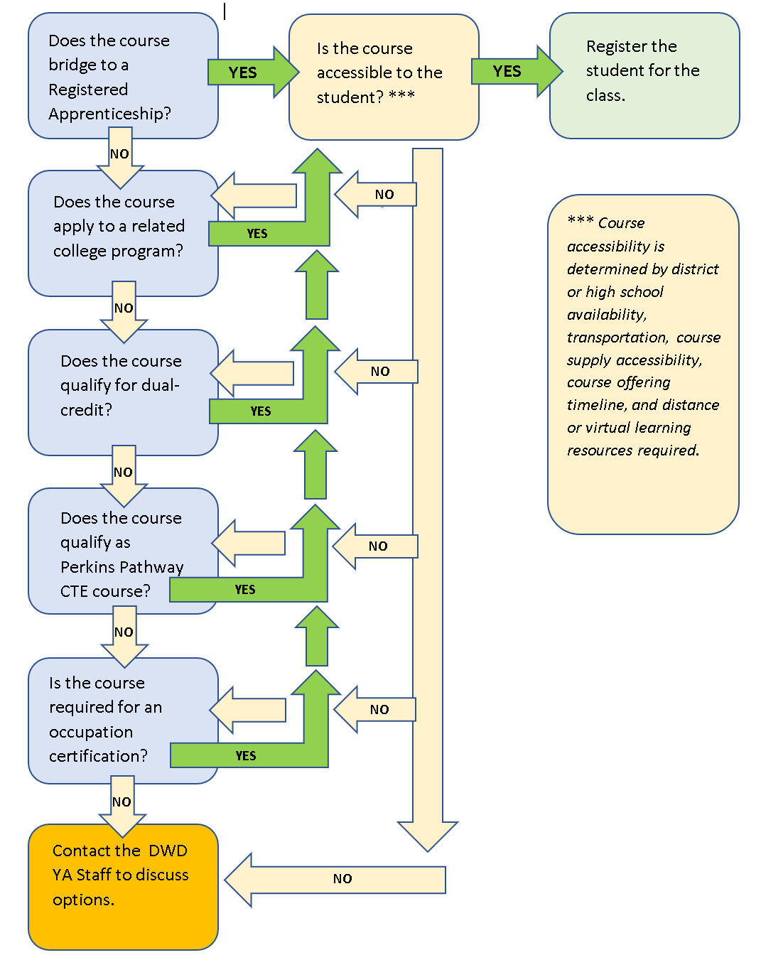

Opportunities for Registered Apprenticeship Bridge
Medical Assistant: Medical assistants perform administrative and certain clinical duties under the direction of a physician. Administrative duties may include scheduling appointments, maintaining medical records, billing, and coding information for insurance purposes. Clinical duties may include taking and recording vital signs and medical histories, preparing patients for examination, drawing blood, and administering medications as directed by physician.
Community Health Worker: A community health worker (CHW) is a frontline public health worker who is a trusted member of and/or has an unusually close understanding of the community served. This trusting relationship enables the CHW to serve as a liaison/link/intermediary between health/social services and the community to facilitate access to services and improve the quality and cultural competence of service delivery.
Pharmacy Technician: Pharmacy technician assists the pharmacist by performing a variety of distribution, technical and clerical duties.

Suggested Related Instruction Courses
The following courses are suggested as options for related instruction because they are aligned to the apprenticeship competencies in the On-the-Job Learning Performance Standards Guide. These recommendations are not all-inclusive.
Suggested College Courses (titles are representative)
Course | Credits (College) | Dental Assistant | Dietary Aide | Medical Assistant | Medical Imaging | Medical Lab Assistant | Medical Office | Nursing Assistant | Optical Assistant | Pharmacy Technician | Phlebotomist | Physical Therapy Aide | Resident Aide
Contemporary Healthcare Practices | 2 |  | X | X | X | X | X | X | X |  | X |  | X
Digital Literacy for Healthcare | 2 |  |  | X | X | X | X | X | X |  | X |  | X
Medical Terminology | 3 | X |  | X | X | X | X | X |  | X | X | X | X
Nursing Assistant | 2-3 |  | X | X | X |  |  | X  * |  |  |  |  | X
CBRF Care Giver Fundamentals (or other CBRF Care Giver training) | 2 |  | X |  |  |  |  | X |  |  |  |  | X  *
Microsoft Office Suite | Varies |  |  | X |  |  | X |  |  |  |  |  | X
Anatomy and Physiology/  General Anatomy | 3-5 | X |  | X | X | X | X | X |  |  | X | X | X
Medical Law, Ethics and Professionalism | 2 |  |  |  |  | X | X | X |  | X | X |  | X
Oral Interpersonal Communication | 3 | X | X |  | X | X |  |  |  | X | X | X
Microbiology | 3-5 | X |  |  |  | X |  |  |  | X | X
Intro to Biochemistry | 3-4 | X
Nutrition | 2-3 |  | X
Basic Lab Skills | 1-3 |  |  |  |  | X |  |  |  | X | X
Pharmacology | 3 |  |  |  |  |  |  |  |  | X
Customer Service | 2-3 |  |  |  | X |  |  |  | X
Psychology | 3 |  |  |  | X |  |  |  |  |  |  | X
First Aid/CPR | 1 | X | X | X | X | X | X | X | X | X | X | X | X
College Mathematics | 3 |  |  |  | X
Written Communication | 3 |  |  | X | X | X |  |  |  |  |  | X
*Note: The Nursing Assistant course is required for the Nursing Assistant youth apprenticeship. CBRF Care Giver training is required for Resident Aides.

Bridged Courses to Registered Apprenticeship

Medical Assistant
The following WTCS courses bridge to the Medical Assistant Registered Apprenticeship.
Course # | Course Title | Credits | Description
10-501-101 | Medical Terminology | 3 Credits | Focuses on the component parts of medical terms: prefixes, suffixes, and word roots. Students practice formation, analysis, and reconstruction of terms. Emphasis on spelling, definition, and pronunciation. Introduction to operative, diagnostic, therapeutic and symptomatic terminology of all body systems, as well as systemic and surgical terminology.
10-501-104 | Contemporary Healthcare Practices | 2 Credits | An introduction to contemporary healthcare practices for students interested in a career serving diverse healthcare communities. Learners explore the essential skills required for equitable and inclusive person-centered interactions. Learners examine various health communities, mindful practices, professionalism, problem solving, and patient confidentiality.
10-501-107 | Digital Literacy for Healthcare | 2 Credits | The focus of this course is the use of technology in healthcare. Learners use common business software applications, including word processing, presentation, spreadsheet, and databases. Communication methods using technology are addressed. Learners gain experience using the electronic health record (EHR). Healthcare EHR security issues, social media use, and digital healthcare resources are examined.
10-501-308/  31-509-308 | Pharm for Allied Health | 2 Credits | Introduces students to medication classification, basic pharmacology principles, and supplements. Students apply basic pharmacodynamics to identify common medications and calculate dosages in preparation for medication administration.
31-509-302 | Human Body in Health & Disease | 3 Credits | Students learn to recognize human body structure and function in health and disease states. Students explore the causes, signs, and symptoms of diseases of the major body systems as well as the diagnostic procedures, usual treatment, prognosis, and prevention of diseases commonly diagnosed and treated in the medical office setting.
31-509-309 | Medical Law, Ethics and Professionalism | 2 Credits | Prepares students to display professionalism and perform within ethical and legal boundaries in the health care setting. Students maintain confidentiality, examine legal aspects of ambulatory healthcare, perform quality improvement procedures, examine legal and bioethical issues, and demonstrate awareness of diversity.

Community Health Worker
The following WTCS courses bridge to the Community Health Worker Registered Apprenticeship.
Number | Title | Credits | Description
10-501-104 | Contemporary Healthcare Practices | 2 Credits | An introduction to contemporary healthcare practices for students interested in a career serving diverse healthcare communities. Learners explore the essential skills required for equitable and inclusive person-centered interactions. Learners examine various health communities, mindful practices, professionalism, problem solving, and patient confidentiality.
10-539-705 | CHW 1: Navigating Health | 2 Credits | Provides an introduction to the role of the community health worker. Learners explore the impact of social determinants on client health. Health literacy, health care access (insurance), and the Affordable Health Care act are examined. In addition, learners consider how to provide safe, culturally sensitive care.
10-539-706 | CHW 2: Promoting Health | 2 Credits | Prepares community health workers to promote health with individual clients and in the community. The role of the social determinants of health in health is explored. Provides basic concepts regarding healthy lifestyles, heart disease and stroke, diabetes, oral health, emotional/mental health, and cancer screening.
10-539-707 | CHW 3: Impacting the Community | 2 Credits | Explores the role of the community health worker as a facilitator, leader, advocate, and capacity builder. Learners build a resource toolkit for use in the community. The importance of self-care to maintaining personal health long-term is examined.

Pharmacy Technician
The following WTCS courses bridge to the Pharmacy Technician Registered Apprenticeship.
Number | Title | Credits | Description
50-536-710 | Math for Pharmacy Technicians | 1 | Provides an overview and practice of key mathematical calculations essential to the duties of the pharmacy technician.
50-536-722 | Pharmacology for Pharmacy Technicians | 1 | The course introduces the principles of pharmacology, including therapeutic classification of medications, their actions, and adverse reactions.
50-536-738 | Orientation to Pharmacy and Outpatient Practice | 1.25 | Provides an introduction to the practice of pharmacy with special emphasis on community pharmacy practice.
50-536-743 | Inpatient Pharmacy Practice | 1.25 | Topics specific to institutional pharmacy practice are presented.

Required WI Community-Based Residential Facilities (CBRF) Caregiver Training
All Residential Aides are required to take the following state approved related instruction (delivered by a state approved instructor). Taking the CBRF Caregiver Fundamentals course offered by the WTCS also meets this requirement.
Content | Hours | Notes
Standard Precautions | 2 hours | Prior to beginning work; can be provided by the employer on the first day.
Fire Safety | 3 hours | Within 90 days of employment
First Aid and Choking | 4 hours | Within 90 days of employment
Medication Administration | 10 hours | Before beginning to pass medication

DWD is an equal opportunity employer and service provider. If you have a disability and need assistance with this information, please dial 7-1-1 for Wisconsin Relay Service. Please contact the Division of Employment and Training at 888-258-9966 and press 6 to request information in an alternate format, including translated to another language.

