|  |  |
| --- | --- |
|  | Education Occupational Pathway  Youth Apprenticeship  Related Instruction Guide |

# Recommendations

These recommendations are intended to be used by the Youth Apprenticeship (YA) Consortia to determine appropriate related technical instruction for the YA programs in the education occupational area. These recommendations are not all-inclusive.

# Related Instruction Credits

The minimum number of related instruction credits for youth apprentices per year is indicated below. Youth apprentices may take more related instruction courses than the minimum required. No matter the options offered for the related instruction, youth apprenticeship students must receive high school credit toward graduation.

Options for related instruction include the following. Students must complete one of the options below.

| Course Options | Minimum Number of Credits |
| --- | --- |
| High school course | 1 high school credit per year |
| College course | 3 college credits per year |
| Other options: employer provided training, online learning, independent study, etc. | 1 high school credit (options may be combined in various ways but must be equal to one high school credit—the student must receive high school credit toward graduation for this work) |

# Related Instruction options

Related instruction must be provided to all youth apprentices to support knowledge attainment necessary to master the competencies. Courses selected for related instruction should be aligned to the competencies identified in the program On-the-Job Learning Performance Standards Guide.

Related courses can be drawn from a variety of options:

| Type | Description |
| --- | --- |
| Registered Apprenticeship bridge courses | Youth apprentices may take courses that are part of the registered apprenticeship at local technical colleges or at other technical colleges online. These courses are excellent options for students because they provide a pathway for the student to seamlessly bridge into registered apprenticeship having completed some of the required coursework. |

|  |  |
| --- | --- |
| Type | Description |
| College transcripted/dual credit courses | Transcripted credit courses (also referred to as dual credit) provide an opportunity for the student to earn college credit directly from the college. Usually offered through the technical college, these courses may be taught by a technical college instructor or a high school instructor who holds an appropriate credential. Transcripted credit courses are good options because they allow students to earn credit toward a degree at the technical college or sometimes toward related instruction in a registered apprenticeship. |
| High school courses | High school courses that relate to the apprenticeship job competencies can be used for related instruction. Sometimes these courses can be articulated with the local technical college for advance standing. If the student goes on to take courses at the technical college, advance standing may be awarded for the course based on an articulation agreement between the high school and the college. |
| Other options | Other options to help students learn related instruction content include:   * Employer-provided training * Online courses provided by professional organizations * Independent study courses offered at the local high school   These options can be combined in various ways provided they are related to the competencies in the On-the-Job Learning Performance Standards Guide and meet the minimum number of hours required for one high school credit. |

# Checklist for Course Selection

When choosing the courses for a youth apprenticeship using the competencies in the On-the-Job Learning Performance Standards Guide, consider these questions or refer to the decision flowchart.

Does the course bridge to a Registered Apprenticeship?

Does the course apply to a related college program?

Does the course qualify for dual credit?

Does the course qualify as a Perkins Pathway Career and Technical Education (CTE) course?

Is the course required for an occupation certification?

If YES to any above:

Is the course accessible to the student?  
NOTE: Course~~s~~ accessibility is determined by district or high school availability, transportation, course supply accessibility, course offering timeline and distance or virtual learning resources required.

If NO to any above, contact the Department of Workforce Development YA Staff through the YA mailbox ([ya@dwd.wisconsin.gov](mailto:ya@dwd.wisconsin.gov)) to discuss options.

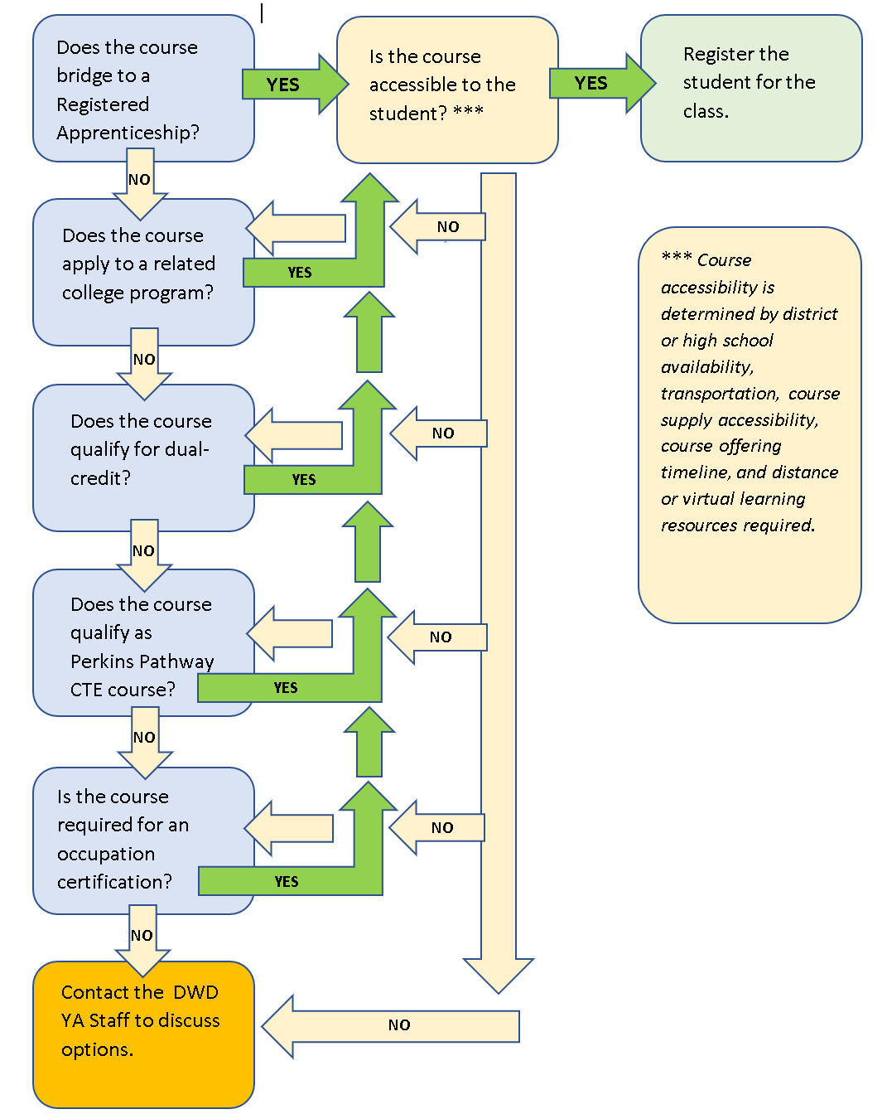

# Opportunities for Registered Apprenticeship Bridge

**Early Childhood Education:** Early childhood educators attend to children at childcare centers performing a variety of tasks such as, dressing, feeding, bathing, and overseeing play. They instruct children (normally up to five years of age) in activities designed to promote social, physical, and intellectual growth. Early childhood educators must also possess specialized knowledge and training in safety, health, first aid (including child CPR certification), child abuse/neglect identification, child nutrition and hygiene, and child development observation. This is a two-year apprenticeship. Applicants must be at least 18 years of age.

The Early Childhood YA program ladders directly into the Early Childhood Educator (ECE) Registered Apprenticeship program.

# Suggested Related Instruction Courses

The following courses are suggested as options for related instruction because they are aligned to the apprenticeship competencies in the On-the-Job Learning Performance Standards Guide. These recommendations are not all-inclusive.

**The Wisconsin Department of Children and Families notes that students may work as school age group leaders and early childhood assistant teachers at age 17 if they have completed the Assistant Child Care Teacher program certificate (ACCT).**

**Suggested Courses (titles are representative)**

|  |  |  |  |
| --- | --- | --- | --- |
| **Course** | **Credits (College)** | **Early Childhood** | **School Age** |
| Assistant Child Care Teacher program (ACCT) skills certificate |  | X | X |
| Cardiopulmonary Resuscitation (CPR) First Aid |  | X | X |
| Health, Safety, and Nutrition | 3 | X |  |
| Foundations of Early Childhood Education | 3 | X |  |
| Child Development | 3 | X | X |
| Guiding Children's Behavior | 3 | X |  |
| Infant & Toddler Development | 3 | X |  |
| Intro to Educational Practices/Foundations of Education | 3 |  | X |
| Child and Adolescent Development | 3 |  | X |
| Technology in Education/Instructional Technology | 3 |  | X |
| Education Policy: Truth and Myths | 3 |  | X |
| Individual, School, and Society | 3 |  | X |
| Culturally Responsive Teaching and Learning | 3 |  | X |

# Bridged Courses to Registered Apprenticeship

## Early Childhood Education

The following Wisconsin Technical College System courses bridge to the ECE Registered Apprenticeship.

| Number | Title | Credits | Description |
| --- | --- | --- | --- |
| 10-307-108 | ECE: Early Language & Literacy | 3 | This 3-credit course explores strategies to encourage the development of early language and literacy knowledge and skill building in children birth to 8 years of age. |
| 10-307-148 | ECE: Foundations of ECE | 3 | This 3-credit course introduces the early childhood profession through a historical overview of the field. The course will explore program trends, quality indicators and developmentally appropriate practices for children birth to 8 years of age. |
| 10-307-151 | ECE: Infant & Toddler Development | 3 | This 3-credit course explores infant and toddler development as it applies to an early childhood education setting. This course focuses on children's development from conception through thirty-six months (3 years). This course includes training for Wisconsin Breastfeeding Friendly Child Care certification. |
| 10-307-167 | ECE: Health Safety & Nutrition | 3 | This 3-credit course examines the topics of health, safety, and nutrition within the context of the early childhood educational setting for children from birth through 8 years of age. This course includes training for Abusive Head Trauma, SIDS and Mandated Reporter certifications. |
| 10-307-179 | ECE: Child Development | 3 | This 3-credit course examines child development within the context of the early childhood education setting. This course focuses on children ages 3-8 years of age. |
| 10-307-187 | ECE: Children with Different Abilities | 3 | This 3-credit course focuses on the child with differing abilities in an inclusive early childhood education setting while examining strategies for cultivating partnerships with families and community supports for children from birth to 8 years of age. |
| 10-307-188 | ECE: Guiding Child Behavior | 3 | This 3-credit course examines positive strategies to guide children's behavior in the early childhood education setting for children from birth to 8 years of age. This course meets the requirements of the Wisconsin Pyramid Model training. |
| 10-307-195 | ECE: Family & Community Relationships | 3 | This 3-credit course will examine the role of relationships with family and community in early childhood education for children from birth to 8 years of age. In this course, students will complete the Strengthening Families Training. |

 This work is licensed under a Creative Commons Attribution-ShareAlike 4.0 International License.

This project is funded whole or in part by the Department of Labor, receiving Federal funding at $9 million which reflects 100% of the project’s total budget.

This workforce product was funded by a grant awarded by the U.S. Department of Labor’s Employment and Training Administration. The product was created by the recipient and does not necessarily reflect the official position of the U.S. Department of Labor. The Department of Labor makes no guarantees, warranties, or assurances of any kind, express or implied, with respect to such information, including any information on linked sites and including, but not limited to, accuracy of the information or its completeness, timeliness, usefulness, adequacy, continued availability, or ownership. This product is copyrighted by the institution that created it.

No part of this document may be altered, duplicated or extracted without written consent from the Wisconsin Department of Workforce Development (DWD).

DWD is an equal opportunity employer and service provider. If you have a disability and need assistance with this information, please dial 7-1-1 for Wisconsin Relay Service. Please contact the Division of Employment and Training at 888-258-9966 and press 6 to request information in an alternate format, including translated to another language.

