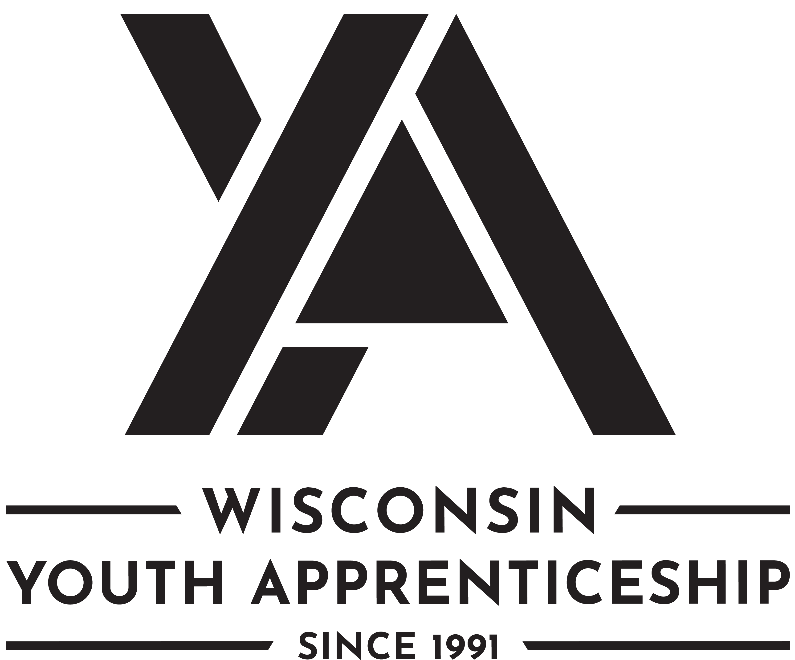 | Barber and Cosmetologist  Youth Apprenticeship

Barber and Cosmetologist
Barber and cosmetologist youth apprentices support stylists in delivering client services, ensuring customer satisfaction, and managing salon operations.
Length of Apprenticeship: One year.

occupational Competencies
Barber and cosmetologist youth apprentices must complete a total of 12 competencies. Eleven of the competencies must be from the list below. If necessary, employers can substitute one competency with another occupationally appropriate skill. That skill should be added to the competency list for assessment.
Competencies
- Manage front desk.
- Manage social media posts and campaigns.
- Process financial transactions
- Promote products, services, or programs.
- Maintain client records.
- Manage client appointments.
- Follow establishment safety procedures.
- Perform cleaning and organizing.
- Demonstrate disinfection procedures.
- Sterilize equipment, materials, and supplies.
- Prepare client for service.
- Assist stylist with salon services (hair color, perm, foils, etc.).

Registered Apprenticeship Bridging Opportunities
The following Registered Apprenticeship programs are available in this area:
- Barber registered apprenticeship.
- Cosmetologist registered apprenticeship

Post-Secondary Pathway Opportunities
There are several post-secondary pathway opportunities in this area. The following is a partial list.
- Barber.
- Cosmetologist.
- Aesthetician.
- Nail Technician.

Barber and Cosmetologist
Youth Apprenticeship
On-the-Job Learning Performance Standards Guide
(tO BE COMPLETED BY ya cONSORTIUM)

Youth Apprentice information
Youth Apprentice Name

YA Coordinator | YA Consortium
School District | High School Graduation Date

Requirements
Level One Requirements
Youth apprentices must complete ALL the items listed below. Check completed areas.
Competency checklist.
Employability Skills checklist (in the on-the-job learning (OJL) guide) or the Wisconsin Department of Public Instruction (DPI) Employability Skills Certificate.
Related instruction equal to one high school credit or at least three college credits.
Minimum of 450 work hours.

Hours
Record the hours the youth apprentice worked.
Total Hours Employed | Company Name | Telephone Number

Related Instruction
Year one: Indicate which related instruction courses the youth apprentice completed.
Dual Credit | Course Number and Title | Credits | Instruction Provider

SIGNATURES
The OJL Performance Standards Guide includes a list of competencies youth apprentices learn through mentoring and training at the worksite.
Instructions for the worksite employers/mentors and school-based or YA coordinators: This document should be reviewed with the employer/mentor, school-based or YA coordinator, and youth apprentice on a regular basis to record progress and plan future steps to ensure completion of the required competencies. The mentors, school-based or YA coordinator, and the apprentice must sign below.
Employer/Mentor Signature | Employer/Mentor Signature
Employer/Mentor | Employer/Mentor
Business/Company | Business/Company
Date Signed | Date Signed
School-Based and/or YA Coordinator Signature | School-Based and/or YA Coordinator Signature
School-Based and/or YA Coordinator | School-Based and/or YA Coordinator
School District or Organization | School District or Organization
Date Signed | Date Signed
Youth Apprentice Signature | Youth Apprentice Signature
Youth Apprentice | Youth Apprentice
School District / High School | School District / High School
Date Signed | Date Signed

employability Skills (TO BE COMPLETED BY yA EMPLOYER/MENTOR)
Youth apprentices must demonstrate key employability skills.
The Department of Workforce Development's YA program employability skills requirement may be attained and demonstrated through two processes (see options listed below). Employability skills must be completed for every year a student is in the program. The Department of Public Instruction (DPI's) Employability Skills Certificate may be counted as meeting one of those two years, provided the certificate is earned in the same year the student is enrolled in YA or they can complete the YA employability skills in the OJL guide. The Employability Skills Certificate must be obtained through DPI.
- If a student has successfully completed a DPI State-Certified Cooperative Education/Co-Op Employability Skill certification, then they have met the YA Employability Skills requirement for that year. A copy of the student’s DPI Co-Op Employability Skills Certificate must be maintained on file with their YA regional consortium.
Earned Wisconsin Employability Skills Certificate (checked if applicable) or,

- Completed and rated “Employability Skills” through this YA OJL guide as described below.
3 | Exceeds Expectations: Exceeds entry-level criteria; requires minimal supervision; consistently displays this behavior
2 | Meets Expectations: Meets entry-level criteria; requires some supervision; often displays this behavior
1 | Working to Meet Expectations: Needs improvement; requires much assistance and supervision; rarely displays this behavior

The following skills are required of all youth apprentices.
 | Employability Skills | Rating
Competency and Rating Criteria |  | Minimum Rating of 2 for EACH  Check Rating
 |  | 1 | 2 | 3
- Develops positive work relationships with others.
Examples of qualities and habits that the employee might exhibit include:
- Interacts with others with respect and in a non-judgmental manner.
- Responds to others in an appropriate and non-offensive manner.
- Helps co-workers and peers accomplish tasks or goals.
- Applies problem-solving strategies to improve relations with others.
- When managing others, shows traits such as compassion, listening, coaching, team development, and appreciation.

- Communicates effectively with others.
Examples of qualities and habits that the employee might exhibit include:
- Adjusts the communication approach for the target audience, purpose, and situation to maximize impact.
- Organizes messages/information in a logical and helpful manner.
- Speaks clearly and writes legibly.
- Models behaviors to show active listening.
- Applies what was read to actual practice.
- Asks appropriate questions for clarity.

- Collaborates with others.
Examples of qualities and habits that the employee might exhibit include:
- Works effectively in teams with people of diverse backgrounds regardless of sex, race, ethnicity, nationality, sexuality, religion, age, political views, and abilities.
- Shares responsibility for collaborative work and decision making.
- Uses the problem-solving process to work through differences of opinion in a constructive manner to achieve a reasonable compromise.
- Avoids contributing to an unproductive group conflict.
- Shares information and carries out responsibilities in a timely manner.

- Maintains composure under pressure.
Examples of qualities and habits that the employee might exhibit include:
- Uses critical thinking to determine the best options or outcomes when faced with a challenging situation.
- Carries out assigned duties while under pressure.
- Acts in a respectful, professional, and non-offensive manner while under pressure.
- Applies stress management techniques to cope under pressure.

- Demonstrates integrity.
Examples of qualities and habits that the employee might exhibit include:
- Carries out responsibilities in an ethical, legal, and confidential manner.
- Responds to situations in a timely manner.
- Takes personal responsibility to correct problems.
- Models behaviors that demonstrate self-discipline, reliability, and dependability.

- Performs quality work.
Examples of qualities and habits that the employee might exhibit include:
- Carries out written and verbal directions accurately.
- Completes work efficiently and effectively.
- Performs calculations accurately.
- Conserves resources, supplies, and materials to minimize costs and environmental impact.
- Uses equipment, technology, and work strategies to improve workflow.
- Applies problem-solving strategies to improve productivity.
- Adheres to worksite regulations and practices.
- Maintains an organized work area.

- Provides quality goods or services (internal and external)
Examples of qualities and habits that the employee might exhibit include:
- Shows support for organizational goals and principles by their personal actions.
- Displays a respectful and professional image to customers.
- Displays an enthusiastic attitude and desire to take care of customer needs.
- Seeks out ways to increase customer satisfaction.
- Produces goods to workplace specifications.

- Shows initiative and self-direction.
Examples of qualities and habits that the employee might exhibit include:
- Prioritizes and carries out responsibilities without being told.
- Responds with enthusiasm and flexibility in handling tasks that need immediate attention.
- Reflects on any unsatisfactory outcome as an opportunity to learn.
- Improves personal performance by doing something different or differently.
- Analyzes how own actions impact the overall organization.
- Supports own action with sound reasoning and principles.
- Balances personal activities to minimize interference with work responsibilities.

- Adapts to change.
Examples of qualities and habits that the employee might exhibit include:
- Shows flexibility and willingness to learn new skills for various job roles.
- Uses problem-solving and critical-thinking skills to cope with changing circumstances.
- Modifies own work behavior based on feedback, unsatisfactory outcomes, efficiency, and effectiveness.
- Displays a "can do" attitude.

- Demonstrates safety and security regulations and practices.
Examples of qualities and habits that the employee might exhibit include:
- Follows personal safety requirements.
- Maintains a safe work environment.
- Demonstrates professionalism in an emergency.
- Follows security procedures.
- Maintains confidentiality.

- Applies job-related technology, information, and media.
Examples of qualities and habits that the employee might exhibit include:
- Applies technology effectively in the workplace.
- Assesses and evaluates information on the job.
- Assesses training manuals, website, and other media related to the job.

- Fulfills training or certification requirements for employment.
Examples of this requirement may include:
- Participation in required career-related training and/or educational programs.
- Passing certification tests to qualify for licensure and/or certification.
- Participation in company training or orientation.

- Sets personal goals for improvement.
Examples of this requirement may include:
- Setting goals that are specific and measurable.
- Setting work-related goals that align with the organization's mission.
- Identifying strategies to reach goals.
- Reflecting on goal progress to regularly evaluate and modify goals.

OCCUPATIONAL Competencies
(TO BE COMPLETED BY yA EMPLOYER/MENTOR)
Youth apprentices must perform a total of 12 competencies. Eleven of the competencies must come from the list below. If necessary, employers can substitute one competency with another occupationally appropriate skill. That skill should be added to the bottom of the list for assessment.
Rating Scale
3: Exceeds entry level criteria | Requires minimal supervision | Consistently displays this behavior
2: Meets entry level criteria | Requires some supervision | Often displays this behavior
1: Needs improvement | Requires much assistance and supervision | Rarely displays this behavior
If any competencies are rated "1" on the final performance review checklist that is submitted to the Wisconsin Department of Workforce Development, it is considered a failed checklist.

Occupational Competencies | Rating
Competency and Rating Criteria | Minimum Rating of 2 for EACH  Check Rating
 | 1 | 2 | 3
- Manage front desk.
- Greet customers when they arrive.
- Check in customers for services.
- Explain procedures and policies.
- Inquire into the client’s experience after service.
- Refer client concerns to appropriate staff.
- Thank clients for coming to the salon.
- Answer phone calls and emails
- Manage walk-ins.

- Manage social media posts and campaigns.
- Write content to be published.
- Select related graphics and images.
- Obtain approvals as needed.
- Schedule posts for release
- Monitor customer feedback.

- Process financial transactions
- Post charges against accounts.
- Receive payments by cash, check, or credit card.
- Issue receipts or refunds.
- Reconcile records of sale or other financial transactions.
- Balance register.

- Promote products, services, or programs.
- Help customers locate products.
- Recommend products or services to customers.
- Answer customer questions about products and services
- Explain technical product or service information to customers.
- Upsell products and services.
- Upkeep retail displays.

- Maintain client records.
- Create a customer profile.
- Enter or update customer information.
- Log customer interactions or transactions
- Maintain records of sales

- Manage client appointments.
- Schedule or confirm appointments for customers.
- Provide appointment reminders.
- Reschedule appointments when necessary.
- Enter data into appointment scheduling system.

- Follow establishment safety procedures.
- Remove hazardous objects from common areas.
- Place warning signs before cleaning or mopping.
- Identify first-aid and emergency equipment.
- Identify hazardous solvents and materials.

- Perform cleaning and organizing.
- Perform daily opening and closing duties.
- Launder linens.
- Fold and put away towels.
- Dust furniture and equipment.
- Sweep and mop floors.
- Clean the checkout area.
- Replace paper products.
- Wash non-metal instruments or equipment in warm water and detergent
- Dispose of trash and non-hazardous waste.
- Stock professional products for back bar.

- Demonstrate disinfection procedures.
- Perform handwashing.
- Mix quats solution.
- Launder towels, linens, and capes.
- Disinfect nonelectrical tools and equipment.
- Disinfect work surfaces.
- Manage disposable supplies.
- Clean shampoo bows.
- Follow procedures for contact with blood and or body fluid.

- Sterilize equipment, materials, and supplies.
- Don appropriate personal protective equipment.
- Prepare sterilizing solution.
- Expose equipment and supplies for the required length of time.
- Maintain sterilizer.

- Prepare client for service.
- Seat the client.
- Attend to client needs.
- Drape the client for wet services.
- Drape the client for dry services.

- Assist stylist with salon services (hair color, perm, foils, etc.)
- Drape the client for service.
- Prepare service tools and equipment for use by the stylist.
- Attend to client during service.
- Perform service clean up.

Competency substitute (if you replaced a competency above, note the competency and rating).

Comments:

Post-Program Completion Survey
Youth Apprenticeship

YA Post-Program Completion survey: Employer Feedback
Employers complete the following information. YA Coordinators will enter this into the Post-Program Completion Survey.
YA Employer Post-Program Completion Questions
Will you offer or have you offered the youth apprentice a continuing position with your company? | Yes  No
If continuing position offered to youth apprentice, did they accept? | Yes  No
If yes, please answer the questions below:
Was the offer for full-time or part-time work? | Full-time  Part-time
Title of the position offered:

What is the wage of the continuing employment offer?

If applicable, will the youth apprentice advance to a Registered Apprenticeship?

YA Post-Program Completion survey: completed by YA consortium
The Post-Program Completion Survey form is to be provided to each student completing the YA program to capture information on the student's plans after leaving the program. This form should be completed by the YA Coordinator to capture information from all high school seniors and their employers after successful completion of the YA program.
The form should be completed during the final meeting between the student, mentor, and YA coordinator, when the final checklist or OJL guide is filled out and signed. Information captured on this form must be entered online using the Bureau of Apprenticeship Standards Electronic Records System (BASERS).

