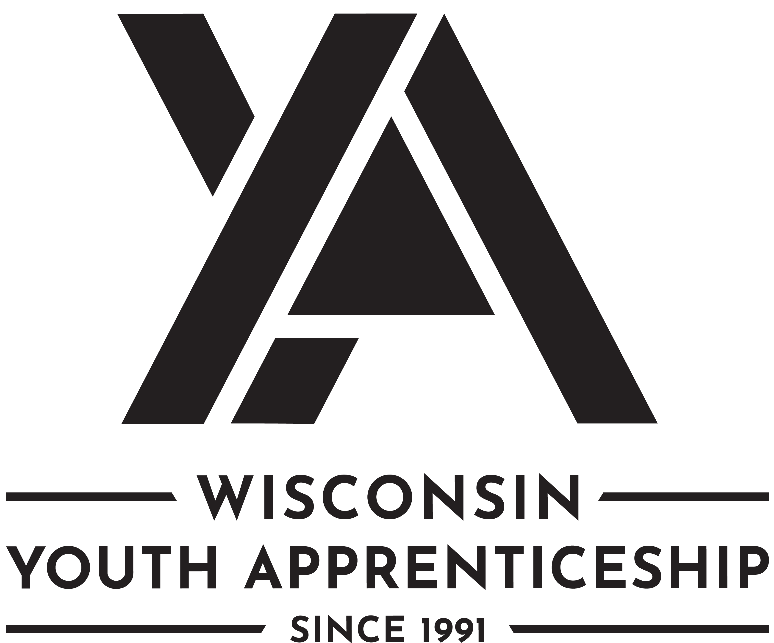 | School Age Education  Youth Apprenticeship

School Age Education
School Age education youth apprentices work in a variety of school age settings and learn valuable skills for working with children and preparing them to become a teacher.
Length of Apprenticeship: One or two years

occupational Competencies
Youth apprentices work with a job site mentor to demonstrate the following competencies.
Year 1: Youth apprentices must complete a total of 10 competencies. Nine must be from the list below. If necessary, employers can substitute 1 competency with another occupationally appropriate skill. That skill should be added to the competency list for assessment.
Year 2: Youth apprentices must complete a total of 9 competencies. Eight must be from the list below. If necessary, employers can substitute 1 competency with another occupationally appropriate skill. Those skills should be added to the competency list for assessment.
Note: In some settings (such as before and after school programs), youth apprentices must meet the requirements set forth by the WI Department of Children and Families (DCF) for School Age Program Assistant (at least 16 years of age) or School Age Group Leader (at least 17 years of age with appropriate training). The DCF requirements are outline in more detail their website: Wisconsin Child Care Regulation.
Youth apprentices working in public schools must meet the requirements identified by the WI Department of Public Instruction (DPI) for training required for school staff: https://dpi.wi.gov/sspw/required-trainings.
Also, in Title I schools, youth apprentices must not function as replacements for or replicate the duties of paraprofessionals.

YEAR 1 Competencies | YEAR 2 Competencies
- Obtain training or certification requirements for employment  - Maintain a clean and sanitary environment  - Maintain a safe learning environment  - Adhere to emergency procedures  - Setup the physical environment  - Foster social interaction during snacks and meals  - Manage groups in various environments  - Provide guidance with academic work*  - Support program/teacher leads  - Build relationships with participants, families, and coworkers | - Maintain training or certification requirements for employment  - Care for minor injuries and illnesses  - Manage snack and meal service  - Plan an activity under the direction of the cooperating teacher/leader**  - Utilize technology to support learning  - Apply positive guidance strategies  - Lead large and small group activities**  - Cultivate a learning environment that meets the needs of all learners  - Model professionalism as an educator

* In Title I schools, the youth apprentice must utilize an alternate competency in which they are not directly instructing students.
**For these competencies, the activities must not include the youth apprentice providing direct instruction to the students

Post-Secondary Pathway Opportunities
There are several post-secondary pathway opportunities in this area. The following is a partial list.
- Foundations of Teacher Education

School Age Education
Youth Apprenticeship
On-the-Job Learning Performance Standards Guide
(tO BE COMPLETED BY ya cONSORTIUM)

Youth Apprentice information
Youth Apprentice Name

YA Coordinator | YA Consortium
School District | High School Graduation Date

Requirements
Level One Requirements
Youth apprentices must complete ALL the items listed below. Check completed areas.
Year 1 Competency checklist
Employability Skills checklist (in this OJL Guide) or the DPI Employability Skills Certificate
Related instruction equal to 1 high school credit or at least 3 college credits
Minimum of 450 work hours

Level Two Requirements
Youth apprentices must complete ALL the items listed below. Check completed areas.
Year 2 Competency checklist
Employability Skills checklist (in this OJL Guide) or the DPI Employability Skills Certificate
Related instruction equal to 2 high school credits or at least 6 college credits
Minimum of 900 work hours

Hours
Record the hours the youth apprentice worked.
Total Hours Employed | Company Name | Telephone Number

Related Instruction
YEAR 1: Indicate which related instruction courses the youth apprentice completed.
Dual Credit | Course Number and Title | Credits | Instruction Provider

YEAR 2: Indicate which related instruction courses the youth apprentice completed.
Dual Credit | Course Number and Title | Credits | Instruction Provider

SIGNATURES
The On-the-Job Learning Performance Standards Guide includes a list of competencies youth apprentices learn through mentoring and training at the worksite.
Instructions for the Worksite Employers/Mentors and School-Based or YA coordinators: This document should be reviewed with the employer/mentor, school-based or YA coordinator on a regular basis with the youth apprentice to record progress and plan future steps to ensure completion of the required competencies. Mentors, school-based/YA coordinator, and the apprentice sign below.
Employer/Mentor Signature | Employer/Mentor Signature
Employer/Mentor | Employer/Mentor
Business/Company | Business/Company
Date Signed | Date Signed
School-Based and/or YA Coordinator Signature | School-Based and/or YA Coordinator Signature
School-Based and/or YA Coordinator | School-Based and/or YA Coordinator
School District or Organization | School District or Organization
Date Signed | Date Signed
Youth Apprentice Signature | Youth Apprentice Signature
Youth Apprentice | Youth Apprentice
School District / High School | School District / High School
Date Signed | Date Signed

employability Skills (TO BE COMPLETED BY yA EMPLOYER/MENTOR)
Youth apprentices must demonstrate key employability skills.
The DWD YA program employability skills requirement may be attained and demonstrated through two processes. (See options listed below.) Employability skills must be completed for every year a student is in the program. The DPI Employability Skills Certificate may be counted as meeting one of those two years, provided the certificate is earned in the same year the student is enrolled in youth apprenticeship or they can complete the YA Employability Skills in the OJL. The Employability Skills Certificate must be obtained through the DPI.
- If a student has successfully completed a Wisconsin Department of Public Instruction (DPI) State-Certified Cooperative Education, Co-Op Employability Skill certification then they have met the YA Employability Skills requirement for that year. A copy of the student’s DPI Co-Op Employability Skill Certificate must be maintained on file with their YA regional consortium.
Earned Wisconsin Employability Skills Certificate (checked if applicable) or,

- Completed and rated “Employability Skills” through this YA OJL guide as described below.
3 | Exceeds Expectations: Exceeds entry-level criteria; requires minimal supervision; consistently displays this behavior
2 | Meets Expectations: Meets entry-level criteria; requires some supervision; often displays this behavior
1 | Working to Meet Expectations: Needs improvement; requires much assistance and supervision; rarely displays this behavior

The following skills are required of all youth apprentices.
 | Employability Skills | Rating
Competency and Rating Criteria |  | Minimum Rating of 2 for EACH  Check Rating
 |  | 1 | 2 | 3
- Develops positive work relationships with others.  Examples of qualities and habits that the employee might exhibit include . . .  - Interacts with others with respect and in a non-judgmental manner  - Responds to others in an appropriate and non-offensive manner  - Helps co-workers and peers accomplish tasks or goals  - Applies problem-solving strategies to improve relations with others  - When managing others, shows traits such as compassion, listening, coaching, team development, and appreciation |  | Year 1 Rating
 |  | Year 2 Rating
- Communicates effectively with others  Examples of qualities and habits that the employee might exhibit include . . .  - Adjusts the communication approach for the target audience, purpose, and situation to maximize impact  - Organizes messages/information in a logical and helpful manner  - Speaks clearly and writes legibly  - Models behaviors to show active listening  - Applies what was read to actual practice  - Asks appropriate questions for clarity |  | Year 1 Rating
 |  | Year 2 Rating
- Collaborates with others  Examples of qualities and habits that the employee might exhibit include . . .  - Works effectively in teams with people of diverse backgrounds regardless of sex, race, ethnicity, nationality, sexuality, religion, political views, and abilities  - Shares responsibility for collaborative work and decision making  - Uses the problem-solving process to work through differences of opinion in a constructive manner to achieve a reasonable compromise  - Avoids contributing to an unproductive group conflict  Shares information and carries out responsibilities in a timely manner |  | Year 1 Rating
 |  | Year 2 Rating
- Maintains composure under pressure  Examples of qualities and habits that the employee might exhibit include . . .  - Uses critical thinking to determine the best options or outcomes when faced with a challenging situation  - Carries out assigned duties while under pressure  - Acts in a respectful, professional, and non-offensive manner while under pressure  - Applies stress management techniques to cope under pressure |  | Year 1 Rating
 |  | Year 2 Rating
- Demonstrates integrity  Examples of qualities and habits that the employee might exhibit include . . .  Carries out responsibilities in an ethical, legal and confidential manner  - Responds to situations in a timely manner  - Takes personal responsibility to correct problems  - Models behaviors that demonstrate self-discipline, reliability, and dependability |  | Year 1 Rating
 |  | Year 2 Rating
- Performs quality work  Examples of qualities and habits that the employee might exhibit include . . .  - Carries out written and verbal directions accurately  - Completes work efficiently and effectively  - Performs calculations accurately  - Conserves resources, supplies, and materials to minimize costs and environmental impact  - Uses equipment, technology, and work strategies to improve workflow  - Applies problem-solving strategies to improve productivity  - Adheres to worksite regulations and practices  - Maintains an organized work area |  | Year 1 Rating
 |  | Year 2 Rating
- Provides quality goods or services (internal and external)  Examples of qualities and habits that the employee might exhibit include . . .  - Shows support for the organizational goals and principles by own personal actions  - Displays a respectful and professional image to customers  - Displays an enthusiastic attitude and desire to take care of customer needs  - Seeks out ways to increase customer satisfaction  - Produces goods to workplace specifications |  | Year 1 Rating
 |  | Year 2 Rating
- Shows initiative and self-direction  Examples of qualities and habits that the employee might exhibit include . . .  - Prioritizes and carries out responsibilities without being told  - Responds with enthusiasm and flexibility to handle tasks that need immediate attention  - Reflects on any unsatisfactory outcome as an opportunity to learn  - Improves personal performance by doing something different or differently  - Analyzes how own actions impact the overall organization  - Supports own action with sound reasoning and principles  - Balances personal activities to minimize interference with work responsibilities |  | Year 1 Rating
 |  | Year 2 Rating
- Adapts to change  Examples of qualities and habits that the employee might exhibit include . . .  Shows flexibility and willingness to learn new skills for various job roles  - Uses problem-solving and critical-thinking skills to cope with changing circumstances  - Modifies own work behavior based on feedback, unsatisfactory outcomes, efficiency, and effectiveness  - Displays a "can do" attitude |  | Year 1 Rating
 |  | Year 2 Rating
- Demonstrates safety and security regulations and practices  Examples of qualities and habits that the employee might exhibit include . . .  - Follows personal safety requirements  - Maintains a safe work environment  - Demonstrates professional role in an emergency  - Follows security procedures  - Maintains confidentiality |  | Year 1 Rating
 |  | Year 2 Rating
- Applies job-related technology, information, and media  Examples of qualities and habits that the employee might exhibit include . . .  - Applies technology effectively in the workplace  - Assesses and evaluates information on the job  - Assesses training manuals, website, and other media related to the job |  | Year 1 Rating
 |  | Year 2 Rating
- Fulfills training or certification requirements for employment  Examples of this requirement may include . . .  - Participation in required career-related training and/or educational programs  - Passing certification tests to qualify for licensure and/or certification  - Participation in company training or orientation |  | Year 1 Rating
 |  | Year 2 Rating
- Sets personal goals for improvement  Examples of this requirement may include . . .  - Setting goals that are specific and measurable  - Setting work-related goals that align with the organization's mission  - Identifying strategies to reach goals  - Reflecting on goal progress to regularly evaluate and modify goals |  | Year 1 Rating
 |  | Year 2 Rating

YEAR 1 occupational Competencies
(TO BE COMPLETED BY yA EMPLOYER/MENTOR)
Year one youth apprentices must complete a total of 10 competencies. Nine must be from the list below. If necessary, employers can substitute 1 competency with another occupationally appropriate skill. That skill should be added to the competency list for assessment.
Rating Scale
3: Exceeds entry level criteria | Requires minimal supervision | Consistently displays this behavior
2: Meets entry level criteria | Requires some supervision | Often displays this behavior
1: Needs improvement | Requires much assistance and supervision | Rarely displays this behavior
If any competencies are rated "1" on the final performance review checklist that is submitted to WI DWD it is considered a failed checklist.

Occupational Competencies | Ratings
Competency and Rating Criteria | Minimum Rating of 2 for EACH  Check Rating
 | 1 | 2 | 3

Obtain training or certification requirements for employment
- complete required career-related training and/or educational programs
- pass certification tests to qualify for licensure and/or certification
- participate in organization training or orientation

Maintain a clean and sanitary environment
- implement cleaning procedures according to the schedule
- complete three-step sanitation process
- apply universal standard precautions

Maintain a safe learning environment
- identify and remove health and safety hazards
- report safety hazards that are non-mobile
- ensure all hazardous materials are inaccessible to participants

Adhere to emergency procedures
- follow employer security procedures
- follow employer evacuation procedures
- follow employer emergency medical procedures

Setup the physical environment
- setup and take down the physical environment
- reset rooms as needed
- return equipment and materials to storage
- report equipment and materials that are damaged or need repair
- ensure the environment is clear of hazards

Foster social interaction during snacks and meals
- sit with children during snacks and meals
- encourage children to talk and be social with their peers
- generate discussion during the meals
- model appropriate social interactions

Manage groups in various environments
- conduct name to face checks
- monitor activities
- track children during transitions
- facilitate routines and procedures
- report observations and incidents as needed
- assist with transitions between learning environments and activities

Provide guidance with academic work
- work one-on-one and in small groups in support of teacher-directed instruction
- reinforce learning
- create a supportive environment
- encourage participant responsibility and independence
- allow for differences in learning styles and abilities

Support program/teacher leads
- gather instructional materials
- help children who may need extra support
- take initiative to provide assistance
- maintain bulletin boards/classroom/space visuals
- coordinate and distribute snacks, supplies, etc.
- distribute teaching materials
- organize and label materials
- participate in training

Build relationships with participants, families, and coworkers
- greet people by name
- initiate and engage in genuine conversations
- respond with sensitivity
- demonstrate active listening skills
- show warmth, caring, and respect for others

Competency Substitute (if you replaced a competency above, note the competency and rating)

Comments:

YEAR 2 Occupational COMPETENCIES
(TO BE COMPLETED BY yA EMPLOYER/MENTOR)
Year two youth apprentices must complete a total of 9 competencies. Eight must be from the list below. If necessary, employers can substitute 1 competency with another occupationally appropriate skill. Those skills should be added to the competency list for assessment.

Rating Scale
3: Exceeds entry level criteria | Requires minimal supervision | Consistently displays this behavior
2: Meets entry level criteria | Requires some supervision | Often displays this behavior
1: Needs improvement | Requires much assistance and supervision | Rarely displays this behavior
If any competencies are rated "1" on the final performance review checklist that is submitted to WI DWD it is considered a failed checklist.
Occupational Competencies | Ratings
Competency and Rating Criteria | Minimum Rating of 2 for EACH  Check Rating
 | 1 | 2 | 3

Maintain training or certification requirements for employment
- complete required career-related training and/or educational programs
- pass certification tests to qualify for licensure and/or certification
- participate in organization training or orientation

Care for minor injuries and illnesses
- assess the injury or illness
- complete necessary care per employer policy
- complete documentation as directed

Manage snack and meal service
- prepare nutritional snacks and meals
- track food/milk served
- clean up snack and meal service
- organize food storage
- manage inventory
- engage children in food preparation and clean up

Plan an activity under the direction of the cooperating teacher/leader
- create a plan for the activity
- gather materials and supplies
- reflect on activity: what went well and what can be improved

Utilize technology to support learning
- use interactive presentation devices
- use assistive technology
- research activities to support learning plans
- develop learning materials

Apply positive guidance strategies
- follow organization procedures for managing behavior
- reinforce positive behavior
- reinforce interventions
- implement transitions between activities and environments

Lead large and small group activities
- provide clear instructions
- follow activity plans
- address teacher directed adaptations as needed to support individual children
- reinforce developmentally appropriate expectations
- conduct demonstrations to teach skills

Cultivate a learning environment that meets the needs of all learners
- pronounce names accurately
- modify environments and activities to ensure equal access
- show empathy to all students
- use practices and materials that respect children’s culture
- facilitate a sense of belonging and community in the group

Model professionalism as an educator
- greet families and children by name and on the child's level
- demonstrate ethical standards in daily practice
- demonstrate willingness to accept feedback
- demonstrate professional verbal and nonverbal communications
- demonstrate professional appearance and demeanor

Competency Substitute (if you replaced a competency above, note the competency and rating)

Comments:

Post-Program Completion Survey
Youth Apprenticeship

YA Post-Program Completion survey: Employer Feedback
Employers complete the following information. YA Coordinators will enter this into the Post-Program Completion Survey.
YA Employer Post-Program Completion Questions
Will you offer or have you offered the Youth Apprentice a continuing position with your company? | Yes  No
If continuing position offered to youth apprentice, did they accept? | Yes  No
If yes, please answer the questions below:
Was the offer for full time or part time work? | Full-time  Part-time
Title of the position offered:

What is the wage of the continuing employment offer?

If applicable, will the youth apprentice advance to a Registered Apprenticeship?

YA Post-Program Completion survey: completed by YA consortium
The Post-Program Completion Survey form is to be provided to each student completing the Youth Apprenticeship program to capture information on the student's plans after leaving the program. This form should be completed by the Youth Apprenticeship Coordinator to capture information from all high school seniors and level two youth apprentices and their employers after successful completion of the Youth Apprenticeship Program.
The form should be completed during the final meeting between the student, mentor, and Youth Apprenticeship Coordinator, when the final checklist or On-the-Job Learning (OJL) Guide is filled out and signed. Information captured on this form must be entered online using the Youth Apprenticeship Online Data Application (YODA) System.

No part of this document may be altered, duplicated and/or extracted without written consent from the Wisconsin Department of Workforce Development (DWD).
DWD is an equal opportunity employer and service provider. If you have a disability and need assistance with this information, please dial 7-1-1 for Wisconsin Relay Service. Please contact the Division of Employment and Training at 888-258-9966 and press 6 to request information in an alternate format, including translated to another language.

