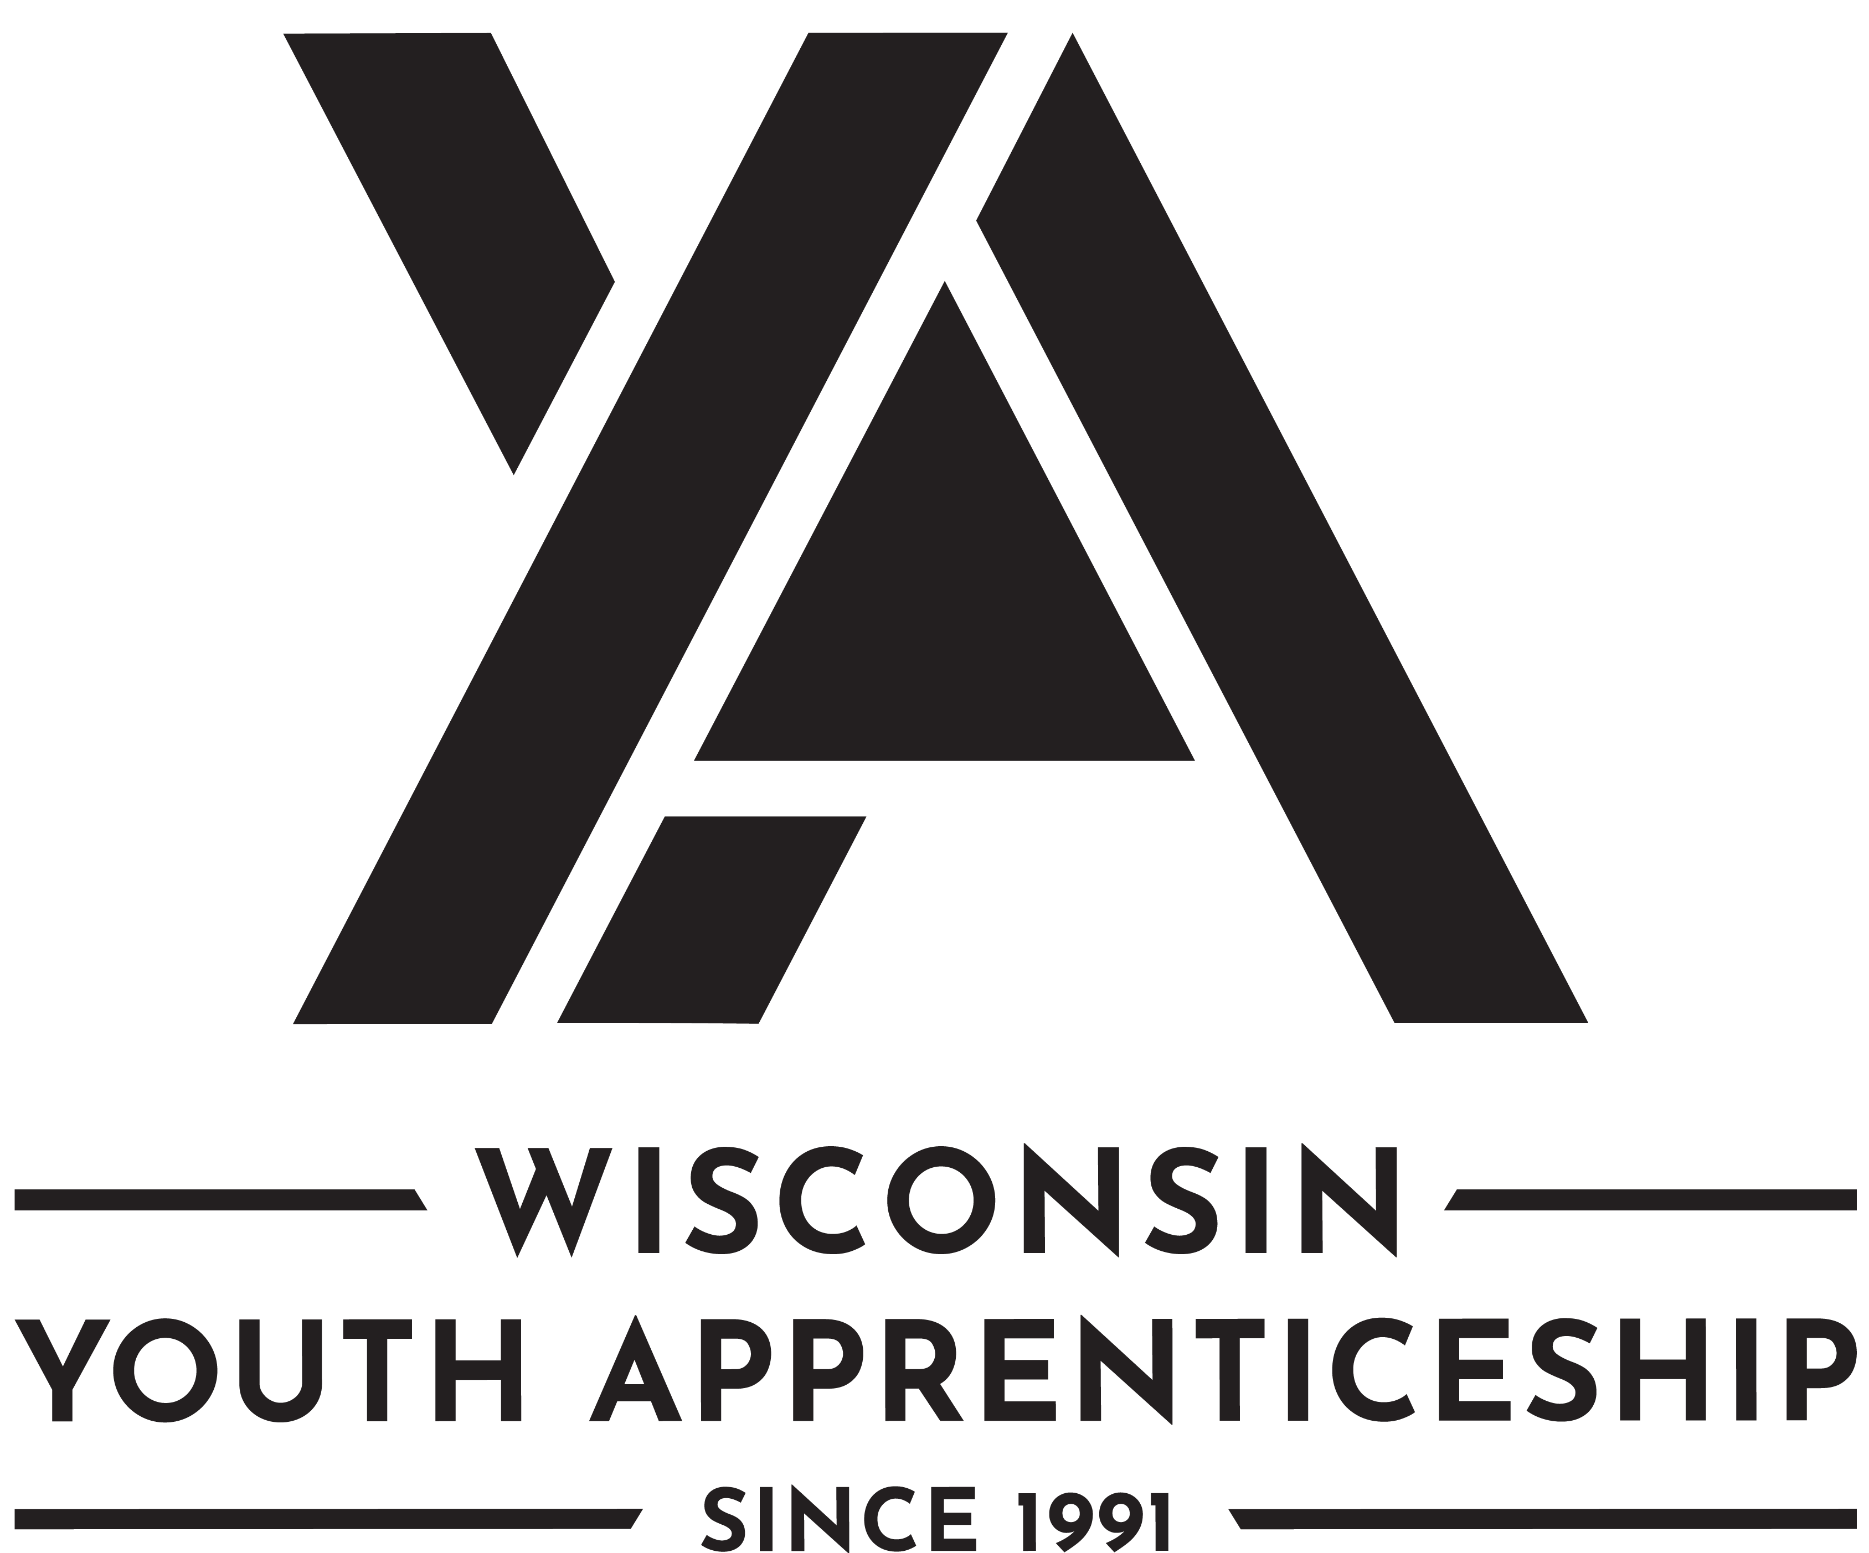 | Food and Beverage Service  Youth Apprenticeship

Food and Beverage Service
The Food and Beverage Service can be broadly defined as the process of preparing, presenting, and serving of food and beverages. Food and beverage service and related workers perform a variety of customer service, food preparation, management, and cleaning duties in restaurants, cafeterias, bakeries, and other eating and drinking establishments.
Length of Apprenticeship: One year

occupational Competencies
Youth apprentices must complete a total of 14 competencies per year. Thirteen must be from the list below. If necessary, employers can substitute 1 competency per year with another occupationally appropriate skill. That skill should be added to the competency list for assessment.
Competencies
- Apply service and production area safe food handling and sanitation procedures
- Assist with managing guest safety and security standards
- Manage service and production area operating procedures
- Apply customer service management skills
- Perform counter and/or table service activities
- Complete (Point of Sale) POS activities
- Operate foodservice equipment
- Manage orders
- Prepare/cook order items
- Clean service and production areas
- Perform leadership administrative activities
- Assist with inventory management
- Assist with finance management
- Apply formal dining room service skills

Post-Secondary Pathway Opportunities
There are several post-secondary pathway opportunities in this area. The following is a partial list.
- Food and Beverage Management
- Culinary Arts
- Restaurant Management

Food and Beverage Service
Youth Apprenticeship
On-the-Job Learning Performance Standards Guide
(tO BE COMPLETED BY ya cONSORTIUM)

Youth Apprentice information
Youth Apprentice Name

YA Coordinator | YA Consortium
School District | High School Graduation Date

Requirements
Level One Requirements
Youth apprentices must complete ALL the items listed below. Check completed areas.
Competency checklist
Employability Skills checklist (in this OJL Guide) or the DPI Employability Skills Certificate
Related instruction equal to 1 high school credit or at least 3 college credits
Minimum of 450 work hours

Hours
Record the hours the youth apprentice worked.
Total Hours Employed | Company Name | Telephone Number

Related Instruction
YEAR 1: Indicate which related instruction courses the youth apprentice completed.
Dual Credit | Course Number and Title | Credits | Instruction Provider

SIGNATURES
The On-the-Job Learning Performance Standards Guide includes a list of competencies youth apprentices learn through mentoring and training at the worksite.
Instructions for the Worksite Employers/Mentors and School-Based or YA coordinators: This document should be reviewed with the employer/mentor, school-based or YA coordinator on a regular basis with the youth apprentice to record progress and plan future steps to ensure completion of the required competencies. Mentors, school-based/YA coordinator, and the apprentice sign below.
Employer/Mentor Signature | Employer/Mentor Signature
Employer/Mentor | Employer/Mentor
Business/Company | Business/Company
Date Signed | Date Signed
School-Based and/or YA Coordinator Signature | School-Based and/or YA Coordinator Signature
School-Based and/or YA Coordinator | School-Based and/or YA Coordinator
School District or Organization | School District or Organization
Date Signed | Date Signed
Youth Apprentice Signature | Youth Apprentice Signature
Youth Apprentice | Youth Apprentice
School District / High School | School District / High School
Date Signed | Date Signed

employability Skills (TO BE COMPLETED BY yA EMPLOYER/MENTOR)
Youth apprentices must demonstrate key employability skills.
The DWD YA program employability skills requirement may be attained and demonstrated through two processes. (See options listed below.) Employability skills must be completed for every year a student is in the program. The DPI Employability Skills Certificate may be counted as meeting one of those two years, provided the certificate is earned in the same year the student is enrolled in youth apprenticeship or they can complete the YA Employability Skills in the OJL. The Employability Skills Certificate must be obtained through the DPI.
- If a student has successfully completed a Wisconsin Department of Public Instruction (DPI) State-Certified Cooperative Education, Co-Op Employability Skill certification then they have met the YA Employability Skills requirement for that year. A copy of the student’s DPI Co-Op Employability Skill Certificate must be maintained on file with their YA regional consortium.
Earned Wisconsin Employability Skills Certificate (checked if applicable) or,

- Completed and rated “Employability Skills” through this YA OJL guide as described below.
3 | Exceeds Expectations: Exceeds entry-level criteria; requires minimal supervision; consistently displays this behavior
2 | Meets Expectations: Meets entry-level criteria; requires some supervision; often displays this behavior
1 | Working to Meet Expectations: Needs improvement; requires much assistance and supervision; rarely displays this behavior

The following skills are required of all youth apprentices.
 | Employability Skills | Rating
Competency and Rating Criteria |  | Minimum Rating of 2 for EACH  Check Rating
 |  | 1 | 2 | 3
- Develops positive work relationships with others.
Examples of qualities and habits that the employee might exhibit include . . .
- Interacts with others with respect and in a non-judgmental manner
- Responds to others in an appropriate and non-offensive manner
- Helps co-workers and peers accomplish tasks or goals
- Applies problem-solving strategies to improve relations with others
- When managing others, shows traits such as compassion, listening, coaching, team development, and appreciation

- Communicates effectively with others
Examples of qualities and habits that the employee might exhibit include . . .
- Adjusts the communication approach for the target audience, purpose, and situation to maximize impact
- Organizes messages/information in a logical and helpful manner
- Speaks clearly and writes legibly
- Models behaviors to show active listening
- Applies what was read to actual practice
- Asks appropriate questions for clarity

- Collaborates with others
Examples of qualities and habits that the employee might exhibit include . . .
- Works effectively in teams with people of diverse backgrounds regardless of sex, race, ethnicity, nationality, sexuality, religion, political views, and abilities
- Shares responsibility for collaborative work and decision making
- Uses the problem-solving process to work through differences of opinion in a constructive manner to achieve a reasonable compromise
- Avoids contributing to an unproductive group conflict
- Shares information and carries out responsibilities in a timely manner

- Maintains composure under pressure
Examples of qualities and habits that the employee might exhibit include . . .
- Uses critical thinking to determine the best options or outcomes when faced with a challenging situation
- Carries out assigned duties while under pressure
- Acts in a respectful, professional, and non-offensive manner while under pressure
- Applies stress management techniques to cope under pressure

- Demonstrates integrity
Examples of qualities and habits that the employee might exhibit include . . .
- Carries out responsibilities in an ethical, legal and confidential manner
- Responds to situations in a timely manner
- Takes personal responsibility to correct problems
- Models behaviors that demonstrate self-discipline, reliability, and dependability

- Performs quality work
Examples of qualities and habits that the employee might exhibit include . . .
- Carries out written and verbal directions accurately
- Completes work efficiently and effectively
- Performs calculations accurately
- Conserves resources, supplies, and materials to minimize costs and environmental impact
- Uses equipment, technology, and work strategies to improve workflow
- Applies problem-solving strategies to improve productivity
- Adheres to worksite regulations and practices
- Maintains an organized work area

- Provides quality goods or services (internal and external)
Examples of qualities and habits that the employee might exhibit include . . .
- Shows support for the organizational goals and principles by own personal actions
- Displays a respectful and professional image to customers
- Displays an enthusiastic attitude and desire to take care of customer needs
- Seeks out ways to increase customer satisfaction
- Produces goods to workplace specifications

- Shows initiative and self-direction
Examples of qualities and habits that the employee might exhibit include . . .
- Prioritizes and carries out responsibilities without being told
- Responds with enthusiasm and flexibility to handle tasks that need immediate attention
- Reflects on any unsatisfactory outcome as an opportunity to learn
- Improves personal performance by doing something different or differently
- Analyzes how own actions impact the overall organization
- Supports own action with sound reasoning and principles
- Balances personal activities to minimize interference with work responsibilities

- Adapts to change
Examples of qualities and habits that the employee might exhibit include . . .
- Shows flexibility and willingness to learn new skills for various job roles
- Uses problem-solving and critical-thinking skills to cope with changing circumstances
- Modifies own work behavior based on feedback, unsatisfactory outcomes, efficiency, and effectiveness
- Displays a "can do" attitude

- Demonstrates safety and security regulations and practices
Examples of qualities and habits that the employee might exhibit include . . .
- Follows personal safety requirements
- Maintains a safe work environment
- Demonstrates professional role in an emergency
- Follows security procedures
- Maintains confidentiality

- Applies job-related technology, information, and media
Examples of qualities and habits that the employee might exhibit include . . .
- Applies technology effectively in the workplace
- Assesses and evaluates information on the job
- Assesses training manuals, website, and other media related to the job

- Fulfills training or certification requirements for employment
Examples of this requirement may include . . .
- Participation in required career-related training and/or educational programs
- Passing certification tests to qualify for licensure and/or certification
- Participation in company training or orientation

- Sets personal goals for improvement
Examples of this requirement may include . . .
- Setting goals that are specific and measurable
- Setting work-related goals that align with the organization's mission
- Identifying strategies to reach goals
- Reflecting on goal progress to regularly evaluate and modify goals

OCCUPATIONAL Competencies
(TO BE COMPLETED BY yA EMPLOYER/MENTOR)
Youth apprentices must perform a total of 14 competencies from the list below. If necessary, employers can substitute 1 competency per year with another occupationally appropriate skill. That skill should be added to the bottom of the list for assessment.
Rating Scale
3: Exceeds entry level criteria | Requires minimal supervision | Consistently displays this behavior
2: Meets entry level criteria | Requires some supervision | Often displays this behavior
1: Needs improvement | Requires much assistance and supervision | Rarely displays this behavior
If any competencies are rated "1" on the final performance review checklist that is submitted to WI DWD it is considered a failed checklist.

Occupational Competencies | Rating
Competency and Rating Criteria | Minimum Rating of 2 for EACH  Check Rating
 | 1 | 2 | 3
- Apply service and production area safe food handling and sanitation procedures
- maintain principles of nationally recognized sanitation protocols (e.g., SERV Safe®)
- use protective gloves and clothing applicable to service or production area
- use, handle, clean, and sanitize equipment and utensils
- avoid contamination and cross-contact of food
- maintain safe work environment
- demonstrate frequent and thorough handwashing procedures
- maintain food items at appropriate storage requirements
- thaw, prepare, cook, reheat, and hold food items according to appropriate requirements as applicable
- follow personal hygiene standards
- apply food allergen safety protocols
- maintain food safety documentation
- follow blood borne pathogen and bodily fluid procedures

Assist with managing guest safety and security standards
- adhere to organization-specific risk management protocols
- assist with performing safety and/or risk management audits
- review disaster response procedures/policies
- maintain first-aid, emergency, and crisis response supplies

Manage service and production area operating procedures
- assist with and/or perform beginning of shift production area procedures
- adhere to organization uniform and appearance standards
- prepare, clean, maintain tables/table-side service equipment (i.e. carts, trays, condiment dispensers)
- identify operational needs and assess urgency
- assist with audit of production area maintenance
- assist in product recall procedures and response
- follow operational chain of command to address operational needs
- sets up, clean and maintain self-service areas
- support team in service and production area preparation
- adhere to federal, state, local and insurance directed laws and regulations for service and production areas

Apply customer service management skills
- acknowledge guest(s)
- make offer of service
- identify guest needs
- direct guest to appropriate area
- display product knowledge
- thank guests
- use appropriate channels for resolving guest concerns/issues
- review/interpret customer feedback from multiple sources
- assist in responding to customer feedback
- adhere to organization-specific processes for customer follow-up
- solicit guest feedback
- address POS issues and respond accordingly
- identify fraud and respond according to organization procedure/policy
- use customer feedback to determine organization strengths and weaknesses
- create action plan based on customer feedback
- adhere to organization-specific processes for customer follow-up

Perform counter and/or table service activities
- take food and beverage orders accurately
- perform table order services if applicable
- deliver appropriate pre-service items
- deliver order accurately
- package orders
- verify order
- follow organization’s food service procedure
- respond to guest dietary concerns
- answer customer questions about the food or beverage item
- suggestive sell, as appropriate
- prepare take-away items
- prepare service area for the next guests
- lift and carry a loaded tray

Complete Point of Sale (POS) activities
- calculate guest check, including taxes and gratuity, accurately
- process payment via all available payment options
- present the guest check/receipt
- give guest correct change
- operate a POS (point of sale) system and/or cash register
- adhere to cash control practices
- adhere to credit card/debit card security practices
- assesses urgency of POS issues

Operate foodservice equipment
- exhibit appropriate selection, use, and care of small and large equipment
- adhere to lock out/tag out procedures for food service equipment
- calibrate measurement equipment
- apply measurement and portion control standards
- handle equipment safely to prevent burns and scalding
- handle equipment safely to prevent cuts
- use, clean and sanitize equipment, as required
- identify equipment failures/issues
- assess urgency of equipment issues
- identify equipment solutions and respond accordingly
- adhere to organization-specific procedures for equipment use

Manage orders
- ensure eating and serving equipment are assembled
- verify that orders are prepared as required by sequence and storage requirements
- ensure garnishes and/or condiments are prepared
- verify portion control, if applicable
- ensure prepared orders are placed in appropriate area
- monitor appropriate serving temperature maintenance
- monitor order accuracy and quality
- verify orders are completed in specified timeframe

Prepare/cook order items
- assist team in preparation where needed
- prepare items using proper timing
- adhere to quality standards and portion controls
- apply basic food preparation techniques
- prepare items according to standardized recipe/procedure
- set up preparation station
- maintain production levels

- Clean service and production areas
- assist team in preparation where needed
- sweep/mop floors
- clean and polish stainless steel surfaces
- clean floor mats
- clean and maintain sink area
- empty and clean trash cans
- follow recycling programs
- wash service equipment
- wash walls and ceilings
- clean production equipment
- clean kitchen hoods and ventilation grills
- clean and sanitize dispensing equipment
- clean and sanitize work surfaces
- clean reach-in/walk-in freezers/refrigerators
- clean and treat drains
- clean food storerooms
- clean large trash bins/surrounding areas
- clean carts

- Perform leadership administrative activities
- assist to coordinate work schedules
- use administrative technology
- assist talent acquisition and retention
- adhere to labor laws related to employment and scheduling
- adhere to organization policies/procedures
- accommodate employee workable abilities
- schedule training
- assist in training employees
- maintain scheduling and training records
- develop an organization-specific org chart
- assist with scheduling based on business volume and budget
- assist with ordering based on business volume and current inventory
- participate in community relations/activities, where applicable
- review regulatory documentation display policies/procedures
- maintain regulatory documentation displays

- Assist with inventory management
- assist with ordering based on business volume and current inventory
- assist with performing physical inventory
- review use of inventory
- apply principles of inventory management
- maintain inventory organization
- verify inventory deliveries
- manage inventory discard
- maintain inventory records
- follow organization-specific inventory procedures/policies

- Assist with finance management
- review organization financial reports
- apply financial data information to daily operations
- explain organization-specific finance vocabulary
- adhere to organization confidentiality policies
- review accounts payable/receivable procedures
- review payroll processes
- adhere to cash control practices
- adhere to credit card/debit card security practices

- Apply formal dining room service skills
  - review organization financial reports
  - apply financial data information to daily operations
  - inspect dining room, table settings, and chairs
  - lift and carry a loaded tray for formal dining service
  - arrange flatware and silverware from the outside in, starting with the first course
  - remove any cutlery, plates, and napkins for empty seats
  - manage the guest reservation system
  - move/place glasses and silverware by holding the base
  - serve and remove items from the left (do not reach over or across the guest)
  - remove used plates and silverware at the end of every course
  - clear plates when everyone in the party is finished with the course
  - stack plates one at a time from the table to avoid making noise while clearing table
  - bring out dessert and drink menus before offering the check if the meal is not prix fixe
  - fold cloth napkins according to organization standards
  - ensure glassware and dish settings are correct for the service (breakfast, lunch, dinner)
  - present entrée and other dish ingredient and preparation details to guest(s)
  - serve a Family Service meal
  - serve an English Service meal
  - serve an American service meal
  - serve a French service meal
  - serve a Flying service meal
  - perform beverage services
  - perform host responsibilities

Competency Substitute (if you replaced a competency above, note the competency and rating)

Comments:

Post-Program Completion Survey
Youth Apprenticeship

YA Post-Program Completion survey: Employer Feedback
Employers complete the following information. YA Coordinators will enter this into the Post-Program Completion Survey.
YA Employer Post-Program Completion Questions
Will you offer or have you offered the Youth Apprentice a continuing position with your company? | Yes  No
If continuing position offered to youth apprentice, did they accept? | Yes  No
If yes, please answer the questions below:
Was the offer for full time or part time work? | Full-time  Part-time
Title of the position offered:

What is the wage of the continuing employment offer?

If applicable, will the youth apprentice advance to a Registered Apprenticeship?

YA Post-Program Completion survey: completed by YA consortium
The Post-Program Completion Survey form is to be provided to each student completing the Youth Apprenticeship program to capture information on the student's plans after leaving the program. This form should be completed by the Youth Apprenticeship Coordinator to capture information from all high school seniors and their employers after successful completion of the Youth Apprenticeship Program.
The form should be completed during the final meeting between the student, mentor, and Youth Apprenticeship Coordinator, when the final checklist or On-the-Job Learning (OJL) Guide is filled out and signed. Information captured on this form must be entered online using the Youth Apprenticeship Online Data Application (YODA) System.

No part of this document may be altered, duplicated, or extracted without written consent from the Wisconsin Department of Workforce Development (DWD).
DWD is an equal opportunity employer and service provider. If you have a disability and need assistance with this information, please dial 7-1-1 for Wisconsin Relay Service. Please contact the Division of Employment and Training at 888-258-9966 and press 6 to request information in an alternate format, including translated to another language.

