Department of Workforce Development State of Wisconsin
Division of Employment and Training

Heat Illness Prevention Plan

Template for Wisconsin employers/migrant labor contractors who employ migrant workers.
Employers are required to establish, implement, and maintain an effective heat illness prevention (See Wis. Admin. Code § DWD 301.09(2m)(d)2.) Employers are free to adjust this sample heat illness prevention plan to suit their individual needs. However, the main elements of the sample plan must comply with the requirements of § DWD 301.09(2m)(d)2.
Employers and migrant labor contractors who employ migrant workers must post this plan at the migrant labor camp and encourage migrant workers to read the plan and understand their own risk factor and the signs and symptoms heat related illnesses.
Company/Business/Migrant Labor Contractor

Responding to Signs and Symptoms of heat-related illness
We are required to monitor workers for signs and symptoms of heat related illness and have a plan to response, provide first aid, and contact emergency services as needed. (See DWD 301.09(2m)(d)1)
We will monitor workers for signs and symptoms of heat related illness by the following methods:

Steps below will be taken by managers/supervisors/crew leaders when a worker shows signs and symptoms of heat related illness:

The first aid measures will include:

Procedures on how emergency medical services will be contacted including, if necessary, transporting workers engaged in hand labor to a place where they can be reached by an emergency medical services provider:

Water
(See DWD 301.09(2m)(b))
We will furnish 1 quart of water per employee, per hour.
Below is our plan for furnishing drinking water.
- Water is located throughout the work area(s). Locations include:

- We have made arrangements to replenish water throughout the day, as necessary. These arrangements include:

- For our mobile crews, we will replenish water by the following methods:

- We will keep the water cool through the following methods:

- For those working alone, we have made the following arrangements to (for you) replenish your water supply.

Shade
We will furnish shade, at all times, when the outdoor temperature in a work area exceeds 80 degrees Fahrenheit and the amount of shade be must enough to a accommodate the number of workers resting or taking outdoor meals so that they can sit fully in the shade in a normal posture without being in physical contact with each other. The shade shall be located as close as practicable to the areas where workers are working. (See DWD 301.09(2m)(e)1)
When the outdoor temperature in a work area DOES NOT exceed 80 degrees, timely access to shade must be made available upon a worker's request. The amount of shade be must enough to a accommodate the number of workers resting or taking outdoor meals so that they can sit fully in the shade in a normal posture without being in physical contact with each other. The shade shall be located as close as practicable to the areas where workers are working. (DWD 301.09(2m)(e)2)
- We have taken the steps below to provide you with shade when the outdoor temperature in a work area exceeds 80 degrees Fahrenheit.

- The steps below will be taken to provide you with shade when the outdoor temperature in a work area DOES NOT exceeds 80 degrees Fahrenheit. Shade must be provided upon request.

- For those working alone, we have made the following arrangements to (for you) to have shade on your rest breaks.

Heat Illness Prevention Rest Breaks
Employers, migrant labor contractors, crew leaders, supervisors, etc. shall allow and encourage workers to take a preventative cool-down rest in the shade at any time when they feel the need to do so to protect themselves from overheating. (See DWD 301.09(2m)(e)3) and DWD 272.12(2)(c))
If a worker takes a preventative cool-down rest, all the following apply:
- The worker shall be monitored and asked if the worker is experiencing symptoms of heat illness.
- The worker shall be encouraged to remain in the shade.
- The worker may not be ordered back to work until any signs or symptoms of heat illness have abated or until 5 minutes after the worker obtained access to the shade, whichever is later.
- The worker is paid for the break time of less than 30 minutes.
- The worker is not penalized for taking breaks.
Implementation
This is how we are going to implement our employees’ heat illness prevention rest breaks:
- For piece rate employees, here is how we will educate and encourage worker to take cool-down rest breaks:

- For hourly employees, here is how we will educate and encourage worker to take cool-down rest breaks:

- Below is a list of supervisors, managers, and crew leaders trained to monitor workers during breaks to observe signs and symptoms of heat related illness:

Communication
(See DWD 301.09(2m)(d)2)
- We will ensure that methods of communication are established for workers to contact the supervisor/manager/crew leader with they or another worker may need medical services. Below are those methods of communication:

- Cell phone service can be inconsistent in rural areas. Here is how we will use other methods to communication among the workers and supervisor/manager/crew leader:

- We will also ensure that methods of communication will be established to contact emergency services and provide information on how workers will be able to share their location with the first responders. Below are those methods of communication that will be used when emergency contacts are needed:

- Cell phone service can be inconsistent in rural areas. Here is how we will use other methods to communication with emergency services:

- The steps below will be followed each day and at each worksite if workers are moved during the day, to ensure all workers are able to communication their location to emergency services if needed:

- The following methods will be taken to train workers and supervisor/manager/crew leaders regarding these communication methods:

High Heat Procedures
When temperatures are expected to and do exceed 95 degrees Fahrenheit, additional procedures are in place to help prevent and identify for signs and symptoms of heat related illness. (See DWD 301.09(2m)(e)5))
- We will use the following methods to host a pre-shift meeting to discuss the high heat procedures:

During this meeting, we will:
- Review the high heat procedures.
- Encourage workers to drink plenty of water.
- Remind workers of their right to take a preventative cool-down rest when necessary.
- Review how and where shade will be available all day.
- Review signs and symptoms of heat related illness and encourage workers to take breaks and report these symptoms to the manager/supervisor/crew leader.
- Remind workers that if they are experiencing symptoms they should remain in shade and drink water until they are no longer experiencing symptoms.
Below is how we plan to share this information in a way that is understood by the workers and demonstrates that this is important to the supervisor/manager/crew leader, as well:

We will take the following steps to communicate to the workers that we will not retaliate against them for taking cool-down breaks or reporting signs and symptoms of heat related illnesses:

The following supervisor/manager/crew leader is designated to call emergency services:

The following worker(s) are trained on how to call emergency services:

We will take the following steps to increase observation of workers for alertness and signs or symptoms of heat illness:

Resources
OSHA-NIOSH Heat Safety Tool App
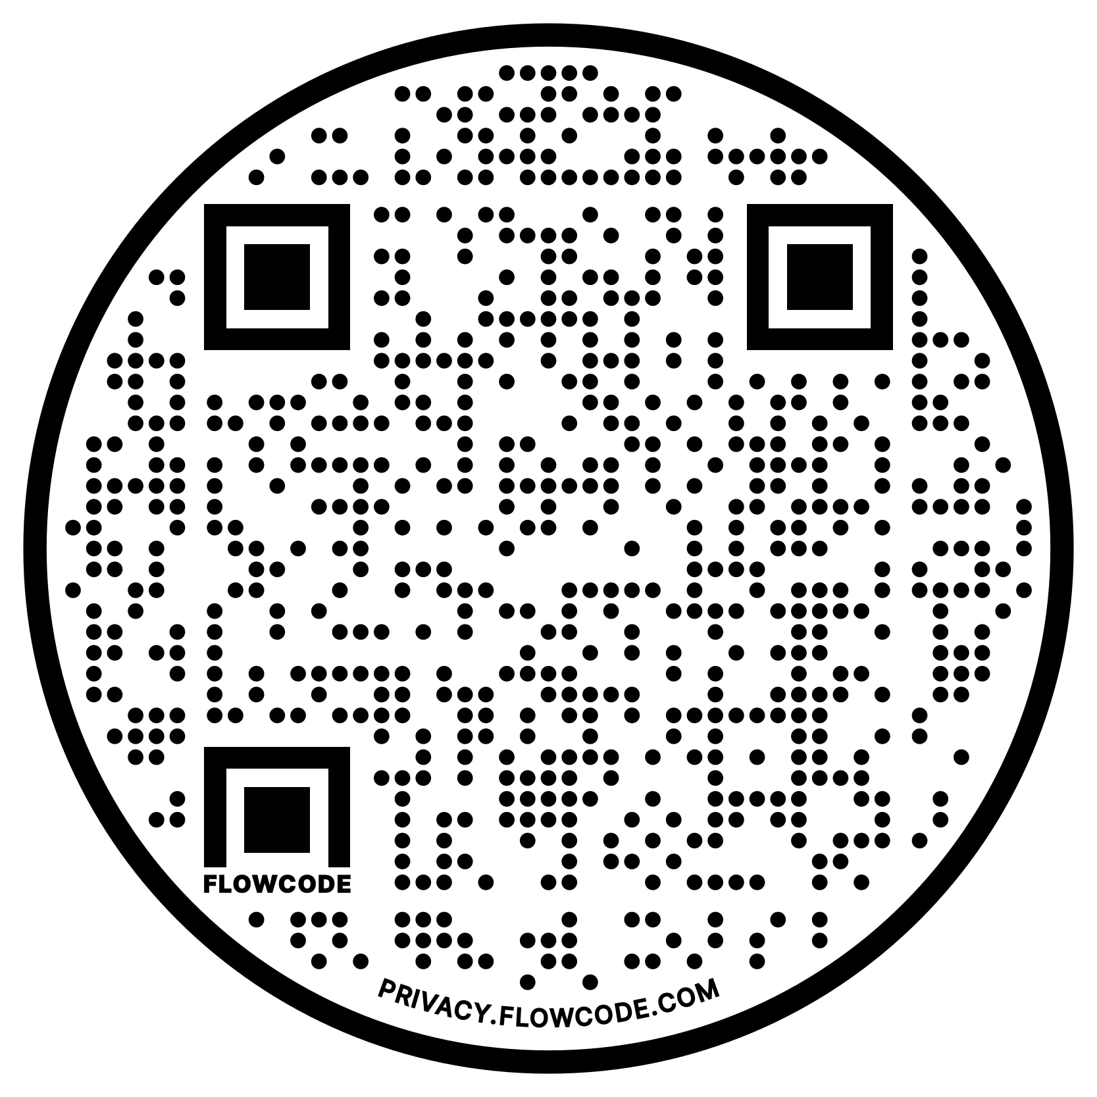
NIOSH Heat Stress App
It is suggested that all supervisors, managers, and crew leaders should
download The National Institute for Occupational Safety and Health (NIOSH)
Heat Stress App to help keep our employees safe. Please encourage
employees to download the application as well (available for iPhone and
Android devices). Federal OSHA has provided training on how to use the
app. https://www.cdc.gov/niosh/topics/heatstress/heatapp.html
Heat-Related Illnesses and Symptoms
For more information about this heat-related illnesses, visit:

OSHA Heat Exposure  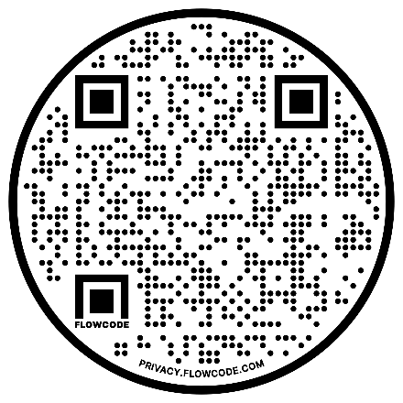 |  | CDC Heat Related Illness
Preventing Heat-Related Illnesses
CDC Preventing Heat Related Illness |  | OSHA Heat Illness Prevention  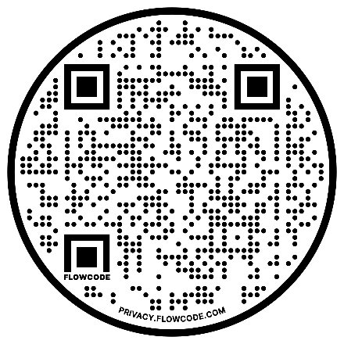
Heat Stress Prevention |  | Heat Stress Prevention Flipchart  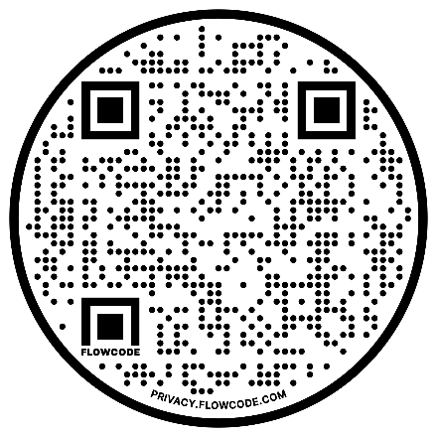 |  | Heat Stress Prevention Pocket Size Brochure

