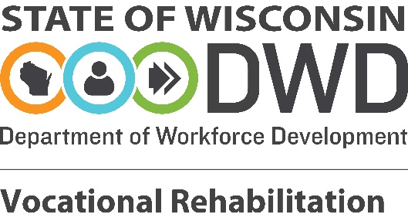

Authorization for Release of Employment Records
I, the undersigned, grant the Wisconsin Department of Workforce Development's Division of Vocational Rehabilitation ("DVR") permission to share my name, resume, cover letter, and references with prospective employers at my request. I acknowledge that sharing this information will inform employers that I am eligible for and receiving services through DVR. While DVR will not share specific information related to my disability, I acknowledge that DVR sharing these materials with prospective employers on my behalf may result in disclosure of my disability status with the employer's management, hiring, or human resources staff. DVR will notify me when information will be released to a prospective employer.
My signature is authorization for release of the records specified above. I understand that I may refuse to sign this release or revoke my authorization at any time except to the extent that information was released as a result of this authorization. Unless revoked, this authorization remains in effect until the expiration date stated below. No further release of records is authorized without my informed written consent except as provided by 34 CFR 361.38 and Ch. DWD 68 Wis. Admin. Code. If no expiration date is specified, the authorization expires one year after the date it was signed. I understand I have the right to receive a copy of this release and any information obtained by this release at any time.
Choose One
☐This authorization expires as of: (Date)
☐This authorization expires after the following action takes place: ____________________
Unless signed by a parent or guardian below, I declare that I am of legal age and have every right to contract in my own name in relation to this matter.
Name: __________________________________
IRIS Number: ____________________________
Address: _________________________________________________________________
Consumer Signature: Date:
Approved: Date:
Signature of Parent or Legal Guardian
(If under 18)
If you need help to complete this form, ask the person who gave you the form or call DVR at 800-442-3477.
DVR-18753 (N. 02/2020)

