School Catalog
for
Tucker's Truck Driving Academy

March 1, 2018

Volume 1

Mission Statement

The trucking industry has grown to become a very large portion of the United States economy. In 2011 for example, the trucking industry average revenue was $106,602,448, up 10.8 million from the average of 95,775,335 in 2010. (Bulk Transporter's Tank Truck Carrier 2011 Gross revenue Report). Trucking has become a necessity. Shippers utilize the railroads for shipping goods across the country. But, trucks have to carry that freight to the distribution centers and to the stores.

Without trucks, our economy will come to a complete stop.
Truck drivers are in great demand. Major trucking firms are offering great incentives for new drivers to come their firms. Yet, these companies are without drivers due to the demographic locations. Therefore, we introduce Tucker's Truck Driving Academy.
Classes will be instructed by a certified instructor who holds a Class A CDL.
Our classroom is located in a modern facility for your comfort and excellence in learning experience.
Our driving course is large enough for you to maneuver a tractor / trailer around safely.
You will have a docking facility to practice backing into a dock and detaching a trailer from the tractor.
You will learn about landing gears, tandems, fifth wheel engagement, and air tanks that supply air to the system.

Page 1
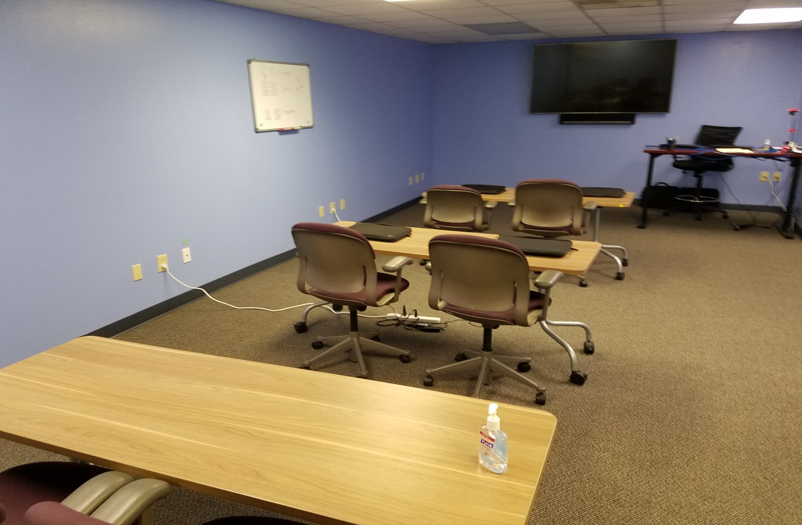
Our classroom is clean, comfortable and set up for our students to learn the trucking industry.
Students' desks, chairs and white boards are easily seen by all the students.
We also have a 55" Television monitor for video training classes.

Page 2
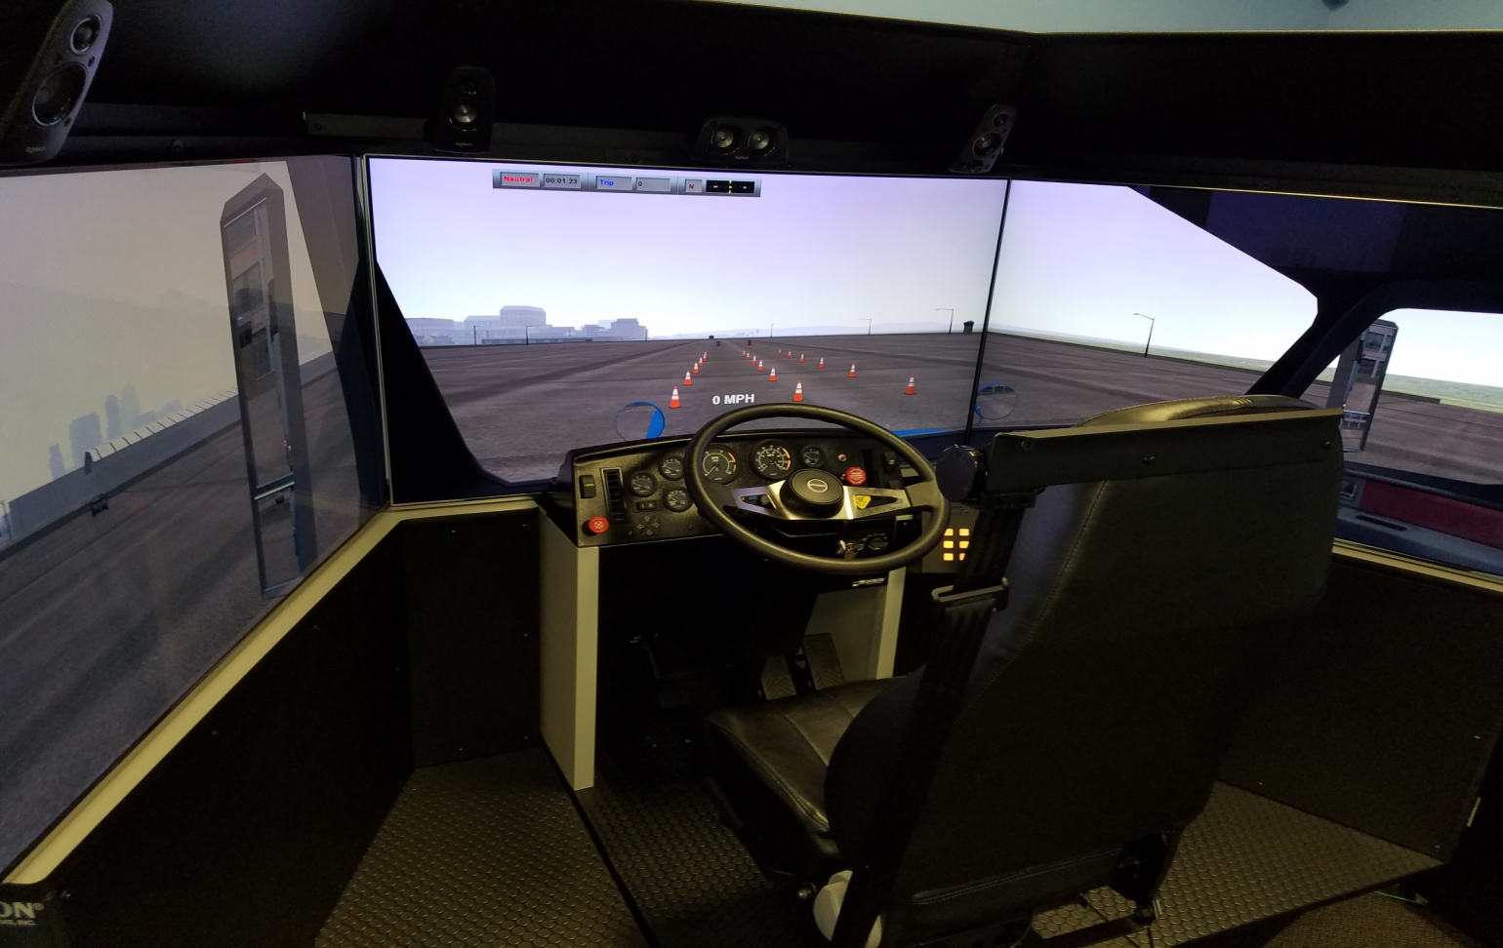
We offer a driving simulator to help new candidates to obtain their Class A CDL

Page 3
Personnel of the Academy

Melvin Tucker - President, CEO and Certified Instructor

Melvin has over 20 years experience in the trucking industry. 16 of those years is with his current employer, JB Hunt Transport, Inc.
Melvin will conduct class room instruction, driving course instruction, and on-road instruction.
Melvin will also mentor all students in order to achieve their Class A CDL.

Viola Tucker - Academy Administrator

Viola has over 25 years of office experience. She will perform all office tasks. She will submit applications for students' financial aid, collect down payments for the course, and submit applications for students CDL permits and Class A CDL. She will also keep all files of student current for a period of 3 years in accordance with the regulations of the State of Wisconsin.

Tony Wang - Field Instructor

Tony has 13 years of driving experience. He has the talent and patience to help others to obtain their Class A CDL.

Page 4
Dates of all holidays and vacation periods
class will not be in session

December 24-------------Christmas Eve
December 25-------------Christmas Day
December 31 -------------New Years Eve
January 1, ----------------New Years Day
May 30th -----------------Memorial Day
July 4th ----------------Independence Day
August 1st thru 10th ----- Vacation time
September 3rd ------------------Labor Day
November 22 ----------Thanksgiving Day

Page 5
Name of faculty

Melvin Tucker - President, CEO and Certified Instructor

Melvin has over 20 years experience in the trucking industry. 16 of those years is with his current employer, JB Hunt Transport, Inc.
Melvin will conduct class room instruction, driving course instruction, and on road instruction.
Melvin will also mentor all students in order to achieve their Class A CDL.

There are no guarantees on the achievement of a Class A CDL. Then 3rd examiner will be the final phase of testing. You must pass the 3rd party examiner in order to obtain a Class A CDL.

Page 6
Admissions and Entrance requirements

Students must provide a down payment of $500.00 to be applied to the fee for the class.
Students must hold a valid driver's license from any state. They also must pass a drug screen
Students must be able to speak, write and understand English. Students must have at least a high school diploma. Students can apply with the application attached to our brochure or they can apply online on our website. Or, they can call 1-855-669-2235. Press 1 for the Academy Administrator.
A letter and a phone call will be placed to the student when the student has passed the drug screen exam and the down payment has been made.
The balance of the fee for the class must be paid within 3 business days of the course.
That balance is $4,000.
The application deadline is 1 week before the beginning of the next class.
Classes will begin on the first Monday of the month. Then, continue for 4 weeks according to the class summary. In the case of a short month, we will adjust our calendar to accommodate the student for their full 4 week course. Students should check our website for the most up to date calendar of sessions.

page 7

This Page Left Blank on Purpose

Page 8

Grading and Progress System

Students will have homework to perform when going home for the evening.
They must complete the homework with a satisfactory grade of 80% or better. The student will be given the correct answers in the next class. If they continue to have issues, we will instructor them to pass the homework test. The instructor will not just pass them through.
If the student continues to fail (less than 80%) homework two days in a row, he or she would go on probation and get a tutor. If the student fails 2 more times, the student is dismissed and refunded under our refund policy.
Students must maintain progress in order to obtain their Class A CDL. Grades are assessed according to the knowledge they have obtained throughout the course.
Students will receive daily grades.

Student Records
Student records will be maintained forever. If a student wants to obtain a copy of his or her records. He or she must request it.
Student records will be kept on confidential disks, locked in a safe deposit box.

Academic Probation, Dismissal and Readmittance
If the student cannot comprehend the knowledge of obtaining their Class A CDL based on daily quizzes, the student will be given a probationary period of 2 days in order to catch up with the class. If the student does not demonstrate comprehension by the end of this probationary period, the student will be terminated from the program and be refunded based on our refund policy. If the student fails the 3rd party exams, they have an option to return to the driving portion of the next class for a fee of $1,500.00.

Page 9

Student Conduct

Students must be present on all days of the class in order to keep pace with the class. Students cannot be absent more than 2 consecutive days of the class. If the student is absent more than 3 consecutive days. The student is dismissed from the course and refunded according to our refund policy.
Students cannot disrupt others in the class. Students must maintain their log books and keep them current during the completion of the course. Inappropriate behavior, i.e., drinking of alcoholic beverages, drug use, fighting, vulgar language, unsafe behavior, or any unsafe act while a student at TTDA will not be tolerated and said student is subject to dismissal from the course. If the student does not comply, Tucker's Truck Driving Academy maintains the right to dismiss the student and a refund will be granted based on the number of hours completed.
If the student shows unsatisfactory conduct during the class, the student will be held after the class. Then, we will make an attempt to find out what is wrong. If the student finds that this course is not for them, they will be dismissed and granted a refund based on the refund policy.
Leave of Absence
There is no leave of absence with this course.
Attendance
Students must be present on all days of the class unless there is sickness or a family emergency. In those cases, we will work with the student to reschedule them to come back to the class. Attendance records will be maintained for a period of 6 years as required by the state. We consider a student withdrawn when he/she does not attend class after 3 days.
Tardiness
Students cannot be no more than 5 minutes late. Weather, transportation issues, family issues and personal problems will be discussed and the student can continue with the course.
If there is constant tardiness, the student can be dismissed from the course.
Page 10

Student Complaints
If the student has a complaint for any reason, we will address that complaint and try to work out the issue. The student can contact the Academy Administrator or Instructor verbally to address any complaint that they may have.
If the student has any issue regarding the class, we will make an attempt to correct the issue.
Students may appeal the termination with the school president, Mel Tucker based upon extenuating circumstances.
TTDA will do everything possible to resolve the students complaint. If the complaint is not resolved, then the student can go to the Educational Approval Program 1400 E. Washington Avenue. PO Box 8366, Madison, WI. 53708-8366
Tuition and Fees
The tuition of the class is $4,500.00. $500.00 must be paid upon application of the class. Fees include the DOT physical, drug screens and all paperwork. The remaining $4,000.00 must be paid 3 days before the beginning of the class. If the student cannot pay the remaining costs, they will be dismissed from the class.
No installments of the tuition will be available with this course. We will provide logbooks, writing paper and pencils for the students.
Cancellation and Refunds
If the student wants to cancel the course, he or she will have a 3 business day cancellation period after signing the enrollment agreement. The student will be refunded within 10 business days. Refunds are as follows. . . . .
1. Based on a course curriculum of 140 hours, if need be, the student will be refunded based on the number of hours completed. We will take the number of hours left in the program, divided by 140 hours and round down to the nearest 10 percent. The resulting percentage will be applied to the tuition, that amount will be refunded. The refund policy will be for both terminations and withdrawals of the course. See additional refund policy on supplemental page attached.
2 . After 84 hours of course study, no refund will be issued.
Page 11 + 2 following pages

Refund Policy

The student will receive a full refund of all money paid if the student:
1. Cancels within the three-business-day cancellation period under EAB 6.03;
2. Accepted was unqualified and the school did not secure a disclaimer under EAB 9.04;
3.Enrollment was procured as the result of any misrepresentation in the written materials used by the school or in oral representations made by or on behalf of the school.
Refunds will be made within 10 business days of cancellation.
A student who withdraws or is dismissed after attending at least one class, but before completing 60% of the instruction in the current enrollment period is entitled to a pro rata refund as follows:

At Least
1 unit/class
10%
20%
30%
40%
50%
60%

But Less Than
10%
20%
30%
40%
50%
60%
no
Refund of Tuition
90%
80%
70%
60%
50%
40%
no refund
As part of this policy, the school may retain a one-time application fee of no more than $100. The
school will make every effort to refund prepaid amounts for books, supplies and other charges. A student will receive the refund within 40 days of termination date. If a student withdraws after completing 60% of the instruction, and withdrawal is due to mitigating circumstances beyond the student’s control, the school may refund a pro rata amount.

A written notice of withdrawal is not required. But helpful.

Program Curriculum
Tucker's Truck Driving Academy
Course Summary / Classroom
Class 1 - 8 hours
Responsibility of vehicle operations
Acceleration, clutching, braking, shifting and mirrors.
Looking forward into your future.(c)
Be aware of your surroundings.(c)
Move your eyes to different objects.(c)
Keep an escape plan active at all times.(c)
Bring attention to yourself. Driving with headlamps on. Your intentions must be signaled.(c)
Paper and electronic logging.
Test given for homework.
Class 2 - 8 Hours
Vehicle mechanical and control features
Air Pressure, Braking, Backing, Ignition, Oil Pressure, Starting, Steering, Clutch, Shifting Gears, Water Temp, and learning to read all gauges.
Air line hose (glad hands) attachments. Both blue and red hoses. Pigtail power cord. Fifth wheel operation along with fifth wheel release handle and strike pin for emergency release. Raising and lowering the landing gear (Dollies). Trailer tandems. How to slide trailer tandems to adjust weight balance on trailer.
Air bag positioning on both tractor and trailer. Since most of today's tractors and trailers are equipped with air bags, it is important to know where they are, and inflated properly.
Test given for homework.
Page 12

Class 3 - 8 hours
Vehicle ownership responsibilities
The owner of the vehicle shall provide all documentation, including licensing, registration, insurance, fuel, maintenance and bonds when needed. Tractor and trailer will be provided clean, fueled and operative. If not, report it. Do not attempt to drive it. All paperwork should be provided in a book that is placed in the driver's door pocket. In that book should be all necessary valid insurance forms, permits cards, and accident reporting forms. A hazmat book should also be included in the driver's door pocket.
Applications given for CDL Drivers Permit.
Test given for homework.

Class 4 - 8 Hours
Environmental Dynamics
Some of the drivers here will go on to hauling hazardous material. You must have a hazardous material endorsement on your Class A CDL before you can haul this type of load. Placards must be placed on the trailer in the proper positions. You also must have a hazardous material briefing before leaving the shipper. It is the responsibility of the shipper to provide placards and proper paperwork for this type of load. Paperwork must include the type of hazardous material, weight of the material, and class of the material. This paperwork should be placed in the driver's door pocket when hauling this material for access in case of an emergency. The hazmat book will have all the emergency phone numbers in the event of a spill or accident.
Students will complete applications for CDL drivers permit.
Test given for homework.

Page 13
Class 5 - 8 Hours
Pre-Driving skills and maneuvers
Once the tractor is attached to the trailer, turn off the ignition. Bring log book to updated duty status. The driver will then perform a pre-trip inspection. Turn on the emergency flashers..You will get out and attach the airlines (glad hands) and lighting cord, i.e." pigtail" properly. Then, as you walk towards the rear of the trailer. You bend down to insure that the fifth wheel handle is in the locked position. "IN". Check your driver side drive tires for damage or low pressure. Raise the landing gear (Dollies) on the trailer. As you walk towards the rear of the trailer, check to see if the driver side marker lamp is flashing and on. If so, continue to the rear of the trailer and check the driver side tandem tires to see if there is any damage or low pressure. Then, proceed to the rear of the trailer to see if all lamps are working. This includes clearance lamps at the top of the trailer. Tail lamps should be on. The turn signal lamps should be flashing. Then, continue to walk around the passenger side of the trailer. Check the passenger side tandem tires to see if there is any damage or low pressure. Check to see if the passenger side marker lamp is flashing and on. Then, continue to walk towards the front of the tractor and examine the passenger side drive tires to check for damage and low pressure. Then continue to walk towards the front of the tractor to examine all lighting. Headlamps, turn signals, clearance lamps at the top. If you are alone, use a snowbrush or a long handled stick to depress the brake pedal to engage the brake lamps. Then walk towards the rear of the trailer to insure that the brake lamps are on.
Test given for homework.

Page 14
Class 6 - 8 Hours
City Driving
The most important thing to remember about a load going to or thru a city." TIME MANAGEMENT". Time management is so important. You will be delayed at one point or the other. There is 24 hours in a day. 14 hours of that day will approximately be used for on duty performances. 11 hours of those 14 will just about be used for driving. Patience is very important while driving into and thru a city. Many drivers in automobiles will be distracted doing other things such as talking on the phone, texting, eating and not paying close attention to the task at hand. You must be very attentive while driving in the city. It is important to stay in a lane and not perform too many lane changes unless absolutely necessary. You must use turn signals to signal your intentions before you make any lanes changes. Lane changes, if not performed carefully will cause major damage or death.
It is most important to take your time when driving in or thru the city.
Test given for homework.
Class 7 - 8 Hours
Freeway / Highway Driving
Usually, major trucking firms have their truck governed at a regulated speed between 60 to 63 miles per hour. The reason for this is because of fuel efficiency. With fuel costs at the range that it is, truck firms are trying their best to save money on fuel. Once you have merged onto to the highway, you must utilize your mirrors to maintain information to be aware of your surroundings. TIME MANAGEMENT is a factor when driving a tractor / trailer at all times. Once, you are on the highway. Look into your future. Meaning, look far ahead of you. If you see brake lamps, begin to slow down before you get to where you saw those brake lamps. Remember, you can't stop as fast as a smaller vehicle. You have brake lag. Brake lag is when you depress the brakes, it takes approximately 1 to 2 seconds before your brakes are engaged. When driving on the highway, maintain a constant speed as traffic allows. You should drive in a lane with the least resistance. Normally, this means tractor / trailers drive in the 2 far right lanes on the highway, if it is designed that way. maintain your focus on the passenger side mirrors if you are in the 2nd lane from the shoulder. Smaller vehicles will try to pass you. Keep your eyes moving at all time to gather fresh information about your surroundings. That is so important. Remember, you must use your turn signals to signal your intentions before you make any lane changes.
Test given for homework.
Class 8 - 8 Hours
Rural Driving
Rural driving can be just as dangerous as city driving. Why? Because of hidden entry / exit roads. You will encounter hills, blind driveways, and crossroads. You will see a lot of signs that indicate deer crossings. You will see deer crossing the highways in front of you. If you encounter a deer crossing the highway, expect to see others following. Do not try to swerve around the animal. You may lose control of your vehicle and cause injury or death. It is better to strike the animal and then pull over to the side of the road, call your dispatch office and notify the authorities. Driving on rural roads may have only 2 lanes. One lane in each direction. You must extra careful when approaching oncoming traffic. You don't know what the other driver is doing or thinking.
Test given for homework.
Class 9 - 8 Hours
Hazards of farm animals and machinery
Rural driving on 2 lane highways can be hazardous because of farm animals and machinery. Why? Farm implements are out there when planting and harvest seasons begin. Farm animals can get away from the farm perimeters. Sometimes, they may come into the roads in front of you. This is why you must be aware of your surroundings. Farm implements, such as tractors, pickup trucks pulling trailers, hay bailers, and the such are moving at a very slow speed. Usually on the right shoulder of the road. You will see a slow moving vehicle sign on the rear of the vehicle. You must slow down, and make sure you can pass the vehicle safety. If you cannot pass the vehicle safely. You must remain behind the vehicle at a slow speed until you can pass the vehicle safely. Planting season usually begins in the early spring. harvest season begins in the late fall. Caution is always advised during these periods of time.
Test given for homework.

Class 10 - 8 Hours
Hazards of railroad crossings
When approaching a railroad crossing, you must be aware of your surroundings. You will see railroad crossing signs that indicate the crossing of train tracks. The majority of times, there will be signals at the crossings. But, you cannot just depend on the crossing signal. When approaching a railroad crossing, open your window to listen for train whistles. Those are air horn blasts that indicate a train approaching. Remember, you are driving a 53' trailer behind you. If you encounter a railroad crossing with the signals starting to flash and you hear a trains air horn blasts. Stop before you get to the railroad crossing. It is always better to wait it out. This is why "Time management" is so important. There may be times when a train stops and delay you for a period time. You can encounter a train in the city and in rural areas. So, plan your trip.
Test given for homework.
Class 11 - 6 Hours
Psychophysical aspects
When driving a tractor / trailer, you must be rested and in good health. You will be required to have your medical card in your possession at all times. "Time management is key to this aspect. The fastest way to lose your Class A CDL license is a DUI. That means if you are driving your personal vehicle also. Your health is a key component to keeping your Class A CDL in good standing. If you need to take medication, it must be approved by your company in order for your to maintain your employment. The company you choose to work for will gather all information for you to keep them advised of your medication. Also, don't drive a tractor / trailer if you are in a bad mood. Don't report to work if something is weighing on your mind that will cause you to make bad decisions. That will cause you great harm, damage to property or death to you or someone else. You don't need that in your life. Take the day off if you need to.
Test given for homework.

Class 12 - 4 Hours
Organ and tissue donation
Under the law of the United States, the regulation of organ donation is left to states within the limitations of the Uniform Determination of Death Act, the National Organ Transplant Act of 1984, and the United Network for Organ Sharing (UNOS). Each state's Uniform Anatomical Gift Act seeks to streamline the process and standardize the rules among the various states. Many states have sought to encourage the donations to be made by allowing the consent to be noted on the driver's license. Donor registries allow for a central information center for an individual's wish to be a donor. It is a pure consent system rather than an extended consent system or a dissent opt-out system. The issue of consent is pressing, as the number of patients on the waiting list in the country has increased from approximately 20,000 in 1990 to over 100,000 in 2010. Alongside absolute organ donation increases from the late 1980s up until the mid-2000s, donation rates did not increase or decrease significantly from 2004-2010.
Test given for homework.
Class 13 - 6 hours
Traffic citizenship and highway safety progress
WASHINGTON, D.C.—A report released by the Governors Highway Safety Association (GHSA) highlights the continued role speeding plays in traffic deaths and makes recommendations to address the problem. Despite progress in nearly every other area of highway safety, speeding continues to be a factor in approximately one third of traffic deaths every year. In 2010, 10,530 people lost their lives in speeding-related crashes in the U.S. and Puerto Rico, representing 31 percent of all traffic deaths. Since 2000, the share of traffic fatalities linked to speeding has increased by seven percent, even as seat belt non-use in fatal crashes dropped 23 percent and alcohol-impaired fatalities declined three percent. Speed remains the one highway safety area where progress has not been made in almost three decades. If you need further information, visit GHSA.GOV. If you break down, you must place your signal flares or triangles in the proper manner to advise traffic that you have broken down. It is the law.
Test given for homework.

Class 14 - 6 Hours
Awareness of motorcycles, bicycles and pedestrians
You must be aware of motorcycles. Because they are so hard to see. They can get into your blind spot. It is so important to be aware of your surroundings at all times by utilizing your mirrors and looking into your future. In the summer, motorcycles are everywhere.
Livable communities are a high priority of the U.S. Department of Transportation and the Obama Administration. A livable community is one that provides safe and convenient transportation choices to all citizens, whether it’s by walking, bicycling, transit, or driving. Each year, unfortunately, pedestrian fatalities comprise about 12 percent of all traffic fatalities and there are approximately 4,000 pedestrian deaths. Another 59,000 pedestrians are injured in roadway crashes annually. The numbers are improving, but we still have a ways to go. Pedestrian safety improvements depend on an integrated approach that involves the 4 E’s: Engineering, Enforcement, Education, and Emergency Services. The FHWA’s Office of Safety develops projects, programs and materials for use in reducing pedestrian and bicyclist fatalities.
Test given for homework.
Class 15 - 6 Hours
Move-Over Law
When looking into your future, if you see flashing red and blues lights. Check to see if the left lane is clear before you begin to move into that lane. If the lane is not clear, you must slow down and pay close attention to the shoulder where the flashing lights are. An officer or emergency personnel may walk close to that lane in which you are driving. Move Over laws were originated in the US after a South Carolina Paramedic, James D. Garcia, was struck and injured at an accident scene Jan. 28, 1994, in Lexington, SC. Garcia was listed at fault, leading to his work to create a law to protect other emergency responders. SC's version (SC 56-5-1538) passed in 1996, and was revised in 2002.
After a series of similar events across the US in 2000, the US Dept of Transportation and Federal Highway Administration began to address the issue of Emergency Scene Safety, and issued recommended changes for the new MUTCD (Manual of Uniform Traffic Control Devices) that finally addressed the need for improved standards and protection for Emergency Workers. With the further assistance of public interest groups such as the Emergency Responder Safety Institute (www.respondersafety.com), "Move Over Laws" became standard across the US and Canada.
In United States, the move over laws are aimed at protecting emergency responders working along the roadside. Forty-nine U.S. states have passed move over laws, which were promoted in response to increasing roadside fatalities in the line of duty. The law require drivers, upon noticing either emergency vehicle with sirens or flashing lights, to move away from the vehicle by one lane, or if that is not possible, slow down by 20 mph (32kmh) below the posted speed limit. This includes law enforcement vehicles, fire trucks and ambulances. In New York State, drivers must use due care when approaching an emergency vehicle that displays red and/or white emergency lighting such as law enforcement vehicles, fire trucks and ambulances and also vehicles with flashing amber lighting such as tow trucks, construction vehicles and other service workers stopped along the side of the road while performing their duties.
Currently, only Hawaii and Washington, D.C. do not have move over laws. On June 17, 2009, Connecticut Governor M. Jodi Rell signed House Bill 5894, establishing a Move Over requirement in the state. Connecticut's Move Over law took effect on October 1, 2009. On August 13, 2010, New York's governor signed a move over law to take effect 1/1/2011. On 1/1/12 the move over law was modified to include, not only police, fire trucks and ambulances, but also hazard vehicles, such as tow trucks. Maryland's move over law provisions, which were approved by Governor O'Malley on May 20, 2010, came into effect on October 1, 2010.
Test given for homework.
Class 16 - 4 Hours
Hazards of cell phone usage and texting
When 28 percent of all automobile accidents have a tie to cell phone usage and 200,000 of them are linked to text messaging while driving, it is long past time to do something to reverse those numbers.
A new national campaign called Focus Driven is setting its sights on raising awareness about the dangers and perhaps getting a ban on cell phone usage and texting while driving.
The group is patterning itself after Mothers Against Drunk Driving, the grassroots movement that grew to become a national and powerful voice in legislation against driving under the influence.
Carrying on a cell phone conversation while driving is a distraction that poses an obvious danger, and text messaging is even more of a safety hazard. The moments of inattention it takes to be able to text is a threat that needs to be dealt with quickly.
Test given for homework

. Tucker's Truck Driving Academy
Class Schedule

Morning Schedule Afternoon Schedule
Class begins . . . . . . . 0800 Class begins . . . . . 1300
Class break . . . . . . . .0915 Class break . . . . . . 1415
Class resumes . . . . . .0930 Class resumes . . . .1430
Class break . . . . . . . .1030 Class break . . . . . . 1515
Class resumes . . . . . .1045 Class resumes . . . .1530
Class break (Lunch) . 1200 Class dismissed . . .1600

These times are militarized. These times are frequently used by most trucking firms and the Department of Transportation. It is most important that you become familiar with these time formats.

Page 15

Employment Services

Although students has completed the course for their Class A CDL, Tucker's Truck Driving Academy cannot guarantee job placement for anyone.
Our academy administrator will work with students in attempting to obtain a driving career with trucking firms. But, again we cannot guarantee job placement.
Trucking recruiters will meet with the student during the course of the program. Some trucking firms will accept students fresh out of class. Some won't.
Student referral to prospective employers are not based on direct contact with the employer regarding current job openings.

Page 16
Tucker's Truck Driving Academy
Field Instruction
Introduction to the Tractor / Trailer
Class 1 - 8 Hours
Becoming familiar with the tractor
Students will become familiarized with the operation of the tractor. Including instrument panel, gear shifting, clutch pedal, fifth wheel and release handle, air lines, power cord, air brake system, lighting system, seat position, and mirrors.
Each student will pass a test to make sure they know what all components and functions of the tractor will perform.
Becoming familiar with the trailer
Students will become familiarized with the trailer. Connection of the airlines, glad hands, lighting cord, raising and lowering of the dollies, tandem locking pins, tire pressure.
Each student will pass a test to make sure they a familiar with the trailer.
Connecting the Tractor to the Trailer
Each student will connect to and release from the trailer. Checking to make sure the fifth wheel is locked into position. They will raise and lower the dollies, connect and disconnect the air lines and power cords properly. Check tandem positioning and tire pressure.
Driving on Obstacle Course
Student will drive on obstacle course to become familiar with the movement of the vehicle. They will perform turns, both left and right turns with safety cones in place. They will also perform backing maneuvers to simulate backing into dock areas. They will also perform parking in parallel positions.

Page 17
Class 2 - 8 Hours
Becoming familiar with city and highway driving
The instructor will drive first to demonstrate the proper way to handle city driving. He /She will perform proper turns, command the turn lane, and watch for other vehicles. Then, the instructor will turn over control to the first student. That student will drive for about a half an hour to get the feel of the vehicle at hand. Then, that student will turn over control to the next student. Depending on how many students, this process will take approximately 2 to 3 days.
Class 3 - 8 Hours
Road test for obtaining the Class A CDL
The instructor and the students will travel to a State of Wisconsin's Road testing facility. Then, the student will be tested by a Department of Transportation Official. When the student passes the D.O.T. exams, that student will receive their Class A CDL. Depending on how many students, this process will take approximately 2 to 3 days.
Class 4 - 2 Hours
Graduation
An official certificate of completion will be granted to each student that passes our courses. We take great pride in guiding and training our students in order to obtain their Class A CDL.
Class 5 - 2 Hours
Job Placement
Graduated students will apply for truck driving positions with trucking firms. There is no guarantee of job placement. But, we will advise our students of job opportunities.

Page 18

