Tucker's Truck Driving Academy, LLC.
Class A CDL Driver’s License Program

School Catalog
Volume 1

Jan. 1st, 2023

Mission Statement

The trucking industry has grown to become a very large portion of the United States economy. In 2011 the trucking industry average revenue was $107 million, an increase of over $10 million from 2010. (Bulk Transporter's Tank Truck Carrier 2011 Gross Revenue Report).

Trucking has become a necessity. Shippers may utilize the railroads for shipping goods across the country, but trucks have to carry that freight to the distribution centers and to the stores. Without trucks, our economy will come to a complete stop.

Truck drivers are in great demand. While major trucking firms offer great incentives for new drivers, they still are without drivers due to the demographics and geographic locations.

The mission of Tucker's Truck Driving Academy (TTDA) is to offer a personal and thorough training experience in a unique location so that graduates can safely drive a tractor and trailer under all conditions and obtain their Class A CDL license.
Classes are taught by a certified instructor who holds a Class A Commercial Driver’s License (CDL). The classroom is located in a modern facility for your comfort and to promote a learning experience.
Our driving course is large enough to safely maneuver a tractor or tractor-trailer combination. The docking facility allows for practice in backing into a dock and detaching a trailer from the tractor.
With modern equipment, you will learn about vehicle pre-trip inspections, landing gears, tandems, fifth wheel engagement and air tanks that supply air to the system.

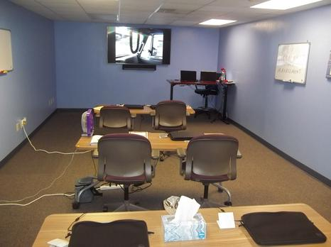
Our classroom is clean, comfortable and enable our students to learn the trucking industry.
Students' desks, chairs and white boards are easily seen by all the students.
We also have a digital projector for video training sessions.

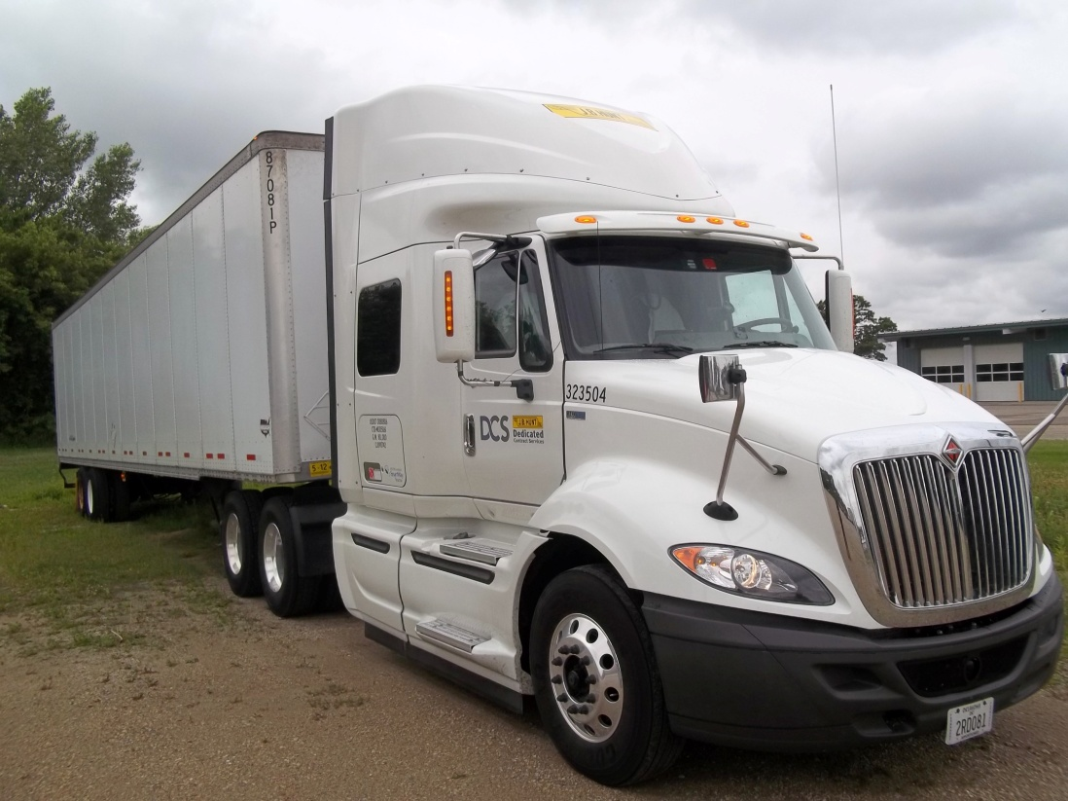
Tractor / Trailer equipment will be leased from a reputable dealer for training students.
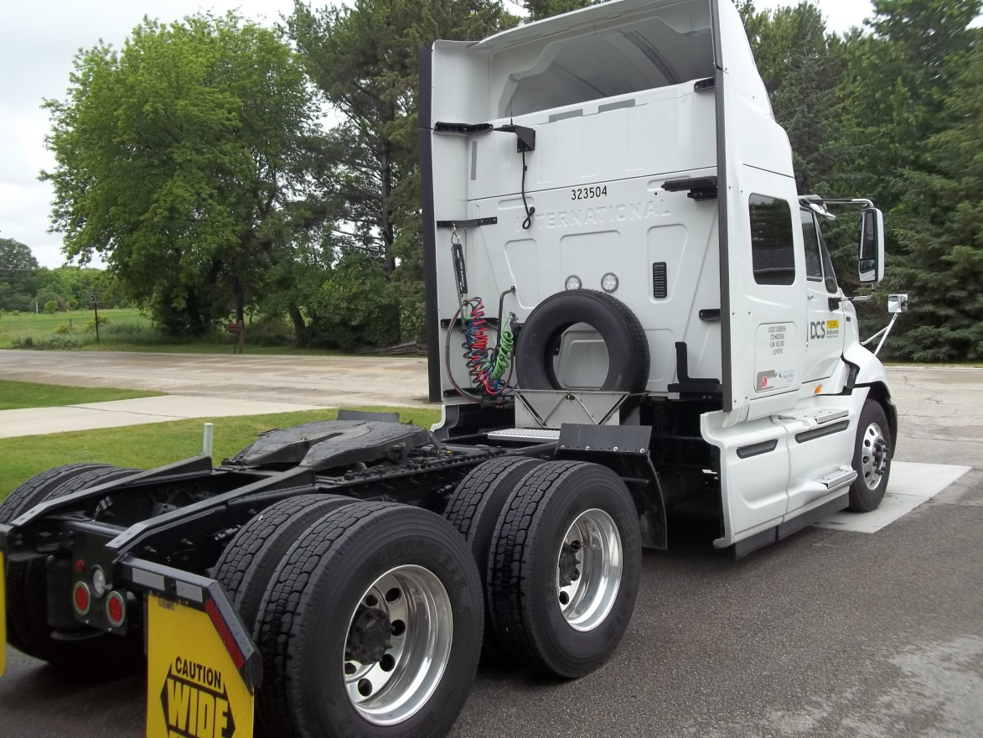

Academy Management and Staff

Melvin Tucker - President, CEO and Certified Instructor

Melvin has over twenty years of experience in the trucking industry. He has spent eighteen years with his previous employer, JB Hunt Transport, Inc.

Melvin will conduct class room instruction, driving course instruction, and on-road instruction. He also mentors all students in order to achieve their Class A CDL.

Viola Tucker - Academy Administrator

Viola has over twenty-five years of office experience. She will perform all office tasks. She will submit applications for students' financial aid, collect down payments for the course, and submit applications for student CDL permits and Class A CDL. She will also keep all files of student current for a period of 3 years in accordance with the regulations of the State of Wisconsin and as required by the US Department of Veterans Affairs (VA) for students using the federal GI Bill.

Academy Address

8200 W. Brown Deer Rd.
Milwaukee, WI. 53223

Training Yard Address

8200 W. Brown Deer Rd.
Milwaukee, WI. 53223

Holidays and Vacation Periods
When the Academy Will Be Closed

December 24 – Christmas Eve
December 25 – Christmas Day
December 31 – New Year’s Eve
January 1 – New Year’s Day
Last Monday in May – Memorial Day
July 4 – Independence Day
August 1 thru 10 – Academy Closed for Staff Vacation
First Monday in September – Labor Day
Fourth Thursday in November – Thanksgiving Day

Admissions and Entrance Requirements
Tuition and fees are due in-full three business days before the beginning of class. The application deadline is 1 week before the beginning of the next class. See page 12 for current costs.
Application requirements:
- Hold a valid driver's license with no significant violations.
- Proof of having passed a Wisconsin Department of Transportation (DOT) physical and drug screen. Contact the TTDA Administrator for information on the physical and drug screen process.
- Fluent use and understanding of English, i.e., reading, writing and speaking.
Application Process:
- Complete and submit the application attached to our brochure.
- Apply online on our website.
- Call the Academy Administrator, 855-669-2235, and press 1.
Students will be notified via US Mail and telephone when:
- Results of the DOT physical and drug screen (required for a CDL) are received by the school.
- The tuition down payment has been received by TTDA.

Classes will begin on the first Monday of the month. Then, continue for four weeks according to the class summary. In the case of a short month, we will adjust our calendar to accommodate the student for their full four week course. Students should check our website for the most up to date calendar of sessions.

This Page Left purposely blank

Grading and Progress System
Students will have daily homework to perform when going home for the evening.
They must complete the homework with a satisfactory grade of 80% or better. The student will be given the correct answers in the next class. If they continue to have issues, we will tutor them to pass the homework test, but the tutor will not just pass them through; they will have to demonstrate knowledge and understanding of the material.
If the student continues to fail (less than 80%) homework two days in a row, he or she would go on probation and get a tutor. If the student fails two more times, he or she will be dismissed and tuition will be refunded according to school policy.
Students must demonstrate academic and practical progress in order to obtain a license. Grades will reflect the cumulative knowledge and understanding obtained throughout the course.
Students will receive daily grades.

Transfer Credits for Prior Training
Program credit may be given for experience, education, credentials or military service pertaining to training for which the student is enrolled at TTDA. Verification of credentials and/or documentation may be required. Transfer of credit must be approved by the school president prior to commencement of training. Transfer credit may shorten the training program and reduce total tuition charges. TTDA does not guarantee transferability of our credits to another institution without a written agreement between that institution and TTDA.

Student Records
Student records are permanently retained. Records are available upon request with appropriate processing and mailing fees.
Student records will be kept on confidential disks, locked in a safe deposit box

Academic Probation and Dismissal
If based on the results of daily quizzes, the student does not demonstrate the comprehensive knowledge and understanding needed to operate a tractor / trailer, he or she will be placed on a two day probationary period in order to catch up with the class. If the student does not demonstrate comprehension by the end of this probationary period, the student will be terminated from the program and tuition will be refunded accordingly.

Student Conduct
Students must be present for all classroom and driving sessions to keep pace with the class. Students cannot be absent more than two consecutive days of the class. If the student is absent more than three consecutive days, he or she will be dismissed from the course and tuition will be refunded accordingly.
Disruptive conduct in the classroom and in the truck will not be allowed. Students must maintain their log books and keep them current throughout the course.
Inappropriate behavior, such as drinking of alcoholic beverages, drug use, fighting, vulgar language, unsafe behavior, or unsafe acts while a student at TTDA, will not be tolerated and may be subject to dismissal from the course. TTDA maintains the right to dismiss an offending student, in which case tuition will be refunded accordingly.
Disruptive or offending conduct will be discussed with the student. If the behavior cannot be corrected and it is determined that the student will not be able to complete the training at TTDA, he or she will be dismissed and tuition will be refunded accordingly.

Leave of Absence
There is no leave of absence with this course.

Attendance
Students must be present at all class or driving sessions unless there is sickness or a family emergency, in which case, we will work with the student to reschedule them to come back to the class.
Attendance records will be maintained for a period of six years, as required by the State of Wisconsin.

Tardiness
Students cannot be more than five minutes late. Weather, transportation, family and/or personal issues will be addressed and corrected so that the student can continue with the current class.
If there is constant tardiness, the student may be dismissed from the course.

Student Complaints
If the student has a complaint for any reason, we will address the complaint in an attempt to resolve the issue. The student can contact the Academy Administrator or Instructor to address any complaint that he or she may have.
If the student has an issue regarding the class, we will make an attempt to correct the issue.
If dismissed from TTDA, the dismissal may be appealed with the school president, if it is found that there are extenuating circumstances.
TTDA will do everything possible to resolve the student complaints. If the complaint is not resolved, then the student can contact the Wisconsin Educational Approval Board, 431 Charmany Drive, Suite 102, Madison, WI. 53719. Phone: (608) 266-1996; Fax: (608) 264-8477.
Email: eabmail@eab.wisconsin.gov
Website: http://eab.state.wi.us.

Tuition and Fees
Tuition: $6,500
Fees: (1) DOT physical and drug screening: $100; (2) CDL permit: $30
All tuition and fees must be paid in-full three business days before the beginning of class. The Academy does not accept installment payments.
We will provide logbooks and note-taking instruments.

Veterans’ Education Benefits
Depending on the student’s eligibility with the US Department of Veterans Affairs (VA) and the Wisconsin Department of Veterans Affairs (WDVA), veterans’ education benefits, including Vocational Rehabilitation and Employment (VR&E), aka Chapter 31, may be used while attending the Academy. The GI Bill may pay the tuition and fees depending on the GI Chapter being used. Please contact the Academy Administrator for more information.
As eligible person with remaining GI Bill entitlement may seek reimburse from the VA for the cost of the CDL examination ($300 in 2015) through the License and Certification Program of the GI Bill: http://www.benefits.va.gov/gibill/licensing_certification.asp

Cancellation and Veteran Refund Policy
If a student, who has enrolled at TTDA, wishes to not attend or to withdraw from the program, he or she will have a three business day cancellation period after signing the enrollment agreement.
The amount charged to the student for tuition, fees and other charges when only a portion of a course is completed shall not exceed the approximate pro rata portion of the total charges that the length of the completed portion of the course bears to its total length. The non-refundable portion of the registration fee will not exceed $10. Refunds will be made within forty days after the last class attended, or the effective date of a withdrawal or termination. This policy is in compliance with the requirements of 38 CFR 21.4255.

Daily Training Schedule
Morning Schedule Afternoon Schedule
Class begins: 0800 Class resumes: 1230
Break: 0915 Break: 1345
Class resumes: 0930 Class resumes: 1400
Break: 1030 Break: 1515
Class resumes: 1045 Class resumes: 1530
Lunch: 1200 Class dismissed: 1630
Class times are militarized to familiarize students with the standard frequently used by many trucking firms and the DOT. It is very important that you are familiar with this time format.

Employment Services
Although graduates will have completed the course for their Class A CDL, TTDA does not guarantee job placement for anyone.
The Academy Administrator will work with licensed graduates for employment with a trucking firm, but we cannot guarantee job placement.
TTDA offers a job advisory for graduates. Some trucking firms will accept students fresh out of class; some won't.

Program Curriculum I

Class 1 Eight (8) Clock Hours
Responsibility of Vehicle Operations
Acceleration, clutching, braking, shifting and mirrors.
Looking forward into your future. (c)
Be aware of your surroundings. (c)
Move your eyes to different objects. (c)
Keep an escape plan active at all times. (c)
Bring attention to yourself. Driving with headlamps on. Your intentions must be signaled. (c)
Paper and electronic logging.
Test given for homework.

Class 2 Eight (8) Clock Hours
Vehicle Mechanical and Control Features
Air Pressure, Braking, Backing, Ignition, Oil Pressure, Starting, Steering, Clutch, Shifting Gears, Water Temp, and learning to read all gauges.
Air line hose (glad hands) attachments. Both blue and red hoses. Pigtail power cord. Fifth wheel operation along with fifth wheel release handle and strike pin for emergency release. Raising and lowering the landing gear (Dollies). Trailer tandems. How to slide trailer tandems to adjust weight balance on trailer.
Air bag positioning on both tractor and trailer. Since most of today's tractors and trailers are equipped with air bags, it is important to know where they are, and inflated properly.
Test given for homework.

Class 3 Eight (8) Clock Hours
Vehicle Ownership Responsibilities
The owner of the vehicle shall provide all documentation, including licensing, registration, insurance, fuel, maintenance and bonds when needed. Tractor and trailer will be provided clean, fueled and operative. If not, report it. Do not attempt to drive it. All paperwork should be provided in a book that is placed in the driver's door pocket. In that book should be all necessary valid insurance forms, permits cards, and accident reporting forms. A hazmat book should also be included in the driver's door pocket.
Applications given for CDL Drivers Permit.
Test given for homework.

Class 4 Eight (8) Clock Hours
Environmental Dynamics
Some of the drivers here will go on to hauling hazardous material. You must have a hazardous material endorsement on your Class A CDL before you can haul this type of load. Placards must be placed on the trailer in the proper positions. You also must have a hazardous material briefing before leaving the shipper. It is the responsibility of the shipper to provide placards and proper paperwork for this type of load. Paperwork must include the type of hazardous material, weight of the material, and class of the material. This paperwork should be placed in the driver's door pocket when hauling this material for access in case of an emergency. The hazmat book will have all the emergency phone numbers in the event of a spill or accident.
Students will complete applications for CDL drivers permit.
Test given for homework.

Class 5 Eight (8) Clock Hours
Pre-Driving Skills and Maneuvers
Once the tractor is attached to the trailer, turn off the ignition. Bring log book to updated duty status. The driver will then perform a pre-trip inspection. Turn on the emergency flashers..You will get out and attach the airlines (glad hands) and lighting cord, i.e." pigtail" properly. Then, as you walk towards the rear of the trailer. You bend down to insure that the fifth wheel handle is in the locked position. "IN". Check your driver side drive tires for damage or low pressure. Raise the landing gear (Dollies) on the trailer. As you walk towards the rear of the trailer, check to see if the driver side marker lamp is flashing and on. If so, continue to the rear of the trailer and check the driver side tandem tires to see if there is any damage or low pressure. Then, proceed to the rear of the trailer to see if all lamps are working. This includes clearance lamps at the top of the trailer. Tail lamps should be on. The turn signal lamps should be flashing. Then, continue to walk around the passenger side of the trailer. Check the passenger side tandem tires to see if there is any damage or low pressure. Check to see if the passenger side marker lamp is flashing and on. Then, continue to walk towards the front of the tractor and examine the passenger side drive tires to check for damage and low pressure. Then continue to walk towards the front of the tractor to examine all lighting. Headlamps, turn signals, clearance lamps at the top. If you are alone, use a snowbrush or a long handled stick to depress the brake pedal to engage the brake lamps. Then walk towards the rear of the trailer to insure that the brake lamps are on.
Test given for homework.

Class 6 Eight (8) Clock Hours
City Driving
TIME MANAGEMENT is the most important thing to remember about a load going to or thru a city. Time management is so important. You will be delayed at one point or the other. There are 24 hours in a day; approximately 14 hours of which will be on-duty performance. 11 hours of the 14 will be used for driving. Patience is very important while driving into and thru a city. Many automobile drivers are distracted by talking on the phone, texting, eating or not paying close attention to the task at hand. You must be very attentive while driving in the city. It is important to stay in a lane and not perform too many lane changes unless absolutely necessary. Use turn signals before changing lanes. Lane changes, if not performed carefully, will cause major damage or death.
It is most important to take your time when driving in or thru the city.
Test given for homework.

Class 7 Eight (8) Clock Hours
Freeway / Highway Driving
Usually, major trucking firms have their speed governors set between 60 to 63 MPH for fuel efficiency – that is, to save money on fuel. Once you have merged onto the highway, utilize your mirrors to maintain information on your surroundings. TIME MANAGEMENT is a factor when driving a tractor / trailer at all times. Look into your future; which means, look far ahead of you. If you see brake lamps, begin to slow down beforehand. Remember, you can't stop as fast as a smaller vehicle. You have brake lag. Brake lag is when you depress the brakes; it takes 1 to 2 seconds before brakes engage. When driving on the highway, maintain a constant speed as traffic allows. Drive in a lane with the least resistance. Normally, this means tractor / trailers drive in the two far right lanes, if it is designed that way. Maintain focus on the passenger side mirrors if you are in the 2nd lane from the shoulder. Smaller vehicles will try to pass you. Keep your eyes moving at all time to gather fresh information about your surroundings. That is so important. Remember, you must use your turn signals to signal your intentions before you make any lane changes.
Test given for homework.
Class 8 Eight (8) Clock Hours
Rural Driving
Rural driving can be just as dangerous as city driving. Why? Because of hidden entry / exit roads. You will encounter hills, blind driveways, and crossroads. You will see a lot of signs that indicate deer crossings. You will see deer crossing the highways in front of you. If you encounter a deer crossing the highway, expect to see others following. Do not try to swerve around the animal. You may lose control of your vehicle and cause injury or death. It is better to strike the animal and then pull over to the side of the road, call your dispatch office and notify the authorities. Driving on rural roads may have only 2 lanes. One lane in each direction. You must extra careful when approaching oncoming traffic. You don't know what the other driver is doing or thinking.
Test given for homework.

Class 9 Eight (8) Clock Hours
Hazards of Farm Animals and Machinery
Rural driving on 2 lane highways can be hazardous because of farm animals and machinery. Why? Farm implements are out there when planting and harvest seasons begin. Farm animals can get away from the farm perimeters. Sometimes, they may come into the roads in front of you. This is why you must be aware of your surroundings. Farm implements, such as tractors, pickup trucks pulling trailers, hay bailers, and the such are moving at a very slow speed. Usually on the right shoulder of the road. You will see a slow moving vehicle sign on the rear of the vehicle. You must slow down, and make sure you can pass the vehicle safety. If you cannot pass the vehicle safely. You must remain behind the vehicle at a slow speed until you can pass the vehicle safely. Planting season usually begins in the early spring. harvest season begins in the late fall. Caution is always advised during these periods of time.
Test given for homework.

Class 10 Eight (8) Clock Hours
Hazards of Railroad Crossings
When approaching a railroad crossing, you must be aware of your surroundings. You will see railroad crossing signs that indicate the crossing of train tracks. The majority of times, there will be signals at the crossings. But, you cannot just depend on the crossing signal. When approaching a railroad crossing, open your window to listen for train whistles. Those are air horn blasts that indicate a train approaching. Remember, you are driving a 53' trailer behind you. If you encounter a railroad crossing with the signals starting to flash and you hear a trains air horn blasts. Stop before you get to the railroad crossing. It is always better to wait it out. This is why "Time management" is so important. There may be times when a train stops and delay you for a period time. You can encounter a train in the city and in rural areas. So, plan your trip.
Test given for homework.

Class 11 Six (6) Clock Hours
Psychophysical Aspects
When driving a tractor / trailer, you must be rested and in good health. You will be required to have your medical card in your possession at all times. "Time management is key to this aspect. The fastest way to lose your Class A CDL license is a DUI. That means if you are driving your personal vehicle also. Your health is a key component to keeping your Class A CDL in good standing. If you need to take medication, it must be approved by your company in order for your to maintain your employment. The company you choose to work for will gather all information for you to keep them advised of your medication. Also, don't drive a tractor / trailer if you are in a bad mood. Don't report to work if something is weighing on your mind that will cause you to make bad decisions. That will cause you great harm, damage to property or death to you or someone else. You don't need that in your life. Take the day off if you need to.
Test given for homework.

Class 12 Four (4) Clock Hours
Organ and Tissue Donation
Under the law of the United States, the regulation of organ donation is left to states within the limitations of the Uniform Determination of Death Act, the National Organ Transplant Act of 1984, and the United Network for Organ Sharing (UNOS). Each state's Uniform Anatomical Gift Act seeks to streamline the process and standardize the rules among the various states. Many states have sought to encourage the donations to be made by allowing the consent to be noted on the driver's license. Donor registries allow for a central information center for an individual's wish to be a donor. It is a pure consent system rather than an extended consent system or a dissent opt-out system. The issue of consent is pressing, as the number of patients on the waiting list in the country has increased from approximately 20,000 in 1990 to over 100,000 in 2010. Alongside absolute organ donation increases from the late 1980s up until the mid-2000s, donation rates did not increase or decrease significantly from 2004-2010.
Test given for homework.

Class 13 Six (6) Clock Hours
Traffic Citizenship and Highway Safety Progress
WASHINGTON, D.C.—A report released by the Governors Highway Safety Association (GHSA) highlights the continued role speeding plays in traffic deaths and makes recommendations to address the problem. Despite progress in nearly every other area of highway safety, speeding continues to be a factor in approximately one third of traffic deaths every year. In 2010, 10,530 people lost their lives in speeding-related crashes in the U.S. and Puerto Rico, representing 31 percent of all traffic deaths. Since 2000, the share of traffic fatalities linked to speeding has increased by seven percent, even as seat belt non-use in fatal crashes dropped 23 percent and alcohol-impaired fatalities declined three percent. Speed remains the one highway safety area where progress has not been made in almost three decades. If you need further information, visit GHSA.GOV. If you break down, you must place your signal flares or triangles in the proper manner to advise traffic that you have broken down. It is the law.
Test given for homework.

Class 14 Six (6) Clock Hours
Awareness of Motorcycles, Bicycles and Pedestrians
You must be aware of motorcycles. Because they are so hard to see. They can get into your blind spot. It is so important to be aware of your surroundings at all times by utilizing your mirrors and looking into your future. In the summer, motorcycles are everywhere.
Livable communities are a high priority of the U.S. Department of Transportation (DOT) and the Obama Administration. A livable community provides safe and convenient transportation choices to all citizens, whether by walking, bicycling, transit, or driving. Each year, unfortunately, pedestrian fatalities comprise about 12% of all traffic fatalities and there are approximately 4,000 pedestrian deaths. Another 59,000 pedestrians are injured in roadway crashes annually; the numbers are improving, but we still have a ways to go. Pedestrian safety improvements depend on an integrated approach that involves the 4 E’s: Engineering, Enforcement, Education, and Emergency Services. The FHWA’s Office of Safety develops projects, programs and materials for use in reducing pedestrian and bicyclist fatalities.
Test given for homework.

Class 15 Six (6) Clock Hours
Move-Over Law
When looking into your future, if you see flashing red and blues lights. Check to see if the left lane is clear before you begin to move into that lane. If the lane is not clear, you must slow down and pay close attention to the shoulder where the flashing lights are. An officer or emergency personnel may walk close to that lane in which you are driving. Move Over laws were originated in the US after a South Carolina Paramedic, James D. Garcia, was struck and injured at an accident scene Jan. 28, 1994, in Lexington, SC. Garcia was listed at fault, leading to his work to create a law to protect other emergency responders. SC's version (SC 56-5-1538) passed in 1996, and was revised in 2002.
After a series of similar events in 2000, the DOT and Federal Highway Administration began to address the issue of Emergency Scene Safety, and issued recommended changes for the new MUTCD (Manual of Uniform Traffic Control Devices) that finally addressed the need for improved standards and protection for Emergency Workers. With the further assistance of public interest groups such as the Emergency Responder Safety Institute (www.respondersafety.com), "Move Over Laws" became standard in the US and Canada.

In the US, the move over laws aim at protecting emergency responders working along the roadside. Forty-nine states have passed move over laws, which were promoted in response to increasing roadside fatalities in the line of duty. Laws require drivers, upon noticing either emergency vehicle with sirens or flashing lights, to move away from the vehicle by one lane, or if that is not possible, slow down by 20 mph (32kmh) below the posted speed limit. This includes law enforcement vehicles, fire trucks and ambulances. In New York State, drivers must use due care when approaching an emergency vehicle that displays red and/or white emergency lighting such as law enforcement vehicles, fire trucks and ambulances and also vehicles with flashing amber lighting such as tow trucks, construction vehicles and other service workers stopped along the side of the road while performing their duties.
Currently, only Hawaii and Washington, D.C. do not have move over laws. On June 17, 2009, Connecticut Governor M. Jodi Rell signed House Bill 5894, establishing a Move Over requirement in the state. Connecticut's Move Over law took effect on October 1, 2009. On August 13, 2010, New York's governor signed a move over law to take effect 1/1/2011. On 1/1/12 the move over law was modified to include, not only police, fire trucks and ambulances, but also hazard vehicles, such as tow trucks. Maryland's provisions, which were approved by Governor O'Malley on May 20, 2010, came into effect on October 1, 2010.
Test given for homework.
Class 16 Four (4) Clock Hours
Hazards of Cell Phone Usage and Texting While Driving
When 28 percent of all automobile accidents have a tie to cell phone usage and 200,000 of them are linked to text messaging while driving, it is long past time to do something to reverse those numbers.
A new national campaign called Focus Driven is setting its sights on raising awareness about the dangers and perhaps getting a ban on cell phone usage and texting while driving.
The group is patterning itself after Mothers Against Drunk Driving, the grassroots movement that grew to become a national and powerful voice in legislation against driving under the influence.
Carrying on a cell phone conversation while driving is a distraction that poses an obvious danger, and text messaging is even more of a safety hazard. The moments of inattention it takes to be able to text is a threat that needs to be dealt with quickly.
Test given for homework
Program Curriculum II
Introduction to the Tractor / Trailer
Class 1 Eight (8) Clock Hours
Becoming Familiar With the Tractor
Students will become familiarized with the operation of the tractor. Including instrument panel, gear shifting, clutch pedal, fifth wheel and release handle, air lines, power cord, air brake system, lighting system, seat position, and mirrors.
Each student will pass a test to make sure they know what all components and functions of the tractor will perform.
Becoming Familiar with the Trailer
Students will become familiarized with the trailer. Connection of the airlines, glad hands, lighting cord, raising and lowering of the dollies, tandem locking pins, tire pressure.
Each student will pass a test to make sure they a familiar with the trailer.
Connecting the Tractor to the Trailer
Each student will connect to and release from the trailer. Checking to make sure the fifth wheel is locked into position. They will raise and lower the dollies, connect and disconnect the air lines and power cords properly. Check tandem positioning and tire pressure.
Driving On an Obstacle Course
Student will drive on obstacle course to become familiar with the movement of the vehicle. They will perform turns, both left and right turns with safety cones in place. They will also perform backing maneuvers to simulate backing into dock areas. They will also perform parking in parallel positions.

Class 2 Eight (8) Clock Hours
Becoming Familiar with City and Highway Driving
The instructor will drive first to demonstrate the proper way to handle city driving. He /She will perform proper turns, command the turn lane, and watch for other vehicles. Then, the instructor will turn over control to the first student. That student will drive for about a half an hour to get the feel of the vehicle at hand. Then, that student will turn over control to the next student. Depending on how many students, this process will take approximately 2 to 3 days.

Class 3 Eight (8) Clock Hours
Road Test for Obtaining the Class A CDL
The instructor and the students will travel to a State of Wisconsin's Road testing facility. Then, the student will be tested by a Department of Transportation Official. When the student passes the D.O.T. exams, that student will receive their Class A CDL. Depending on how many students, this process will take approximately 2 to 3 days.

Class 4 Two (2) Clock Hours
Graduation
An official certificate of completion will be granted to each student that passes our courses. We take great pride in guiding and training our students in order to obtain their Class A CDL.

Class 5 Two (2) Clock Hours
Job Placement
Graduated students will apply for truck driving positions with trucking firms. There is no guarantee of job placement. But, we will advise our students of job opportunities.

Child Sex Trafficking
Child sex trafficking refers to the recruitment, harboring, transportation, provision, obtaining, patronizing, or soliciting of a minor for the purpose of a commercial sex act. Offenders of this crime who are commonly referred to as traffickers, or pimps, target vulnerable children and gain control over them using a variety of manipulative methods. Victims frequently fall prey to traffickers who lure them in with an offer of food, clothes, attention, friendship, love, and a seemingly safe place to sleep. After cultivating a relationship with the child and engendering a false sense of trust, the trafficker will begin engaging the child in prostitution, and use physical, emotional, and psychological abuse to keep the child trapped in a life of prostitution. It is common for traffickers to isolate victims by moving them far away from friends and family, altering their physical appearances, or continuously moving them to new locations. Victims are heavily conditioned to remain loyal to the trafficker and to distrust law enforcement. No child is immune to becoming a victim of child sex trafficking, regardless of the child’s race, age, socioeconomic status, or location, and every child involved in this form of commercial sexual exploitation is a victim.
Technological advances, in particular the Internet and mobile devices, have facilitated the sex trafficking of children by providing a convenient worldwide marketing channel. Individuals can now use websites and social media to advertise, schedule, and purchase sexual encounters with minors. The Internet and mobile devices also allow pimps and traffickers to reach a larger clientele base than in the past, which may expose victims to greater risks and dangers.
Child sex trafficking investigations present unique challenges to law enforcement and require a robust multijurisdictional response, with multiple agencies playing a critical role in ensuring the protection of victims and effective prosecution of offenders. The method by which most traffickers identify, recruit, market, and maintain their victims results in a unique combination of sustained violent criminal behavior with reluctant victims and witnesses. Although interviews of sex trafficking victims frequently identify traffickers and other accomplices, some child victims may resist identifying their traffickers because of fear or other means of manipulation that the pimp has exercised over them. Furthermore, the victim may only know their traffickers’ street name and cannot fully identify their traffickers.
Child sex trafficking victims are often not recognized as victims and may be arrested and jailed. The dangers faced by these children—from the traffickers, their associates, and from customers—are severe. These children become hardened by the treacherous environment in which they must learn to survive. As such, they do not always outwardly present as sympathetic victims. They also frequently suffer from short–term and long–term psychological effects such as depression, self-hatred, and feelings of hopelessness. These child victims also need specialized services that are not widely available given they often have illnesses, drug addictions, physical and sexual trauma, lack of viable family and community ties, and total dependence—physical and psychological—on their abusers.

