Tucker's Truck Driving Academy, LLC.
Class A CDL Driver’s License Program

School Catalog
Volume 1

Jan 1st, 2022

Mission Statement

The trucking industry has grown to become a very large portion of the United States economy. In 2011 the trucking industry average revenue was $107 million, an increase of over $10 million from 2010. (Bulk Transporter's Tank Truck Carrier 2011 Gross Revenue Report).

Trucking has become a necessity. Shippers may utilize the railroads for shipping goods across the country, but trucks have to carry that freight to the distribution centers and to the stores. Without trucks, our economy will come to a complete stop.

Truck drivers are in great demand. While major trucking firms offer great incentives for new drivers, they still are without drivers due to the demographics and geographic locations.

The mission of Tucker's Truck Driving Academy (TTDA) is to offer a personal and thorough training experience in a unique location so that graduates can safely drive a tractor and trailer under all conditions and obtain their Class A CDL license.
Classes are taught by a certified instructor who holds a Class A Commercial Driver’s License (CDL). The classroom is located in a modern facility for your comfort and to promote a learning experience.
Our driving course is large enough to safely maneuver a tractor or tractor-trailer combination. The docking facility allows for practice in backing into a dock and detaching a trailer from the tractor.
With modern equipment, you will learn about vehicle pre-trip inspections, landing gears, tandems, fifth wheel engagement and air tanks that supply air to the system.

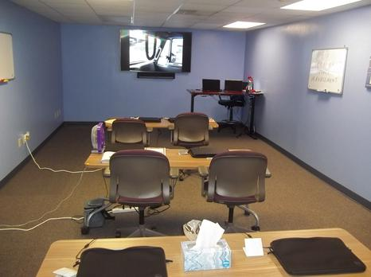
A description of the school's facilities and equipment.
Our classroom is clean, comfortable and enable our students to learn the trucking industry.
Students' desks, chairs and white boards are easily seen by all the students.
We also have a digital projector for video training sessions.

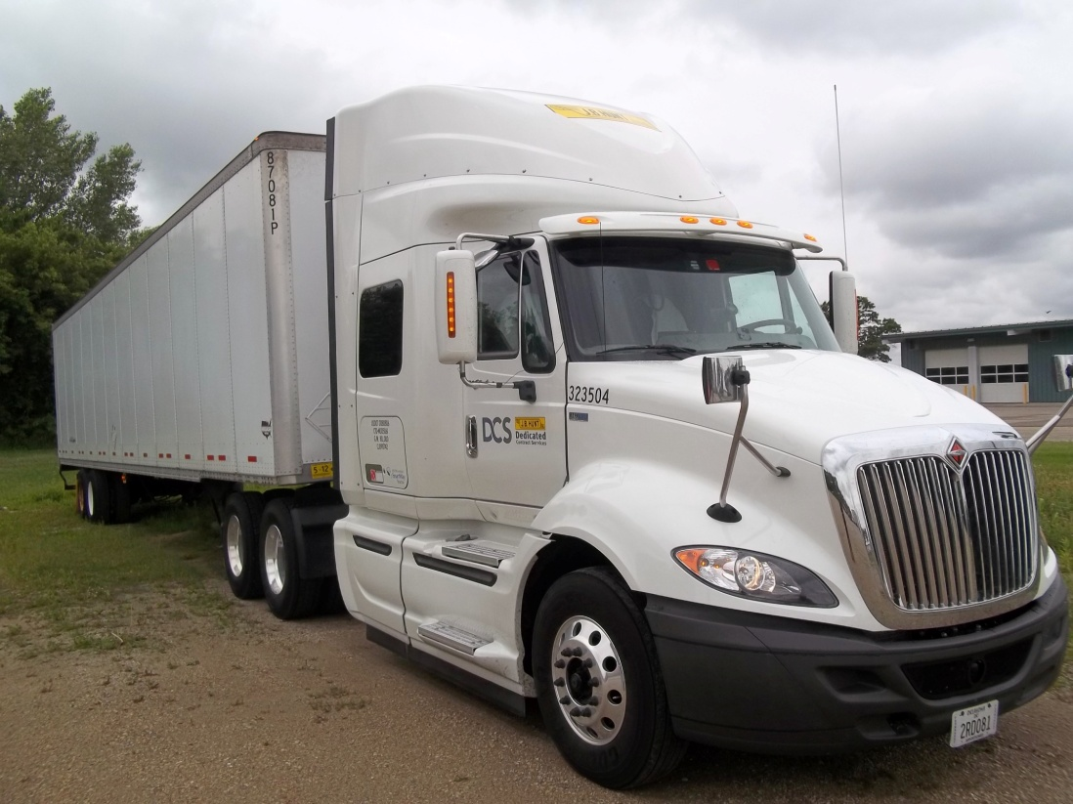
Tractor / Trailer equipment will be leased from a reputable dealer for training students.
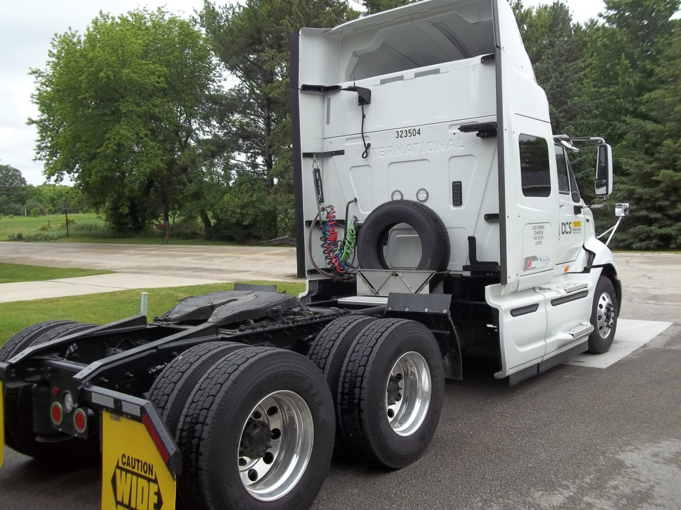

Academy Management and Staff

Melvin Tucker - President, CEO and Certified Instructor

Melvin has over twenty years of experience in the trucking industry. He has spent eighteen years with his previous employer, JB Hunt Transport, Inc.

Melvin will conduct class room instruction, driving course instruction, and on-road instruction. He also mentors all students in order to achieve their Class A CDL.

Viola Tucker - Academy Administrator

Viola has over twenty-five years of office experience. She will perform all office tasks. She will submit applications for students' financial aid, collect down payments for the course, and submit applications for student CDL permits and Class A CDL. She will also keep all files of student current for a period of 3 years in accordance with the regulations of the State of Wisconsin and as required by the US Department of Veterans Affairs (VA) for students using the federal GI Bill.

Academy Address

8200 W. Brown Deer Rd.
Milwaukee, WI. 53223

Training Yard Address

8200 W. Brown Deer Rd.
Milwaukee, WI. 53223

Holidays and Vacation Periods
When the Academy Will Be Closed

December 24 – Christmas Eve
December 25 – Christmas Day
December 31 – New Year’s Eve
January 1 – New Year’s Day
Last Monday in May – Memorial Day
July 4 – Independence Day
August 1 thru 10 – Academy Closed for Staff Vacation
First Monday in September – Labor Day
Fourth Thursday in November – Thanksgiving Day

Admissions and Entrance Requirements
Tuition and fees are due in-full three business days before the beginning of class. The application deadline is 1 week before the beginning of the next class. See page 12 for current costs.
Application requirements:
- Hold a valid driver's license with no significant violations.
- Proof of having passed a Wisconsin Department of Transportation (DOT) physical and drug screen. Contact the TTDA Administrator for information on the physical and drug screen process.
- Fluent use and understanding of English, i.e., reading, writing and speaking.
Application Process:
- Complete and submit the application attached to our brochure.
- Apply online on our website.
- Call the Academy Administrator, 855-669-2235, and press 1.
Students will be notified via US Mail and telephone when:
- Results of the DOT physical and drug screen (required for a CDL) are received by the school.
- The tuition down payment has been received by TTDA.

Classes will begin on the first Monday of the month. Then, continue for four weeks according to the class summary. In the case of a short month, we will adjust our calendar to accommodate the student for their full four week course. Students should check our website for the most up to date calendar of sessions.

This Page Left purposely blank

Grading and Progress System
Students will have daily homework to perform when going home for the evening.
They must complete the homework with a satisfactory grade of 80% or better. The student will be given the correct answers in the next class. If they continue to have issues, we will tutor them to pass the homework test, but the tutor will not just pass them through; they will have to demonstrate knowledge and understanding of the material.
If the student continues to fail (less than 80%) homework two days in a row, he or she would go on probation and get a tutor. If the student fails two more times, he or she will be dismissed and tuition will be refunded according to school policy.
Students must demonstrate academic and practical progress in order to obtain a license. Grades will reflect the cumulative knowledge and understanding obtained throughout the course.
Students will receive daily grades.

Transfer Credits for Prior Training
Program credit may be given for experience, education, credentials or military service pertaining to training for which the student is enrolled at TTDA. Verification of credentials and/or documentation may be required. Transfer of credit must be approved by the school president prior to commencement of training. Transfer credit may shorten the training program and reduce total tuition charges. TTDA does not guarantee transferability of our credits to another institution without a written agreement between that institution and TTDA.

Student Records
Student records are permanently retained. Records are available upon request with appropriate processing and mailing fees.
Student records will be kept on confidential disks, locked in a safe deposit box

Academic Probation and Dismissal
If based on the results of daily quizzes, the student does not demonstrate the comprehensive knowledge and understanding needed to operate a tractor / trailer, he or she will be placed on a two day probationary period in order to catch up with the class. If the student does not demonstrate comprehension by the end of this probationary period, the student will be terminated from the program and tuition will be refunded accordingly.

Student Conduct
Students must be present for all classroom and driving sessions to keep pace with the class. Students cannot be absent more than two consecutive days of the class. If the student is absent more than three consecutive days, he or she will be dismissed from the course and tuition will be refunded accordingly.
Disruptive conduct in the classroom and in the truck will not be allowed. Students must maintain their log books and keep them current throughout the course.
Inappropriate behavior, such as drinking of alcoholic beverages, drug use, fighting, vulgar language, unsafe behavior, or unsafe acts while a student at TTDA, will not be tolerated and may be subject to dismissal from the course. TTDA maintains the right to dismiss an offending student, in which case tuition will be refunded accordingly.
Disruptive or offending conduct will be discussed with the student. If the behavior cannot be corrected and it is determined that the student will not be able to complete the training at TTDA, he or she will be dismissed and tuition will be refunded accordingly.

Leave of Absence
There is no leave of absence with this course.

Attendance
Students must be present at all class or driving sessions unless there is sickness or a family emergency, in which case, we will work with the student to reschedule them to come back to the class.
Attendance records will be maintained for a period of six years, as required by the State of Wisconsin.

Tardiness
Students cannot be more than five minutes late. Weather, transportation, family and/or personal issues will be addressed and corrected so that the student can continue with the current class.
If there is constant tardiness, the student may be dismissed from the course.

Student Complaints
If the student has a complaint for any reason, we will address the complaint in an attempt to resolve the issue. The student can contact the Academy Administrator or Instructor to address any complaint that he or she may have.
If the student has an issue regarding the class, we will make an attempt to correct the issue.
If dismissed from TTDA, the dismissal may be appealed with the school president, if it is found that there are extenuating circumstances.
TTDA will do everything possible to resolve the student complaints. If the complaint is not resolved, then the student can contact the Wisconsin Educational Approval Board, 431 Charmany Drive, Suite 102, Madison, WI. 53719. Phone: (608) 266-1996; Fax: (608) 264-8477.
Email: eabmail@eab.wisconsin.gov
Website: http://eab.state.wi.us.

Tuition and Fees
Tuition: $5,250.00
Fees: (1) DOT physical and drug screening: $100; (2) CDL permit: $30
All tuition and fees must be paid in-full three business days before the beginning of class. The Academy does not accept installment payments.
We will provide logbooks and note-taking instruments.

Veterans’ Education Benefits
Depending on the student’s eligibility with the US Department of Veterans Affairs (VA) and the Wisconsin Department of Veterans Affairs (WDVA), veterans’ education benefits, including Vocational Rehabilitation and Employment (VR&E), aka Chapter 31, may be used while attending the Academy. The GI Bill may pay the tuition and fees depending on the GI Chapter being used. Please contact the Academy Administrator for more information.
As eligible person with remaining GI Bill entitlement may seek reimburse from the VA for the cost of the CDL examination ($300 in 2015) through the License and Certification Program of the GI Bill: http://www.benefits.va.gov/gibill/licensing_certification.asp

Cancellation and Veteran Refund Policy
If a student, who has enrolled at TTDA, wishes to not attend or to withdraw from the program, he or she will have a three business day cancellation period after signing the enrollment agreement.
The amount charged to the student for tuition, fees and other charges when only a portion of a course is completed shall not exceed the approximate pro rata portion of the total charges that the length of the completed portion of the course bears to its total length. The non-refundable portion of the registration fee will not exceed $10. Refunds will be made within forty days after the last class attended, or the effective date of a withdrawal or termination. This policy is in compliance with the requirements of 38 CFR 21.4255.

Daily Training Schedule
Morning Schedule Afternoon Schedule
Class begins: 0800 Class resumes: 1230
Break: 0915 Break: 1345
Class resumes: 0930 Class resumes: 1400
Break: 1030 Break: 1515
Class resumes: 1045 Class resumes: 1530
Lunch: 1200 Class dismissed: 1630
Class times are militarized to familiarize students with the standard frequently used by many trucking firms and the DOT. It is very important that you are familiar with this time format.

Employment Services
Although graduates will have completed the course for their Class A CDL, TTDA does not guarantee job placement for anyone.
The Academy Administrator will work with licensed graduates for employment with a trucking firm, but we cannot guarantee job placement.
TTDA offers a job advisory for graduates. Some trucking firms will accept students fresh out of class; some won't.

Program Curriculum I
Class 1 Eight (8) Clock Hours
Responsibility of Vehicle Operations
Instruction in the Federal Motor Carrier Safety Regulations {FMCSR’s).
Introduction to the basic CMV instruments and controls.
Basic operating characteristics of a CMV
Acceleration, clutching, braking, shifting and mirrors.
Looking forward into your future. (c)
Be aware of your surroundings. (c)
Move your eyes to different objects. (c)
Keep an escape plan active at all times. (c)
Identify, locate, and explain the function of each of the primary and secondary controls including those required for steering, accelerating, shifting, braking systems (e.g., ABS, hydraulic, air), as applicable, and parking.
Class 2 Eight (8) Clock Hours
Vehicle Mechanical and Control Features
Air Pressure, Braking, Backing, Ignition, Oil Pressure, Starting, Steering, Clutch, Shifting Gears, Water Temp, seat belts and learning to read all gauges.
Air line hose (glad hands) attachments. Both blue and red hoses. Pigtail power cord. Fifth wheel operation along with fifth wheel release handle and strike pin for emergency release. Raising and lowering the landing gear (Dollies). Trailer tandems. How to slide trailer tandems to adjust weight balance on trailer.
Air bag positioning on both tractor and trailer. Since most of today's tractors and trailers are equipped with air bags, it is important to know where they are, and inflated properly.
Reading gauges and instruments correctly and the proper use of vehicle safety components, including safety belts and mirrors.

Class 3 Eight (8) Clock Hours
Vehicle Ownership Responsibilities
The owner of the vehicle shall provide all documentation, including licensing, registration, insurance, fuel, maintenance and bonds when needed. Tractor and trailer will be provided clean, fueled and operative. If not, report it. Do not attempt to drive it. All paperwork should be provided in a book that is placed in the driver's door pocket. In that book should be all necessary valid insurance forms, permits cards, and accident reporting forms. A hazmat book should also be included in the driver's door pocket.
Applications given for CDL Drivers Permit.
Test given for homework.

Class 4 Eight (8) Clock Hours
Environmental Dynamics
Some of the drivers here will go on to hauling hazardous material. You must have a hazardous material endorsement on your Class A CDL before you can haul this type of load. Placards must be placed on the trailer in the proper positions. You also must have a hazardous material briefing before leaving the shipper. It is the responsibility of the shipper to provide placards and proper paperwork for this type of load. Paperwork must include the type of hazardous material, weight of the material, and class of the material. This paperwork should be placed in the driver's door pocket when hauling this material for access in case of an emergency. The hazmat book will have all the emergency phone numbers in the event of a spill or accident.
The safety fundamentals, essential regulatory requirements (e.g., overview of FMCSRs and Hazardous Materials Regulations), and students’ responsibilities not directly related to CMV driving, such as proper cargo securement.

Class 5 Eight (8) Clock Hours
Pre-Driving Skills and Maneuvers
Once the tractor is attached to the trailer, turn off the ignition. Bring log book to updated duty status. The driver will then perform a pre-trip inspection. Turn on the emergency flashers..You will get out and attach the airlines (glad hands) and lighting cord, i.e." pigtail" properly. Then, as you walk towards the rear of the trailer. You bend down to insure that the fifth wheel handle is in the locked position. "IN". Check your driver side drive tires for damage or low pressure. Raise the landing gear (Dollies) on the trailer. As you walk towards the rear of the trailer, check to see if the driver side marker lamp is flashing and on. If so, continue to the rear of the trailer and check the driver side tandem tires to see if there is any damage or low pressure. Then, proceed to the rear of the trailer to see if all lamps are working. This includes clearance lamps at the top of the trailer. Tail lamps should be on. The turn signal lamps should be flashing. Then, continue to walk around the passenger side of the trailer. Check the passenger side tandem tires to see if there is any damage or low pressure. Check to see if the passenger side marker lamp is flashing and on. Then, continue to walk towards the front of the tractor and examine the passenger side drive tires to check for damage and low pressure. Then continue to walk towards the front of the tractor to examine all lighting. Headlamps, turn signals, clearance lamps at the top. If you are alone, use a snowbrush or a long handled stick to depress the brake pedal to engage the brake lamps. Then walk towards the rear of the trailer to insure that the brake lamps are on.
Also, you must perform enroute inspections to make sure your vehicle is safe to continue operations. Plan your trip ahead.
Test given for homework.

Class 6 Eight (8) Clock Hours
City Driving
TIME MANAGEMENT is the most important thing to remember about a load going to or thru a city. Time management is so important. You will be delayed at one point or the other. There are 24 hours in a day; approximately 14 hours of which will be on-duty performance. 11 hours of the 14 will be used for driving. Patience is very important while driving into and thru a city. Many automobile drivers are distracted by talking on the phone, texting, eating or not paying close attention to the task at hand. You must be very attentive while driving in the city. It is important to stay in a lane and not perform too many lane changes unless absolutely necessary. Use turn signals before changing lanes. Lane changes, if not performed carefully, will cause major damage or death. Utilize headlights, turn signals and 4-way flashers to communicate with other drivers. You may be required to drive at night or in darkness. Watch for construction zones and slow down.
It is most important to take your time when driving in or thru the city. If driving too fast in slippery conditions, you may skid or jackknife the vehicle.

Class 7 Eight (8) Clock Hours
Freeway / Highway Driving
Usually, major trucking firms have their speed governors set between 60 to 63 MPH for fuel efficiency – that is, to save money on fuel. Once you have merged onto the highway, utilize your mirrors to maintain information on your surroundings. TIME MANAGEMENT is a factor when driving a tractor / trailer at all times. Look into your future; which means, look far ahead of you. If you see brake lamps, begin to slow down beforehand. Remember, you can't stop as fast as a smaller vehicle. You have brake lag. Brake lag is when you depress the brakes; it takes 1 to 2 seconds before brakes engage. When driving on the highway, maintain a constant speed as traffic allows. Drive in a lane with the least resistance. Normally, this means tractor / trailers drive in the two far right lanes, if it is designed that way. Maintain focus on the passenger side mirrors if you are in the 2nd lane from the shoulder. Smaller vehicles will try to pass you. Keep your eyes moving at all time to gather fresh information about your surroundings. That is so important. Remember, you must use your turn signals to signal your intentions before you make any lane changes. Always use headlights when driving at night.

Class 8 Eight (8) Clock Hours
Rural Driving
Rural driving can be just as dangerous as city driving. Why? Because of hidden entry / exit roads. You will encounter hills, blind driveways, and crossroads. You will see a lot of signs that indicate deer crossings. You will see deer crossing the highways in front of you. If you encounter a deer crossing the highway, expect to see others following. Do not try to swerve around the animal. You may lose control of your vehicle and cause injury or death. It is better to strike the animal and then pull over to the side of the road, call your dispatch office and notify the authorities. Driving on rural roads may have only 2 lanes. One lane in each direction. You must extra careful when approaching oncoming traffic. You don't know what the other driver is doing or thinking.
Test given for homework.

Class 9 Eight (8) Clock Hours
Hazards of Farm Animals and Machinery
Rural driving on 2 lane highways can be hazardous because of farm animals and machinery. Why? Farm implements are out there when planting and harvest seasons begin. Farm animals can get away from the farm perimeters. Sometimes, they may come into the roads in front of you. This is why you must be aware of your surroundings. Farm implements, such as tractors, pickup trucks pulling trailers, hay bailers, and the such are moving at a very slow speed. Usually on the right shoulder of the road. You will see a slow moving vehicle sign on the rear of the vehicle. You must slow down, and make sure you can pass the vehicle safety. If you cannot pass the vehicle safely. You must remain behind the vehicle at a slow speed until you can pass the vehicle safely. Planting season usually begins in the early spring. harvest season begins in the late fall. Caution is always advised during these periods of time.
Test given for homework.

Class 10 Eight (8) Clock Hours
Hazards of Railroad Crossings
When approaching a railroad crossing, you must be aware of your surroundings. You will see railroad crossing signs that indicate the crossing of train tracks. The majority of times, there will be signals at the crossings. But, you cannot just depend on the crossing signal. When approaching a railroad crossing, open your window to listen for train whistles. Those are air horn blasts that indicate a train approaching. Remember, you are driving a 53' trailer behind you. If you encounter a railroad crossing with the signals starting to flash and you hear a trains air horn blasts. Stop before you get to the railroad crossing. It is always better to wait it out. This is why "Time management" is so important. There may be times when a train stops and delay you for a period time. You can encounter a train in the city and in rural areas. So, plan your trip.
Test given for homework.

Class 11 Six (6) Clock Hours
Psychophysical Aspects
When driving a tractor / trailer, you must be rested and in good health. You will be required to have your medical card in your possession at all times. "Time management is key to this aspect. The fastest way to lose your Class A CDL license is a DUI. That means if you are driving your personal vehicle also. Your health is a key component to keeping your Class A CDL in good standing. If you need to take medication, it must be approved by your company in order for your to maintain your employment. The company you choose to work for will gather all information for you to keep them advised of your medication. Also, don't drive a tractor / trailer if you are in a bad mood. Don't report to work if something is weighing on your mind that will cause you to make bad decisions. That will cause you great harm, damage to property or death to you or someone else. You don't need that in your life. Take the day off if you need to. Keep your eyes on the road and hands on the wheel. Keep your speed in response of road, weather, and traffic conditions. You may be required to in cold, hot, and inclement weather. Steep hills and sharp turns. If driving in the mountains while snowing. You will have properly place chains on your drive tires.
Test given for homework.

Class 12 Four (4) Clock Hours
Organ and Tissue Donation
Under the law of the United States, the regulation of organ donation is left to states within the limitations of the Uniform Determination of Death Act, the National Organ Transplant Act of 1984, and the United Network for Organ Sharing (UNOS). Each state's Uniform Anatomical Gift Act seeks to streamline the process and standardize the rules among the various states. Many states have sought to encourage the donations to be made by allowing the consent to be noted on the driver's license. Donor registries allow for a central information center for an individual's wish to be a donor. It is a pure consent system rather than an extended consent system or a dissent opt-out system. The issue of consent is pressing, as the number of patients on the waiting list in the country has increased from approximately 20,000 in 1990 to over 100,000 in 2010. Alongside absolute organ donation increases from the late 1980s up until the mid-2000s, donation rates did not increase or decrease significantly from 2004-2010.
Class 13 Six (6) Clock Hours
Traffic Citizenship and Highway Safety Progress
WASHINGTON, D.C.—A report released by the Governors Highway Safety Association (GHSA) highlights the continued role speeding plays in traffic deaths and makes recommendations to address the problem. Despite progress in nearly every other area of highway safety, speeding continues to be a factor in approximately one third of traffic deaths every year. In 2010, 10,530 people lost their lives in speeding-related crashes in the U.S. and Puerto Rico, representing 31 percent of all traffic deaths. Since 2000, the share of traffic fatalities linked to speeding has increased by seven percent, even as seat belt non-use in fatal crashes dropped 23 percent and alcohol-impaired fatalities declined three percent. Speed remains the one highway safety area where progress has not been made in almost three decades. If you need further information, visit GHSA.GOV. If you break down, you must place your signal flares or triangles in the proper manner to advise traffic that you have broken down. It is the law. You may be stopped for weight and size of your vehicle.
Ramifications, including driver disqualification provisions and fines, for non-compliance with Federal and State laws.
State and local laws relating to the safe operation of the CMV, stopping at weigh stations scales, hazard awareness of vehicle size and weight limitations, low clearance areas (e.g., CMV height restrictions)' and bridge laws formulas.

Class 14 Six (6) Clock Hours
Awareness of Motorcycles, Bicycles and Pedestrians
You must be aware of motorcycles. Because they are so hard to see. They can get into your blind spot. It is so important to be aware of your surroundings at all times by utilizing your mirrors and looking into your future. In the summer, motorcycles are everywhere.
Livable communities are a high priority of the U.S. Department of Transportation (DOT) and the Obama Administration. A livable community provides safe and convenient transportation choices to all citizens, whether by walking, bicycling, transit, or driving. Each year, unfortunately, pedestrian fatalities comprise about 12% of all traffic fatalities and there are approximately 4,000 pedestrian deaths. Another 59,000 pedestrians are injured in roadway crashes annually; the numbers are improving, but we still have a ways to go. Pedestrian safety improvements depend on an integrated approach that involves the 4 E’s: Engineering, Enforcement, Education, and Emergency Services. The FHWA’s Office of Safety develops projects, programs and materials for use in reducing pedestrian and bicyclist fatalities.

Class 15 Six (6) Clock Hours
Move-Over Law
When looking into your future, if you see flashing red and blues lights. Check to see if the left lane is clear before you begin to move into that lane. If the lane is not clear, you must slow down and pay close attention to the shoulder where the flashing lights are. An officer or emergency personnel may walk close to that lane in which you are driving. Move Over laws were originated in the US after a South Carolina Paramedic, James D. Garcia, was struck and injured at an accident scene Jan. 28, 1994, in Lexington, SC. Garcia was listed at fault, leading to his work to create a law to protect other emergency responders. SC's version (SC 56-5-1538) passed in 1996, and was revised in 2002.
After a series of similar events in 2000, the DOT and Federal Highway Administration began to address the issue of Emergency Scene Safety, and issued recommended changes for the new MUTCD (Manual of Uniform Traffic Control Devices) that finally addressed the need for improved standards and protection for Emergency Workers. With the further assistance of public interest groups such as the Emergency Responder Safety Institute (www.respondersafety.com), "Move Over Laws" became standard in the US and Canada.

In the US, the move over laws aim at protecting emergency responders working along the roadside. Forty-nine states have passed move over laws, which were promoted in response to increasing roadside fatalities in the line of duty. Laws require drivers, upon noticing either emergency vehicle with sirens or flashing lights, to move away from the vehicle by one lane, or if that is not possible, slow down by 20 mph (32kmh) below the posted speed limit. This includes law enforcement vehicles, fire trucks and ambulances. In New York State, drivers must use due care when approaching an emergency vehicle that displays red and/or white emergency lighting such as law enforcement vehicles, fire trucks and ambulances and also vehicles with flashing amber lighting such as tow trucks, construction vehicles and other service workers stopped along the side of the road while performing their duties.
Currently, only Hawaii and Washington, D.C. do not have move over laws. On June 17, 2009, Connecticut Governor M. Jodi Rell signed House Bill 5894, establishing a Move Over requirement in the state. Connecticut's Move Over law took effect on October 1, 2009. On August 13, 2010, New York's governor signed a move over law to take effect 1/1/2011. On 1/1/12 the move over law was modified to include, not only police, fire trucks and ambulances, but also hazard vehicles, such as tow trucks. Maryland's provisions, which were approved by Governor O'Malley on May 20, 2010, came into effect on October 1, 2010.
Test given for homework.
Class 16 Four (4) Clock Hours
Hazards of Cell Phone Usage and Texting While Driving
When 28 percent of all automobile accidents have a tie to cell phone usage and 200,000 of them are linked to text messaging while driving, it is long past time to do something to reverse those numbers.
A new national campaign called Focus Driven is setting its sights on raising awareness about the dangers and perhaps getting a ban on cell phone usage and texting while driving.
The group is patterning itself after Mothers Against Drunk Driving, the grassroots movement that grew to become a national and powerful voice in legislation against driving under the influence.
Carrying on a cell phone conversation while driving is a distraction that poses an obvious danger, and text messaging is even more of a safety hazard. The moments of inattention it takes to be able to text is a threat that needs to be dealt with quickly.
Program Curriculum II
Introduction to the Tractor / Trailer
Class 1 Eight (8) Clock Hours
Becoming Familiar With the Tractor
Students will become familiarized with the operation of the tractor. Including instrument panel, gear shifting, clutch pedal, fifth wheel and release handle, air lines, power cord, air brake system, lighting system, seat position, and mirrors. Each student will pass a test to make sure they know what all components and functions of the tractor will perform.
Becoming Familiar with the Trailer
Students will become familiarized with the trailer. Connection of the airlines, glad hands, lighting cord, raising and lowering of the dollies, tandem locking pins, tire pressure.
Each student will pass a test to make sure they a familiar with the trailer and backing and docking.
Connecting the Tractor to the Trailer
Each student will connect to and release from the trailer. Checking to make sure the fifth wheel is locked into position. They will raise and lower the dollies, connect and disconnect the air lines and power cords properly. Check tandem positioning and tire pressure.
Driving On an Obstacle Course
Student will drive on obstacle course to become familiar with the movement of the vehicle. Get out and look. They will perform turns, both left and right turns with safety cones in place.
They will also perform backing maneuvers to simulate backing into dock areas. They will also perform parking in parallel positions.
How to properly perform vehicle inspections, control conditions, employ shifting and backing techniques' the motion of CMVs under various road and traffic and properly couple and uncouple combination vehicles.

Class 2 Eight (8) Clock Hours

Becoming Familiar with City and Highway Driving
The instructor will drive first to demonstrate the proper way to handle city driving. He /She will perform proper turns, command the turn lane, and watch for other vehicles. Then, the instructor will turn over control to the first student. That student will drive for about a half an hour to get the feel of the vehicle at hand. Then, that student will turn over control to the next student. Depending on how many students, this process will take approximately 2 to 3 days.

Class 3 Eight (8) Clock Hours
Road Test for Obtaining the Class A CDL
The instructor and the students will travel to a State of Wisconsin's Road testing facility. Then, the student will be tested by a Department of Transportation Official. When the student passes the D.O.T. exams, that student will receive their Class A CDL. Depending on how many students, this process will take approximately 2 to 3 days.

Class 4 Two (2) Clock Hours
Graduation
An official certificate of completion will be granted to each student that passes our courses. We take great pride in guiding and training our students in order to obtain their Class A CDL.

Class 5 Two (2) Clock Hours
Job Placement
Graduated students will apply for truck driving positions with trucking firms. There is no guarantee of job placement. But, we will advise our students of job opportunities.

Child Sex Trafficking
Child sex trafficking refers to the recruitment, harboring, transportation, provision, obtaining, patronizing, or soliciting of a minor for the purpose of a commercial sex act. Offenders of this crime who are commonly referred to as traffickers, or pimps, target vulnerable children and gain control over them using a variety of manipulative methods. Victims frequently fall prey to traffickers who lure them in with an offer of food, clothes, attention, friendship, love, and a seemingly safe place to sleep. After cultivating a relationship with the child and engendering a false sense of trust, the trafficker will begin engaging the child in prostitution, and use physical, emotional, and psychological abuse to keep the child trapped in a life of prostitution. It is common for traffickers to isolate victims by moving them far away from friends and family, altering their physical appearances, or continuously moving them to new locations. Victims are heavily conditioned to remain loyal to the trafficker and to distrust law enforcement. No child is immune to becoming a victim of child sex trafficking, regardless of the child’s race, age, socioeconomic status, or location, and every child involved in this form of commercial sexual exploitation is a victim.
Technological advances, in particular the Internet and mobile devices, have facilitated the sex trafficking of children by providing a convenient worldwide marketing channel. Individuals can now use websites and social media to advertise, schedule, and purchase sexual encounters with minors. The Internet and mobile devices also allow pimps and traffickers to reach a larger clientele base than in the past, which may expose victims to greater risks and dangers.
Child sex trafficking investigations present unique challenges to law enforcement and require a robust multijurisdictional response, with multiple agencies playing a critical role in ensuring the protection of victims and effective prosecution of offenders. The method by which most traffickers identify, recruit, market, and maintain their victims results in a unique combination of sustained violent criminal behavior with reluctant victims and witnesses. Although interviews of sex trafficking victims frequently identify traffickers and other accomplices, some child victims may resist identifying their traffickers because of fear or other means of manipulation that the pimp has exercised over them. Furthermore, the victim may only know their traffickers’ street name and cannot fully identify their traffickers.
Child sex trafficking victims are often not recognized as victims and may be arrested and jailed. The dangers faced by these children—from the traffickers, their associates, and from customers—are severe. These children become hardened by the treacherous environment in which they must learn to survive. As such, they do not always outwardly present as sympathetic victims. They also frequently suffer from short–term and long–term psychological effects such as depression, self-hatred, and feelings of hopelessness. These child victims also need specialized services that are not widely available given they often have illnesses, drug addictions, physical and sexual trauma, lack of viable family and community ties, and total dependence—physical and psychological—on their abusers.
940.302 Human trafficking.
(1) In this section:
(a) “Commercial sex act" means any of the following for which anything of value is given to, promised, or received, directly or indirectly, by any person:
1. Sexual contact.
2. Sexual intercourse.
3. Except as provided in sub. (2) (c), any of the following:
a. Sexually explicit performance.
b. Any other conduct done for the purpose of sexual humiliation, degradation, arousal, or gratification.
(b) “Debt bondage" means the condition of a debtor arising from the debtor's pledge of services as a security for debt if the reasonable value of those services is not applied toward repaying the debt or if the length and nature of the services are not defined.
(c) “Services" means activities performed by one individual at the request, under the supervision, or for the benefit of another person.
(d) “Trafficking" means recruiting, enticing, harboring, transporting, providing, or obtaining, or attempting to recruit, entice, harbor, transport, provide, or obtain, an individual.
(2)
(a) Except as provided in s. 948.051, whoever knowingly engages in trafficking is guilty of a Class D felony if all of the following apply:
1. One of the following applies:
a. The trafficking is for the purposes of labor or services.
b. The trafficking is for the purposes of a commercial sex act.
2. The trafficking is done by any of the following:
a. Causing or threatening to cause bodily harm to any individual.
b. Causing or threatening to cause financial harm to any individual.
c. Restraining or threatening to restrain any individual.
d. Violating or threatening to violate a law.
e. Destroying, concealing, removing, confiscating, or possessing, or threatening to destroy, conceal, remove, confiscate, or possess, any actual or purported passport or any other actual or purported official identification document of any individual.
f. Extortion.
g. Fraud or deception.
h. Debt bondage.
i. Controlling or threatening to control any individual's access to an addictive controlled substance.
j. Using any scheme, pattern, or other means to directly or indirectly coerce, threaten, or intimidate any individual.
k. Using or threatening to use force or violence on any individual.
L. Causing or threatening to cause any individual to do any act against the individual's will or without the individual's consent.
(b) Whoever benefits in any manner from a violation of par. (a) is guilty of a Class D felony if the person knows or reasonably should have known that the benefits come from or are derived from an act or scheme described in par. (a).
(c) Whoever knowingly receives compensation from the earnings of debt bondage, a prostitute, or a commercial sex act, as described in sub. (1) (a) 1. and 2., is guilty of a Class F felony.
(3) Any person who incurs an injury or death as a result of a violation of sub. (2) may bring a civil action against the person who committed the violation. In addition to actual damages, the court may award punitive damages to the injured party, not to exceed treble the amount of actual damages incurred, and reasonable attorney fees.
History: 2007 a. 116; 2013 a. 362 ss. 27 to 33, 37.
Halting Modern Slavery in the Midwest: The Potential of Wisconsin Act 116 to Improve the State and Federal Response to Human Trafficking. Ozalp. 2009 WLR 1391.
Under the Radar: Human Trafficking in Wisconsin. Monaco-Wilcox and Mueller. Wis. Law. Oct. 2017.

Gaining awareness about human trafficking is very important and it can also be a sensitive issue to discuss. It could bring up feelings or trauma related to a sexual assault or victimization experienced by a student, instructor, or someone they know. Even if a student or instructor hasn’t been personally impacted by human trafficking, learning about it can be upsetting. Instructors are invited to consider the following:

- Class conversation and dialogue should be voluntary as this may be difficult to talk about and being called on to contribute or being separated into small groups may not feel safe or may be overwhelming for students.
- Providing advance notice about the topic may allow time for students to prepare and for instructors to be made aware of any concerns from students impacted by this issue.
- Self-care is important. Students and instructors are encouraged to reach out for support and assistance if they need to talk. Resources can be found through the National Human Trafficking Hotline 1 (888) 373-7888 or under “Find Services” above.

Class 6 1 Clock Hour
What to expect during a standard roadside inspection?
You will be required to have your logs or ELD current with sufficient hours to continue. All paperwork in order. i.e. driver’s license, insurance documents, permits and manifests.
If you are out of hours to drive or your paperwork is not in order. You will be placed Out of Service. You will be fined if placed OOS.
Class 7 1 Clock Hour
When not operating the CMV, you may rest in the sleeper berth or at home. Take the time to exercise.
Class 8 1 Clock Hour
If you are live loading or unloading, you must make sure the load is distributed correctly with the proper weight and secured. If flat bedded, it must be tarped correctly. If you are driving a van trailer. The rear doors must be locked and sealed.
All HazMat loads must have proper placards on all 4 sides of the trailer with the proper paperwork in the driver’s door pocket.
Class 9 1 Clock Hour
If involved in a crash, assess yourself, assess the other driver then dial 911 to report the accident. You may be tested for alcohol and other drugs. When speaking with law enforcement officials. Be straight and honest. English is the preferred language. But, the official can access other personnel that speaks different languages.
Class 10 1 Clock Hour
When starting your career, you a CSA score. That score is zero. When you are getting citations, you will add weight on your score, and it remains there for 3 years.
Class 11 1 Clock Hour
You must keep your Fed Med certification up to date. Basic Operation
I. Basic Operation
Instruction in the Federal Motor Canier Safety Regulations {FMCSRs).
The student is informed about the rules and regulations of the FMCSA.
Introduction to the basic CMV instruments and controls.
The student is in the truck learning the CMV instruments and controls.
Basic operating characteristics of a CMV.
The student is taught pre-trip, in-cab, and air brake systems.
A description of the school's facilities and equipment.
The student has taken a tour of the facilities and equipment.
How to properly perform vehicle inspections, control conditions, employ shifting and backing techniques' the motion of CMVs under various road and traffic and properly couple and uncouple combination vehicles.
The safety fundamentals, essential regulatory requirements (e.g., overview of FMCSRs and Hazardous Materials Regulations), and students’ responsibilities not directly related to CMV driving, such as proper cargo securement.
Ramifications, including driver disqualification provisions and fines, for non-compliance with Federal and State laws.
State and local laws relating to the safe operation of the CMV, stopping at weigh station/scales, hazard awareness of vehicle size and weight limitations, low clearance areas (e.g., CMV height restrictions), and bridge laws. formulas.
Reading gauge$ and instruments correctly and the proper use of vehicle safety components, including safety belts and mirrors.
Identify, locate, and explain the function of each primary and secondary controls including those required for steering, accelerating, shifting, braking systems (e.g., ABS, hydraulic, air), as applicable, and parking.
How to conduct pre-trip and post-trip inspections, including appropriate inspection locations.
How to conduct enroute vehicle inspections.
Introduction of basic vehicular control and handling as it applies to combination vehicles.
Basic combination vehicle controls in areas such as executing sharp left and right turns, centering the vehicle, maneuvering in restricted areas, and entering and exiting the interstate or controlled access highway.
Shifting patterns and procedures to safely and competently perform basic shifting maneuvers.
Executing up and clown shifting techniques on multi-speed dual range transmissions, if appropriate.
The importance of increased vehicle control and improved fuel economy achieved by utilizing proper shifting techniques.
Backing and docking the combination vehicle safely.
Get Out and Look., (GOAL). evaluation of backing/loading facilities, knowledge of backing set ups, as well as instruction in how to back with the use of spotters.
The skills necessary to conduct the procedures for safe coupling and uncoupling of combination vehicle units, as applicable,
II. Safe Operating Procedures
practices required for safe operation of the combination vehicle on the highway under various road, weather, and traffic conditions.
Federal rules governing the proper use of $seat belt assemblies.
How to visually search the road for potential hazards and critical objects, including instruction on recognizing i or distracted drivers.
How to communicate intentions to other road users, including the different techniques for different types of communication on the road, proper use of headlights, turn signals, four-way flashers, and horns.
The proper utilization of eye contact techniques with other drivers, bicyclists, and pedestrians.
Federal rules related to distracted driving and other key driver distraction driving issues, including improper cell phone use, texting, and use of in-cab technology.
Training on visual attention (keeping eyes on the road); manual control (keeping hands on the wheel) and cognitive awareness (keeping mind on the task and safe operation of the CMV).
How to manage speed effectively in response to various road, weather, and traffic conditions.
Methods for calibrating safe following distances taking into account CMV braking distances under an array of CMV weight and length conditions including traffic, weather, and CMV weight and length.
The importance of managing the space surrounding the vehicle under various traffic and road conditions.
Factors affecting the safe operation of CMVs at night and in darkness.
Changes in vision, communications, speed space management, and proper use of lights, as needed' to deal with the special problems night driving presents.
Specific problems presented by extreme driving conditions.
Emphasis on the factors affecting the operation of CMVs in cold, hot, and inclement weather and on steep grades and sharp curves.
Proper tire chaining procedures.
III. Advanced Operating Practices
Advanced skills necessary to recognize potential hazards and the procedures needed to handle a CMV when faced with a hazard.
Potential hazards in the driving environment and steps to take to reduce the severity of the hazard and neutralize possible emergency situations.
How to identify road conditions and other road users that are a potential threat to the safety of the combination vehicle and appropriate adjustments.
Hazard recognition, visual search, adequate surveillance, and response to possible emergency-producing situations encountered by CMV drivers in various situations.
How to recognize potential dangers and the safety procedures that must be utilized while driving in construction/work zones.
The causes of skidding and jackknifing and techniques for avoiding and recovering from them.
The importance of maintaining directional control and bringing the CMV to a stop in the shortest possible distance while operating over a slippery surface.
Appropriate responses when faced with CMV emergencies, including evasive steering, emergency braking. and off road recovery, as well as the proper response to brake failures, tire blowouts, hydroplaning, and rollovers.
Unsafe acts and the role the acts play in producing or worsening hazardous situations.
How to recognize potential dangers and the appropriate safety procedure$ to utilize at railroad (RR)-highway grade crossings.
Federal/State RR grade crossing regulations, RR grade crossing environments. obstructed view conditions, clearance around the tracks, and rail signs and signals.
Railroads have personnel available ("Emergency Notification Systems") to receive notification of any information relating to an unsafe condition at the RR-highway grade crossing or a disabled vehicle or other obstruction blocking a railroad track at the RR-highway grade crossing.
IV. Vehicle Systems and Reporting Malfunctions
Knowledge of the combination vehicle and its systems and subsystems.
The driver's role in vehicle inspection, operation, and maintenance and the impact of those factors upon highway safety and operational efficiency.
How to identify major combination vehicle systems.
The function and how to check all key vehicle systems, (e.9., engine, engine exhaust auxiliary systems, brakes, drive train, coupling systems, and suspension) to ensure their safe operation.
Each combination vehicle system, its importance to safe and efficient operation, and what is needed to keep the system in good operating condition.
What to expect during a standard roadside inspection conducted by authorized personnel.
What vehicle and driver violations are classified as out-of-service (OOS), including the ramifications and penalties for operating a CMV when subject to an OOS order.
Basic servicing and checking procedures for various engine and vehicle components and to help develop their ability to perform preventive maintenance and simple emergency repairs.
V. Non-Driving Activities
Activities that do not involve actually operating the CMV
Cargo weight distribution, cargo securement on the vehicle, cargo covering. and techniques for safe and efficient loading and unloading.
Basic cargo security/cargo theft prevention procedures.
Basic information regarding the proper handling and documentation of HM cargo.
Recognizing environmental hazards and issues related to the CMV and load.
City, county, state, and Federal requirements may apply to environmental hazards and issues.
Different hours-of-service (HOS) requirements applicable to different industries and HOS regulatory requirements.
How to complete a Driver's Daily Log {electronic and paper), timesheet, and logbook recap, as appropriate.
The consequences (safety, legal, and personal) of violating the HOS regulations. including the fines and penalties imposed for these types of violations.
The issues and consequences of chronic and acute driver fatigue and the importance of staying alert.
Wellness and basic health maintenance information that affect a driver's ability to safely operate a CMV.
Post-crash procedures, including the requirement that the driver, if possible, assess his or her physical condition immediately after the crash and notify authorities or assign the task to other assess his or her physical condition individuals at the crash scene.
Protecting the crash area; obtaining emergency medical assistance, moving on-road vehicles off the road in minor crashes so as to avoid subsequent crashes or injuries; engaging flashers, placing reflective triangles and other warning devices for stopped vehicles; and properly using a fire extinguisher.
Post-crash testing requirements related to controlled substances and alcohol.
The value of effective interpersonal communication techniques/skills to interact with enforcement officials.
Roadside vehicle inspection process, and what to expect during this activity.
FMCSA English language proficiency requirements.
The impact that violating Federal and state regulations has on driving records and employing motor carrier’s records.
The right being subject of an employee to question the safety practices of an employer without incurring the risk of losing a job or to reprisals simply for stating a safety concern.
Whistleblower protection regulations.
Procedures for reporting to FMCSA incidents of coercion from motor carriers, shippers, receivers, or transportation intermediaries.
The importance of and requirements for planning routes and trips.
Planning the safest route, planning for rest stops, heavy traffic areas, railroad-highway grade crossing safe clearance and ground clearance (i.e., 'high center"), the importance of Federal and State requirements on the need for permits, and vehicle size and weight limitations.
The correct identification of restricted routes, the pros and cons of Global Positioning System (GPS)trip routing software, and the importance of selecting fuel-efficient routes.
The rules applicable to controlled substances (including prescription drugs) and alcohol use and testing related to the operation of a CMV.
Federal rules on medical certification, medical examination procedures, general qualifications, responsibilities, and disqualifications based on various offenses, orders, and loss of driving privileges.
BTW exercises related to basic vehicle control skills and mastery of basic maneuvers necessary to operate the vehicle safely. instruction must also be taught on a driving range.
Conducting pretrip and post-trip inspections, including appropriate inspection locations. Instruction must also be provided on enroute vehicle inspections.
Performing various straight line backing maneuvers to appropriate criteria/acceptable tolerances.
Performing 45/g0 degree alley dock maneuvers to appropriate criteria/acceptable tolerances.
Performing off-set right and left backing maneuvers to appropriate criterial/acceptable tolerances.
Parallel parking blind side positions/maneuvers to appropriate criterial/acceptable tolerances.
Performing sight side parallel parking maneuvers to appropriate criterial/acceptable tolerances.
Recognition and prevention of sex trafficking.
Recognition and prevention of labor trafficking.
VI. Behind the Wheel Range
Basic vehicle control skills and mastery of basic maneuvers necessary to operate the vehicle safely.
Conducting pre-trip and post-trip inspections, including appropriate inspection locations.
Enroute vehicle inspections.
Performing various straight line backing maneuvers to appropriate criteria/acceptable tolerances.
Performing 45/90-degree alley dock maneuvers to appropriate criteria/acceptable tolerances.
Off-set right and left backing maneuvers to appropriate criteria/acceptable. tolerances.
Parallel parking blind side positions/maneuvers to appropriate criteria/acceptable tolerances.
Sight side parallel parking maneuvers to appropriate criteria/acceptable tolerances.
Proper techniques for coupling, inspecting, and uncoupling combination vehicle units, as applicable
VII. Behind the Wheel Public Road
Left Turn, Right Turns. Lane Changes, Curves at Highway Speeds, and Entry and Exit on the interstate or Controlled Access Highway.
Initiating vehicle movement, executing left and right turns, changing lanes, navigating curves at speed, entry and exit on the interstate or controlled access highway, and stopping the vehicle in a controlled manner.
Performing sale and fuel-efficient shifting.
Signaling intentions and effectively communicating with other drivers.
Visually searching the road for potential hazards and critical objects.
Proper habits and techniques for adjusting and maintaining vehicle speed, taking into consideration various factors such as traffic and road conditions.
Maintaining proper speed to keep appropriate spacing between the CMV and other vehicles.
Methods for calibrating safe following distances under an array of conditions including traffic, weather, and CMV weight and length.
Safe driver behavior while operating the CMV.
The basic activities by the HOS regulations, such as completing a Drivers Daily Log {electronic and paper)' timesheet, and recap, as appropriate.
Recognizing potential hazards in the driving environment in time to reduce the severity of the hazard and neutralize possible emergency situations.
Identifying road conditions and other road users that are a potential threat to the safety of the combination vehicle and to suggest appropriate adjustments.
Recognizing potential dangers and to demonstrate appropriate safety procedures when RR-highway grade crossings are available.
How to operate a CMV safely at night, including the special requirements for night vision. Communications, speed, space management, and proper use of tights
Night driving presents specific circumstances that require heightened attention on the part of the driver.
The special risks created by, and the heightened precautions required by, driving CMVs under extreme driving conditions, such as heavy rain, high wind, high heat, fog, snow, ice, steep grades, and sharp curves.,
Recognizing the changes in basic driving habits needed to deal with the specific challenges presented by these extreme driving conditions.
The causes of skidding and jackknifing and techniques for avoiding and recovering from them.
How to maintain directional control and bring the CMV to a stop in the shortest possible distance while operating over a slippery surface.
Proper techniques for responding to CMV emergencies, such as evasive steering, emergency braking, and off-road recovery.
How to prevent or respond to brake failures, tire blowouts, hydroplaning, and rollovers.

