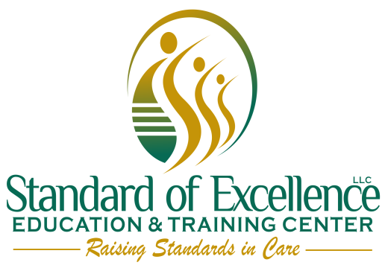

DHS approved CBRF training staff
- Rosland Anderson
- Henry Anderson
- Lindsay Jefferson
- Martine Barber
- Lolita Allen

