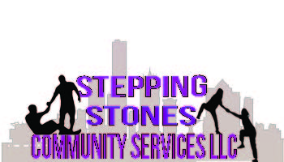

Stepping Stones Community Services, LLC

DHS Approved CBRF Instructors

LaKesha Reid

Stepping Stones Community Services, LLC

Milwaukee, WI
(414) 595-0449
info@mysteppingstone.org

